Wairarapa Regional Positive Ageing Strategy Te Hōkai Nuku
Update July 2022
Earlier this week, I joined an online Question and Answer session hosted by the Wellington Greater Regional Council (GWRC). The GWRC is the Council responsible for our public transport and right now they want to know what we think about the fares for our buses and trains.
They say that they have identified opportunities to improve how they price their fares, including the discounts and concessions, the types of fares products, and how the fares system is structured. They want to achieve the strategic objective of an ‘efficient, accessible and low-carbon public transport network’. Part of this is increasing off peak usage.
They have some great ideas including:
- Increasing the general off-peak discount for all public transport users from 25% to 35%.
- Children to travel free on weekends when accompanied by their parent or guardian.
- Community Services Card holders receive a 50 percent discount on peak and off-peak travel.
- More off peak discounts for those who use Snapper cards
Those of you that are familiar with the Positive Ageing Strategy and/or participated in the engagement that led to its development, would know that access to affordable and accessible transport options was raised many times as an issue. Conversations around transport included the timetabling of the trains and the problem of not being able to use the SuperGold Card both ways.
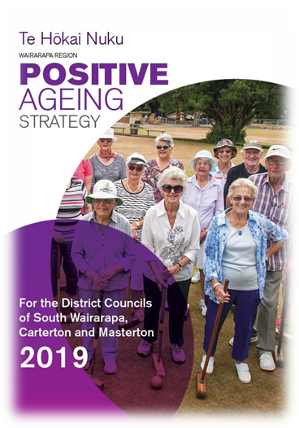
The current proposals outlined in the GWRC’s Fare Review are silent on SuperGold Card use. I raised this as an issue. Their response was that they would welcome feedback from the community about the SuperGold Card.
I would encourage you to get in touch and let them know your views. The consultation closes next Friday July 15th. Information about the Fare Review and a survey can be found here: Metlink: Future Fares Review | Have Your Say | Greater Wellington (gw.govt.nz) or email futurefares@gw.govt.nz
If you have any questions or would like to get in touch, please contact Lisa Matthews, Regional Positive Ageing Strategy Co-ordinator lisa@cdc.govt.nz or 027 444 1887.
The aim of the Positive Ageing Strategy is to improve and integrate council services for older people to help them lead valued, connected and fulfilling lives. You can read the full Strategy on your Council website.

