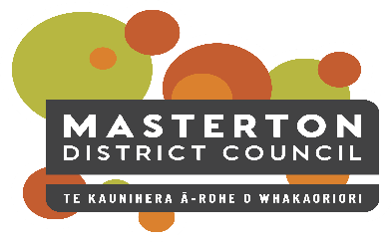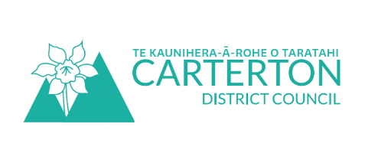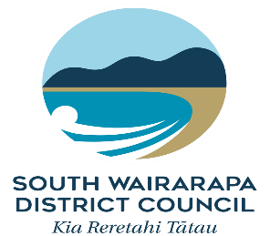

Positive Ageing Strategy Update

July 2021
Deep into winter, we have reached one year of the implementation plan for the Positive Ageing Strategy.
It is a great time to have a look at what has been achieved in this time and we have gathered up some of the work below to show you:
- The Co-ordinator has been working with a range of organisations such as Age Concern, St Johns, Nuku Ora (Sports Wellington), the Wairarapa District Health Board and local Neighbourhood Support to increase communications and information flow. There have been specific projects such as supporting the Age Concern newsletter with Council information, helping St Johns promote and get new volunteers for their Health Shuttle van, and the promotion of Neighbours Day.
- The three Council’s website teams are working to improve accessibility and information on their respective websites. Masterton District Council (MDC) worked with Digital Seniors and CCS Disability Action on their upcoming new website and South Wairarapa District Council (SWDC) worked with Digital Seniors on their recently launched website. Carterton District Council (CDC) will be reviewing their website in the second half of the year but have already made improvements.
- The Roading teams of each Council gathered information about where medical centres, care homes and other places where older people might be, to use in their footpath prioritisation process.
- Disability awareness training was organised for Council staff in recognition that 59 percent of people over 65 have a disability.
- MDC (Trusthouse Recreation Centre, and Rose Cottage) and CDC (Events Centre, library and Courthouse) buildings were audited for accessibility. An audit of SWDC buildings is scheduled for SWDC in August.
- Council staff have looked at how Council events are run and how older people are included, and will be organising an event for United Nations Day of Older Persons in October. They also worked hard to include older persons in their Long Term planning processes.
- The MDC Long Term Plan housing proposal will see more housing for the community, CDC is working on a Housing Plan and SWDC introduced their Spatial Plan looking at the development of housing in the three towns.
- Post the March/April 2020 lockdown, the Co-ordinator interviewed key agencies regarding how older people fared over Lockdown. Both the results of the interviews and the survey results showed that many people were supported over lockdown if they were already connected to their communities. However, little is known about people who may not have such strong links and it was decided to support events and activities that increase connections between individuals.
- Accessible features continue to be added to parks and gardens across the three councils.
Our Positive Ageing Strategy Co-ordinator has been working with the three Councils for 20 hours a week supporting the implementation. Her contract has been extended until December 2021 to continue this work.
If you would like more detail on what has been achieved, or if you have any questions please contact Lisa Matthews, Regional Positive Ageing Strategy Co-ordinator lisa@cdc.govt.nz or 027 444 1887.

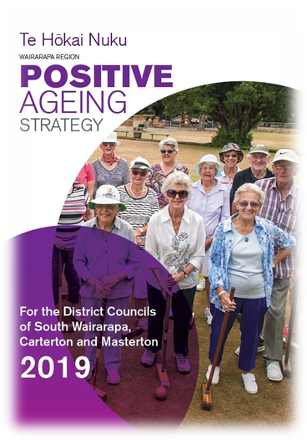
Positive Ageing Strategy
For those of you who don’t know about the Strategy or need a reminder; the aim of the Strategy is to improve and integrate council services for older people to help them lead valued, connected and fulfilling lives.
You can read the full Strategy document on your Council website.

