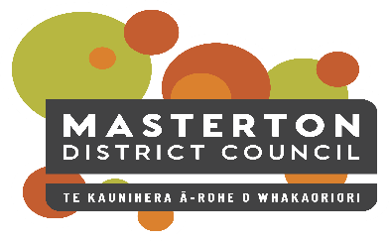 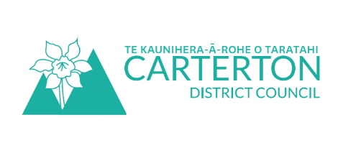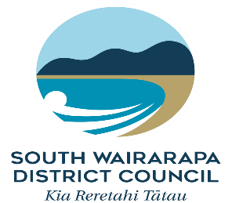

# Positive Ageing Strategy Update

December 2020

Thank you to those of you who got in touch after the October update.

The Positive Ageing Strategy work continues to progress. Outlined below are some examples of the work happening across the three Councils to implement the strategy.

* Improvement to public spaces - South Wairarapa District Council have installed easy access steps in the Greytown Pool to enable people to safely exit the pool instead of using the ladder. Masterton District Council has fitted handrails in the shower cubicles and purchased a smaller mobility hoist to enable transition from chairs to table in the change cubicles at Trust House Recreation Centre.
* Low impact seated gym equipment installed on a concrete pad surrounded by grass in a Council park.
  The equipment has a seat, pedals and handlebars.Improved pathway access - Masterton District Council has refurbished the pathway from Memorial Drive carpark to Douglas Villa Clubrooms to allow for better wheelchair access.
* Footpath prioritisation process - South Wairarapa District Council and Masterton District Council have mapped locations relevant to older people and will use these in their footpath prioritisation process. Carterton District Council has also identified further areas of footpaths that may pose as a trip hazard. Some of these areas were highlighted by the community after the Council put a call out on social media last month to help identify health and safety hazards.

Outdoor gym equipment installed in South Wairarapa Park in September

* Website upgrade - Both Masterton District Council and South Wairarapa District Council are developing new websites to ensure accessibility is improved. Carterton District Council’s website was reviewed and is working on the recommendations.
* Involvement in decision making - South Wairarapa District Council hosted a workshop for older persons as part of their Long-term Plan engagement process.
* Treaty of Waitangi training - Senior staff and Councillors from Carterton District Council attended Treaty of Waitangi training and toured significant sites in the area with mana whenua representatives.
* Accessible housing - Masterton District Council installed a unit at Panama Village with handrails in the porch, living area and bathroom.

If you have any questions, or would like to updated, please contact Lisa Matthews, Regional Positive Ageing Strategy Co-ordinator [lisa@cdc.govt.nz](mailto:lisa@cdc.govt.nz) or 027 444 1887.

## This is a picture of the cover of Te Hokai Nuku Wairarapa Regional Positive Ageing Strategy. the cover show the title, the date (2019) and has the three Wairarapa Councils listed (South Wairarapa, Carterton and Masterton) The picture shows a group of older persons gathered for the photo holding croquet sticks.Positive Ageing Strategy

For those of you who don’t know about the Strategy or need a reminder; the aim of the Strategy is to improve and integrate council services for older people to help them lead valued, connected and fulfilling lives.

The strategy features six strategic goals that are areas of council focus over the medium to long-term including: community support and health services, communication and engagement, transport, cultural diversity, housing, and places, spaces and activities.

You can read the full Strategy document on your Council website.

If you’d like to find out more about Positive Ageing Strategies in New Zealand and internationally, go to [www.superseniors.msd.govt.nz/age-friendlycommunities/index.html](http://www.superseniors.msd.govt.nz/age-friendlycommunities/index.html)

All work on this project is:

* Aligned with Office for Seniors best practice
* Based on the World Health Organisation Age-Friendly cities guidelines
* Designed for cross-Council involvement and participation

Photo shows three older women planting out tiny seedlings at Carterton District Council.