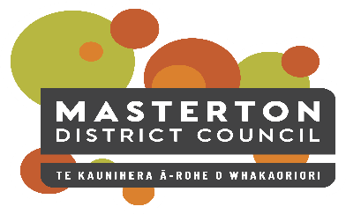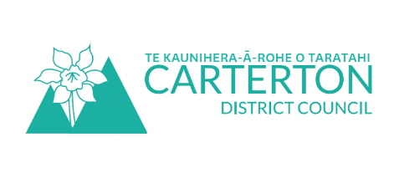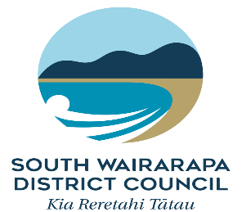

Positive Ageing Strategy Update

April 2021
Thank you to those who responded to the December update – it is great to get such positive feedback.
The implementation of the Positive Ageing Strategy continues into 2021 with various work streams. Below are some examples across the three Councils.
- Long Term Plans. The three Councils have their Long Term Plans out for consultation right now, with an opportunity for people to have their say on the activities of Councils for 2021- 2031. There are some great opportunities to improve life in the Wairarapa for our older persons. Please make a submission if you can.

- Carterton District Council is proposing to work on the Five Trails network which will increase recreational opportunities. Consultation closes April 19. https://cdc.govt.nz/plans/tenyearplan/
- Masterton District Council is hoping to build 25 more homes for older persons. Consultation closes May 3. https://mstn.govt.nz/community-4/current-consultations/long-term-plan-2021-31/
- South Wairarapa District Council wants to increase its spending on new footpaths by $400,000. Consultation closes April 30. https://swdc.govt.nz/long-term-plan/

- Accessibility of buildings. CCS Disability Action visited both Masterton and Carterton District Councils and provided feedback and information on the accessibility of a number of Council buildings. The findings included suggestions or improvements to increase accessibility for all users. Some suggestions can be easily implemented, others require greater planning and budget.

- Social isolation. All Councils supported Neighbourhood Support or other community organisations to host Neighbours Day events. The importance of knowing your neighbours and looking out for Wairarapa’s community members included our older people was actively promoted.

- Website upgrade – Masterton District Council is working with Digital Seniors for the second round of testing on their new website. South Wairarapa District Council asked Digital Seniors to review their new website before launching.

- With 59% of people over 65 having a disability, the three Councils’ front-facing staff attended older persons and disability awareness training. https://www.stats.govt.nz/topics/disability

If you have any questions, or would like to be updated, please contact Lisa Matthews, Regional Positive Ageing Strategy Co-ordinator lisa@cdc.govt.nz or 027 444 1887.

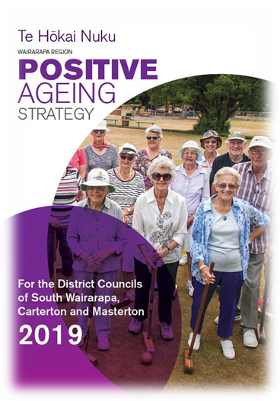
Positive Ageing Strategy
For those of you who don’t know about the Strategy or need a reminder; the aim of the Strategy is to improve and integrate council services for older people to help them lead valued, connected and fulfilling lives.
You can read the full Strategy document on your Council website.

