Wairarapa Regional Positive Ageing Strategy Te Hōkai Nuku

More work to be done

In the last update, I outlined the work that had been done in the last year to make Wairarapa a greater place for older people to live. However, this update is all about looking forward!
With the end of the year in sight, the focus is on determining the Positive Ageing Strategy’s work plan for 2022 and beyond. The three Councils (Carterton, Masterton and South Wairarapa) are committed to this work and have extended the Co-ordinator role through until June 2022 and increased the hours from 20 hours to 32 hours per week. This means more work can be done!
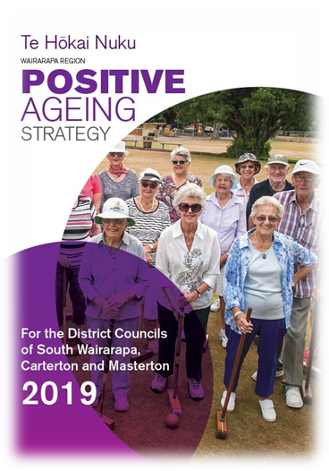
As you know, in 2019, recognising the need to prepare for our rapidly ageing population, the Councils engaged in a widespread dialogue with the community and cemented that kōrero into the Strategy. The vision for the Strategy sets out what the Councils want to achieve:
“Our kaumātua/older residents lead valued, connected and fulfilling lives.”
We think that the vision and goals are still relevant but since the Strategy was written in 2019, life in Wairarapa and New Zealand has changed significantly with the advent of Covid-19 and the use of lockdowns as a control measure. Before writing a three-year work plan, the Councils want to know what you think is important. It might be the same as what you told us last time, you might not have resided here or you might have new issues and ideas for the Council.
Conversation “pop-ups” – informal chats are being held across the Wairarapa in November and December for Wairarapa’s older persons (and anyone who is interested) are invited to meet with the Positive Ageing Strategy Co-ordinator.
The venues and dates are:
Supper Room, Waihinga Centre, Martinborough, 29 November 2021 10.30 – 11.30 am
Carterton Events Centre foyer, Carterton, 2 December 2021 10.30 – 11.30
Senior Citizens Hall, 8 Cole St, Masterton 2 December 1.30 – 2.30 pm
Greytown Town Centre, Greytown, 7 December 2021 10.30 – 11.30 am
Featherston Anzac Hall, Featherston, 7 December 2021 1.30 – 2.30 pm

In these uncertain times please call Lisa Matthews, Regional Positive Ageing Strategy Coordinator on 027 444 1897 or email lisa@cdc.govt.nz one day prior to the event to confirm that it is going ahead.
You can read the full Strategy document on your Council website.

