Report from Infrastructure and Services Committee meeting 14 March 2018, Page 20
Covers have been made for the wastewater sludge drying beds at the Wastewater Treatment Plant. This will speed up the drying time during winter. The aerator that was installed into the number 3 oxidation pond last year and has been running and has helped to maintain the oxygen levels in the pond during the hot, still days. The effluent irrigator has been running since early November and continues to operate within the moisture limits set of the land. The surrounding fences in the paddocks have now been removed for easier mowing of the irrigated area.

Resource Consent Decision summary from Policy and Strategy Committee meeting 14 March 2018, Pages 8 - 9
Land Use Consent Decisions 1.
170011-Discretionary Activity.
Notice of Requirement to designate Council owned land for the purpose of waste water treatment disposal. The designation for the existing wastewater treatment plant is described in the District Plan as “Sewage Treatment Plant”, designation number “Dc007”, for the purpose of a sewage treatment plant. Adjoining this designation is the “Landfill” designation, designation number “Dc006”, for the purpose of landfill. Both designations are show on Map 53 of the District Plan, provided at Appendix 2: District Plan Designations. The proposed designation Dc007a (“Carterton Wastewater Treatment Plant”) and Dc007b (“Daleton Farm Treated Wastewater Storage, Land Irrigation and Public Amenity”) will replace the existing District Plan designation Dc007 (“Sewage Treatment Plant”). Part of the new designation Dc007a will replace part of Designation Dc006 Landfill. In regard to the Sewage Treatment Plant designation, the currently designated site contains a three stage tertiary treatment plant that includes oxidation ponds, a constructed surface flow wetland, a sludge disposal cell, discharge outlet, and treatment facility buildings. Currently, the wastewater treatment plant discharges treated wastewater into a tributary of Mangatārere Stream to the northwest of the site during times when the wastewater treatment plant is at capacity or when the stream flows are high. The existing pivot irrigator is situated adjacent to the Sewage Treatment Plant designation site on land known as Daleton Farm; the irrigation area is outside the bounds of the current designation and was purchased by Carterton District Council in 2012. This land in primarily pasture and is leased to a local farmer. The pivot irrigator also irrigates land within the current landfill designation. There is also an existing dripline fed by the wastewater facility that irrigates the native shelter belt along the eastern boundary of Daleton Farm, is also outside the current designation. The amendment to the designation is to provide for the continued operation of the wastewater treatment facility on the land purchased by Carterton District Council.
The existing Landfill designation requires alterations to provide for the proposed public works for the following reasons:
• An alteration to the boundary between Dc006 and existing designation Dc007: the current plan shown on Maps 53 and 57 of the Wairarapa Combined District Plan incorrectly includes an oxidation pond within the Landfill designation.
• An alteration to the designation applied to a triangular corner of Dc006 from ‘Landfill’ to ‘Wastewater Management Facilities and Public Amenity’. This triangle of land falls within the proposed sweep of the centre pivot irrigator used to irrigate Page 8 46257 3 treated wastewater to land within Daleton Farm and will enable a slight enlargement of the irrigated area (and, therefore, increase the volume of treated wastewater able to be diverted from direct stream discharge to land irrigation).
Consent was granted subject to the following condition: The scope of the works and extent of the works undertaken within the designation shall be in general accordance with the Notices of Requirement and supporting Assessment of Environmental Effects, dated April 2017.
Report from Ordinary Council Meeting 28 March 2018, Pages 18-19
Wastewater Treatment Plant aerial photography was re-flown last month by the local company WAIL (Wairarapa Aerial Imagery) for Council. This provides us with imagery that can be used as reference for the treatment plant upgrade project. Three sets of varying intensity images, a flyover video and elevation data was collected by the use of drone over the property. It is expected that the imagery and video from this imagery will be of use for any community communications or discussions related to the upgrade project. Section 17A of Local Government Act 17A of the Local Government Act places an obligation on Council to review the cost effectiveness of current arrangements for meeting community needs for good quality infrastructure. The first review will be the provision of our transport services and assets. A meeting was held with the Kapiti Coast District Council who has provided a template for the reviews. Kapiti Coast District Council were extremely helpful in providing these resources and have offered ongoing support. An initial meeting with South Wairarapa District Council was held to start the roading services review. There will be regular reporting to Councillors throughout the reviews.
Report from Ordinary Council Meeting 18 April 2018, Pages 18-19
4.1 Sludge drying beds
Frameworks to cover the sludge drying beds have been installed. The framework is made up of galvanised steel, fabricated locally by Tower Gates. The fibre glass sheeting required for the covers has been ordered. Once covers are in place, each cover can be moved individually, which will allow for more efficient management of the sludge, allowing for quicker turn around and reduced odours. Land irrigation is continuing until ground moisture levels rise, with levels being monitored daily.
4.2 Pump Stations
Repairs are being carried out at the Waingawa pump station due to corroded electrical pump connections. This will not affect pump operations.
Extraordinary Council Meeting 24 April 2018 – Adoption of Long Term Plan 2018 – 2028 Consultation Document
Link to agenda

Report from Ordinary Council Meeting 9 May 2018, Pages 35
4.2 Wastewater
The land irrigation season finished on 10 April due to high rainfall and high moisture readings. The irrigation started back on 11 November 2017 giving us five months of irrigation to land. The Daleton Farm project has started the next phase. The relocation of the ephemeral channel is underway, the installation of the solar-powered water supply to the wetlands has been completed and the detailed design of the various project elements has started.
Report from Infrastructure and Services Committee meeting 30 May 2018, Page 25 – 32
Carterton Wastewater Project – Progress Update and Financials
1. PURPOSE To provide an update on progress with implementation of the Carterton Wastewater Project together with the financial implications of that progress and identify the governance arrangements for the project going forward.
2. SIGNIFICANCE The matters for decision in this report are not considered to be of significance under Council’s Significance and Engagement Policy.
3. BACKGROUND New resource consents for the Carterton wastewater treatment plant and effluent irrigation and disposal facilities were issued by Greater Wellington Regional Council in late November 2017. The new consents took effect on 19 January 2018. Instrumental to compliance with those consents is implementation of a four stage capital works programme commencing in 2017/18 and concluding in 2020/21. In addition to the consent based upgrade works, a number of smaller capital works have been programmed. These works relate to general improvements and renewals required to maintain levels of service for the wastewater activity as a whole, including the wastewater treatment plant and reticulation, irrespective of the new consents. In line with other initiatives to improve project management practice, it is timely to establish better governance arrangements about this project.
4. GOVERNANCE ARRANGEMENTS
4.1. Project structure review
The project is a significant one for this Council and the Carterton community. As with projects of this type it is appropriate to review the governance arrangements for the project as it moves from the consenting phase into the detailed design and construction and make appropriate changes to reflect the different activities.
Wellington Water was asked to carry out a review of the structure of the project and make any recommendations it considered appropriate for the delivery phase. Its recommendations are in Attachment 1.
In summary it has been recommended that the Council:
• Prepares a formal project plan for the construction phase, including team structure and roles, delegations, hold points for technical reviews and governance considerations.
• Undertakes some additional peer reviews of the sequential batch reservoirs
• Prepares a formal procurement plan for the project
• Prepares a formal risk register for the project
• Establishes a governance structure to provide technical, management and political governance of the project delivery. The recommendations are currently being implemented. A hold on new works has been temporarily halted ahead of the renewed project structure being put in place. This is to allow the project governance group to get established and provide input into the project and procurement plans and to consider the project risks.
4.2. Project Implementation Governance Group The first action required is to establish the project implementation governance group. The role of this group will be to provide oversight of the capital works programme, procurement processes and manage the various project risks, including budget and timeline risks. The following membership is recommended:
• Chief Executive (project sponsor)
• Operations Manager (project owner)
• Deputy Mayor Keys (political oversight)
• Councillor Deller (political oversight)
• Greater Wellington Regional Council (consent authority)
The Project Manager will report to the Governance Group. It is envisaged the group will oversee the preparation of the various project planning documents and then once completed would meet at milestone points and on a monthly basis. Consideration will be given once the Governance Group is up and running as to whether an additional technical specialist should also be on the group.
4.3. Community Advisory Group
The consent requires that the Council establishes a community advisory group. The consent requires that the Council sends an invitation to the group for a first meeting within six months of the consent becoming operative, i.e. by 19 July 2018. The conditions set out the membership of the group, which is: a. Rangitane o Wairarapa b. Ngati Kahungunu ki Wairarapa.
c. Wairarapa Public Health
d. Sustainable Wairarapa
e. Mangatārere Restoration Society
f. GWRC
g. The Consent Holder.
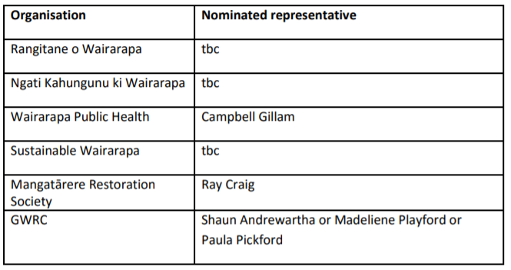
The Council is required to supply copies of all monitoring reports to the members of the Advisory Group at the same time those reports are supplied to the Manager Environmental Regulation, Wellington Regional Council. Reports will also be provided to the Infrastructure and Services Committee and, where appropriate, the Audit and Risk Committee. Meetings of the Group are to be at least once annually and the Advisory Group is able to determine whether more frequent meetings are required. Letters to each of the above parties were sent out in March 2018. The following responses have been received:
It is proposed that the Council will be represented on the group by the Operations Manager. The issue of remuneration for participating on the group has been raised. For those members of the group for which membership of the group would not form part of their normal jobs (i.e. iwi, Sustainable Wairarapa and Mangatārere Restoration Society representatives, an offer of remuneration would be appropriate. It is proposed to pay attendees a per meeting fee commensurate with other Councils fees. Officers will investigate appropriate fee levels and let the participants know, ahead of the first meeting.
Project management
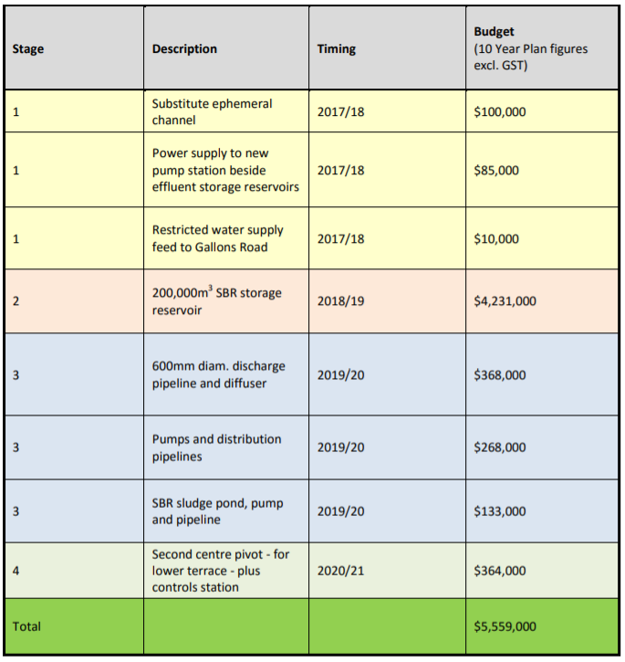
Greg Boyle is currently managing the project on behalf of the Council. He has very successfully guided the project through its consenting phase and for that the Council owes him a debt of gratitude. Greg has indicated he would like to step aside from the project at this point. A new project manager will therefore need to be found. The Council does not have the capacity within the organisation to provide project management, although an in-house project management role is currently being established. We will need to engage a contractor to at least help with the set-up the construction phase, as recommended by Wellington Water. The process is now underway to find a suitable person. 5. CAPITAL WORKS PROGRAMME FOR THE EXPANSION PROJECT The capital works required to complete the wastewater treatment and disposal upgrade are to be carried out over the current and next three years. The description, timing and budget estimate for each of the major works is summarised in the table below:
6. 2017/18 CAPITAL WORKS
Progress on each of the Stage 1 projects comprising the current year’s (2017/18) upgrade programme is summarised as follows:
6.1. Substitute ephemeral channel
Work is required to substitute the existing ephemeral channel with a new, constructed channel located parallel to the western boundary of the Daleton Farm property. There are two reasons for this. Firstly, because the second centre pivot irrigator will operate over the top of the existing ephemeral, and the need to avoid irrigation of effluent into water courses, there is a need to level the existing channel to avoid losing approximately 20% of the irrigable area.
Secondly, the existing ephemeral stream provides a modest level of flood water storage during high river flow events, backing up from the Mangatārere Stream through a culvert beneath Gallons Road. From a flood protection perspective, GWRC required the substitute channel to be constructed to a similar volume.
Due to the late consent determination post the appeal period (mid-January 2018), the available construction season for completing this work as scheduled has been compressed. To expedite the required earthworks, the work was preceded by machine removal of vegetation (mainly willow) in the existing drain.
Since then, the contractor has implemented a methodology comprising essentially a cut and fill operation, but including:
• stripping of topsoil from the existing channel and windrowing adjacent (mainly) on east of the channel
• constructing sedimentation ponds at bottom end
• stripping topsoil from replacement channel and windrowing adjacent to channel
• construct sedimentation pond at bottom end of new channel
• grading excavation from bottom to top • moving subsoil from new channel to old
• re-grading ground level west to east where required
• adding any extra material supplied by Carterton District Council
• replacing topsoil & adding any additional from elsewhere on the site
• grass sowing and reinstatement.
The late autumn soil conditions at the site have made construction increasingly difficult. To avoid the risk of creating excessive damage to surrounding ground and inefficient use of earthmoving plant, further work has been suspended until late spring when soils will have dried sufficiently for access by heavy plant. The ephemeral channel construction is not on the critical path, so the delay will not impact on overall project delivery timeframe.
As at 21 May 2018, the project was approximately 50% complete. The total budget in 2017/18 is $100,000. The unspent portion of the budget will need to carry-forward to the 2018/19 year.

6.2. Power supply to new pump station
Drainage and irrigation from the new SBR storage ponds will require new pumps and power supply. This is budgeted in the 2017/18 Annual Plan for $85k. A proposal has been submitted to Powerco for a new underground 200kVa cable supply crossing beneath SH2 opposite the proposed pumping installations. The current estimate is $57k, assuming that the existing 11kVa switchgear does not need upgrading. That is a moot point at present, with a major industrial supplier at the same end of Carterton increasing its demand and the 11kVa feeder cable nearing its capacity limit. In the meantime, Powerco has essentially placed all increased load applications on hold until its planning engineers have arrived at a solution, which may in turn affect its investment in the work. The next step awaits Powerco’s approval and pricing. This project is likely to be carried through to 2018/19.
6.3. Restricted water supply to Gallons Road
A new 50mm diameter, restricted water supply feed has been laid from Dalefield Road to Gallons Rd. In addition to mitigating the risks of spray drift or groundwater contamination from the irrigation activity on Daleton Farm, a supply will be needed at the new pump station and sludge tank installations associated with the new SBR reservoir. The budget for this work is $10k in 2017/18. It is expected to be completed on budget.
6.4. Fencing and planting
A modest annual sum ($5,000 per year) has been provided for landscaping and fencing of Daleton Farm supplemented by funding grants from Greater Wellington Regional Council and in-kind community contributions in the form of labour. Most of the work to date has focussed on the fencing and planting of Daleton amenity wetland.
7. CAPITAL WORKS REQUIRED TO MAINTAIN CURRENT TREATMENT FACILITIES 2017/18
In addition to the above consent based projects planned for 2017/18, there are a number of other works programmed, summarised as follows: 7.1. Duplicate digester This involves installation of a second heat pump in the existing digester including modifications to the chamber, and a new mixer. This will improve digester processing turnover as sludge volumes increase post construction of the SBR. Work on this project will need to carry-over to the 2018/19 financial year. Budget is $35,000.
7.2. Renovate and cover sludge drying beds
New covers were fitted to the existing, open, sludge drying beds to improve drying time and hence, sludge handling prior to disposal at the lined CDC landfill cell. Work was completed early this year. Budget is $50,000.
7.3. Gas flare at digester
This project provides for the safe removal of methane gas produced from sludge in the anaerobic digester. A gas flare relies on there being sufficient methane concentration to support combustion, otherwise the gas can be stripped through the biofilters. Testing of the gas is required to confirm combustibility, scheduled for completion next month. The budget is $10,000.
8. DESIGN WORK FOR NEW SBR RESERVOIR 2018/19
The new 200,000m3 SBR reservoir is scheduled for completion over the 2018/19 summer construction period. This is by far the dominant capital works element associated with the upgrade. It provides the mechanism for effluent flow harvesting and storage, effluent source for summer irrigation over the whole Daleton Farm property, effluent quality enhancement and managed discharge regime. It is sized to achieve an optimum balance with the available CDC owned land area (approx. 40ha) for irrigation during average flow conditions.
The work required to be completed ahead of the construction period, by Tonkin Taylor Ltd., involves the detailed design phase including drawings, specifications and schedules of quantities, followed by building consent application (to Waikato Regional Council as the consenting authority for dam structures), and procurement. Project construction is scheduled for completion by 29 April 2019. A copy of the project timetable is in Attachment 2.
The detailed design phase was put on hold while the new project arrangements are put in place (see Section 4 above). There is a risk that this may lead to delays with the start of construction. These risks will be managed through the new project arrangements. The Regional Council will be kept informed of any issues before they arise.
9. FINANCIAL REPORT ON 2017/18 CAPITAL WORKS
The 2017/18 budget approved in the Annual Plan for capital expenditure at the wastewater treatment plant, including the development of Daleton Farm, is $395,000. Funding of $343,000 was been carried forward from 2016/17 to cover work being undertaken this year. Against this total of $738,000, $333,000 has been spent up to 31 March 2018 and $514,500 is anticipated to be spent by year-end. See Attachment 3. Potentially $240,000 will be carried through to 2018/19 to complete these projects. Significant among these is the design, building consent and procurement work being done by Tonkin & Taylor ($40k), the power supply for the dam pumps and second pivot ($85k), work being done on the wetlands ($25k), the duplicate digester and gas flare ($40k) and replacement contra sheer ($50k).
10. RECOMMENDATIONS
That the Committee:
1. Receives the report.
2. Agrees to the governance arrangements outlined in Section 4.2 of this report.
3. Notes the progress update on capital works associated with the Carterton Sustainable Wastewater upgrade project.
4. Notes the project timetable for completion of detailed design work for the proposed SBR storage reservoir, and that some timeline slippage may happen as a result of the project set-up activities.
5. Agrees that Councillors Keys and Deller be included on the governance group for the project implementation.
Greg Boyle PROJECT MANAGER, Jane Davis CHIEF EXECUTIVE
Attachments:
1. Wellington Water project review recommendations
2. Project timetable for detailed design up to construction of SBR storage reservoirs 2018/19
3. Financial Report on Waste-water capital expenditure

Attachment 1
Wellington Water Construction Project Phase Set-up Recommendations
1. A formal project plan should be prepared to detail baseline project scope, schedule, budgets, organisational chart, roles and responsibilities, project execution strategy, approach to H&S, communication and community engagement, quality assurance and risk register.
2. The project plan should incorporate clearly defined stages with key milestones such as hold points for project governance and technical reviews
3. Any agreed changes to the project plan should be clearly documented going forward.
4. An independent technical review of the chosen option should be undertaken in order to close out the earlier stages of design, and to assess the risks associated with choosing a solution that has not been used in Australasia. There are a number of companies with global experience to provide process design and operational reviews, such as Stantec, Beca, Black & Veatch and Veolia
5. A summary of the current status and work completed to provide clarity going forward
6. The scope of design for the complete works needs to be identified and needs to consider decommissioning and demolition of redundant existing plant, commissioning and operation of new plant, and additional site services required such as access roads, drainage, lighting, and service water
7. A description of the existing plant and a process flow diagram should be developed to show interface with existing and new plant, and redundancy for operational resilience in the event of breakdowns, operational issues or planned maintenance.
15. A formal procurement plan should be prepared to document the basis of all existing project related contracts and planned approach for future packages of work
16. A formal procurement plan should be created or reviewed by a procurement specialist
17. Confirmation of limits of authority and delegations for contract award and variation management should be detailed in the procurement plan.
18. A formal risk register should be prepared to detail project risks, mitigation measures and dates when risks will have been realised so associated contingency can be released
19. The risk register should form part of a monthly governance report
20. Trade waste management should be included as a specific project risk, including specific considerations around changes to anticipated trade waste loadings and revenue implications.
21. The risk register should include the process risk associated with the chosen option as discussed above.
22. A report should be provided to describe how the estimate has been developed and what has been allowed for risk contingency, operational and maintenance costs.
23. A governance structure should be put in place immediately to detail technical, management and political governance processes to be followed for the delivery phase of this project.
24. A formal change management procedure should be put in place

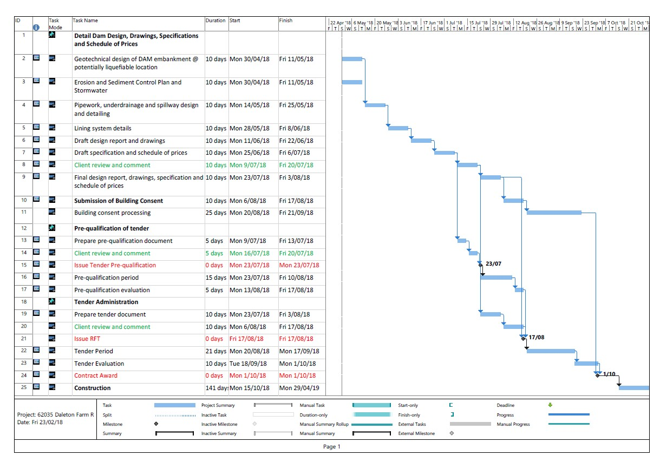

Financial Report Attachment 3
d
n
R
ed

Description of Expenditure |  | Spent  2015/16 | Spent  2016/17 |  | Budget (AP2018) | Planne 2018/19 | B/Fwd Approved | Unbudgeted Approved Council Noted |  |  | Total Budget | Spend i 2017/18 | Not Spent | FULL YEA EXPECTED $ | C/Fwd  LY WIP | Capitalis  To GL & FAR |  | WIP 30/06/2018 | Progress Comment - Year-end Expectation
 | Waste water
 | Project
DFTP | New Inlet Works and Flow Metering |  | 470,435 |  | - |  | 40,000 |  |  |  | 40,000 | - | 40,000 | 40,000 | - |  |  | - | -
DFTP | Consents for Treatment and Disposal |  | - |  | 100,000 |  |  |  |  |  | 100,000 | 146,583 | (46,583) | 150,000 | - |  |  | 146,583 | Consent agreed and i ssued by GWRC.
DFTP | Daleton Farm - Shelter Belt and Fencing |  | - | 23,966 | 5,000 |  |  |  |  |  | 5,000 | 1,465 | 3,535 | 5,000 | 125,855 |  |  | 127,320 | Annual programme activity - work undertaken by volunteers (MRS)
DFTP | Wetlands planting support |  | - |  | - |  |  |  |  |  | - | 7,888 | (7,888) |  | - | 7,888 |  | - | part of annual programme
DFTP | Daleton Farm Dam - design, building consent, procurement, supervision |  | 4,680 |  | - | 169,000 | 48,878 |  |  |  | 48,878 | - | 48,878 | 4,500 | - |  |  | - | The work required to be completed ahead of the construction period by Tonkin Taylor Ltd involves the detailed design phase including  drawings, specifications and schedules of quantities, followed by building consent application (to Waikato Regional Council as the consenting authority for dam structures), and procurement.
DFTP | Lining of wetland channels and flow distribution |  | 125,855 |  | - |  | 74,145 |  |  | X | 74,145 | 128,709 | (54,564) | 150,000 | - |  |  | 128,709 | This project i s to renovate flow distribution the wetlands and replant.  New flow distribution channels have been completed with work on  replanting has been in part delayed pending construction of a bypass channel to divert flows while planting occurs. Work has carried through from last year. Costing more than planned as the final constructed  channelling more sophisticated than original design. Any residual may need to be carried forward to 2018/19.
DFTP | Water Balance Mitigation Measures - Wetland Upgrade or Line Ponds |  | - |  | - |  | 100,000 |  |  |  | 100,000 | - | 100,000 |  | - |  |  | - | The water balance project i s provided as a contingency for the above wetland renewal work. The need will be determined from stream monitoring subsequent to completion of the wetland renewals to  determine the existence of any remaining leakage from the base of the wetlands or ponds. Either the ponds or the wetlands are leaking - we  expect i t i s the ponds, they need attention anyway, so are dealing with ponds fi rst. The residual budget will need to be carried forward to 2018/19
DFTP | Install monitoring and instrumentation - 2nd CPI |  | - |  | - |  | 30,000 |  |  |  | 30,000 | 11,507 | 18,493 | 30,000 | - |  |  | 11,507 | Work undertaken by Harvest.
DFTP | Duplicate UV at storage pond |  | - |  | - |  |  |  |  |  | - | 585 | (585) |  | - |  |  | 585 | -
DFTP | Construct substitute ephemeral |  | - |  | 100,000 |  |  |  |  |  | 100,000 | 20,489 | 79,511 | 100,000 | - |  |  | 20,489 | Work under way - February/March activity
DFTP | Power Supply for Daleton Farm Facilities |  | - |  | 85,000 |  |  |  |  |  | 85,000 | - | 85,000 |  | - |  |  | - | Drainage and irrigation form the new SBR storage ponds will require new pumps and power supply. A proposal has been submitted to Powerco for a new underground 200kVa cable supply crossing beneath SH2 opposite the proposed pumping installations. Powerco has essentially placed all  increased load applications on hold until i ts planning engineers have  arrived at a solution, which may in turn affect its investment in the work.  The next step awaits Powerco’s approval and pricing. This project i s l ikely to be carried through to 2018/19.
DFTP | Duplicate digester |  | - |  | 35,000 |  |  |  |  |  | 35,000 | - | 35,000 |  | - |  |  | - | This involves installation of a second heat pump in the existing digester including modifications to the chamber, and a new mixer. This will  improve digester processing turnover as s ludge volumes increase post  construction of the SBR. Work on this project will need to carry-over to the 2018/19 financial year
DFTP | Water main to Gallons Rd (restricted flow) |  | - |  | 10,000 |  |  |  |  |  | 10,000 | - | 10,000 | 10,000 | - |  |  | - | A new 50mm diameter, restricted water supply feed has been laid from Dalefield Road to Gallons Rd. In addition to mitigating the risks of spray drift or groundwater contamination from the irrigation activity on Daleton Farm, a supply will be needed at the new pumpstation and s ludge tank  installations associated with the new SBR reservoir
 |  |  |  |  |  |  |  |  |  |  | - | - |  |  |  |  |  |  | -
 | Wastewater Treatment Plant |  |  |  |  |  |  |  |  |  | - | - |  |  |  |  |  |  | -
 |  |  |  |  |  |  |  |  |  |  | - | -
WWTP | Replace motor for Contra Sheer |  | - |  | - |  | 50,000 |  |  |  | 50,000 | - | 50,000 |  | - |  |  | - | Second hand contrasheer being obtained to replace current unit. The replacement unit became available due to a change in requirement for current owner.
WWTP | Gas flare at digester |  | - |  | 10,000 |  |  |  |  |  | 10,000 | - | 10,000 | 5,000 | - |  |  | - | This project provides for the safe removal of methane gas produced from sludge in the anaerobic digester. A gas flare relies on there being  sufficient methane concentration to support combustion, otherwise the gas can be stripped through the biofilters. Testing of the gas i s required to confirm combustibility, scheduled for completion next month.
WWTP | Renovate and cover s ludge drying beds |  | - |  | 50,000 |  |  |  |  |  | 50,000 | 15,991 | 34,009 | 20,000 | - |  |  | 15,991 | New covers were fi tted to the existing, open, s ludge drying beds to  improve drying time and hence, s ludge handling prior to disposal at the lined CDC landfill cell. Work was completed early this year
Total Capital Expenditure |  | 320,314 | 743,153 |  | 395,000 | 4,144,632 | 343,023 | 0 0 |  |  | 738,023 | 333,218 | 404,805 | 514,500 | 750,263 | 7,888

6 June 2018

Audit and Risk Committee

RISK REGISTER UPDATE REPORT

PURPOSE OF THE REPORT
To advise the Committee on changes to the Carterton District Council risk register.

SIGNIFICANCE
The matters for decision in this report are not considered to be of significance under the Significance and Engagement Policy.

RISK REGISTER
On the 23 November 2017 the Audit and Risk Committee was presented with the Council’s risk register. The Carterton District Council risk register has been regularly reviewed and updated (see Attachment 1).
Changes to the register are listed below.
  - An addition to the register as potential cost or non-performance of the Waste Water Treatment Plant Upgrade (item number 18)
  - A fire evacuation scheme has been finalised for the administration building and evacuation training scheduled (item number 19).
  - Risk of disease spread through poor animal management identified (item number 28)

RECOMMENDATIONS

That the Committee:

- Receives the report.

- Notes the changes to the Carterton District Council Risk Register.

Dave Gittings

Planning and Regulatory Manager

03/10/2017

CDC RISK REGISTER
Attachment 1

COUNCIL RISK | POSSIBLE CAUSE | MITIGATION | Raw RS | Mitigated RS
1) Reputational damage | - Poor communication  - Poor performance  - Misinformed public  - Poor media relationship  - Conflicts of interest or perception of conflicts not managed  - Inappropriate behaviour of staff | - Code of Conduct and/or appropriate policies  - Leadership by example  - Media training  - Appointment of media liaison advisor
2) Lapses of health and safety | - Contractors carrying out work on Council’s behalf without correct health and safety plans  - Event Centre venue hirers without health and safety plans  - Staff working alone in remote working areas  - Staff interacting with troubled or difficult people who may react badly  - Equipment misuse/failure | - Health and Safety requirements instigated across Council  - Create evacuation guide to be given to hirers and placed in main areas of high visibility  - Adequate training for staff in high risk areas  - Equipment is maintained and regularly serviced  - Personal camera for animal control  - Policy not to work alone where possible danger exists
3) Poor natural disaster response (Lack of preparation) | - Council overwhelmed in a major incident  - Inappropriate decisions being made  - Lack of compliance with policies and processes  - Lack of capability, knowledge and ability  - Lack of well-defined or practiced processes  - Lack of community resilience | - Emergency Management planning and practices  - Regular adequate training  - Policies and procedures in place and followed  - Good relationship with WREMO and other Councils  - Ensure staff are aware of what is required and what their role is  - Asset Infrastructure resilience (purchasing of pipe work, joints and introduction of practices

COUNCIL RISK | POSSIBLE CAUSE | MITIGATION | Raw RS | Mitigated RS
that have shown to be more resilient in the Christchurch earthquakes)
- On-going relationship with ‘Resilient Carterton’
- Public information and education
- Focus on potential earthquake prone buildings within the district
4) Data management system loss | - Sole source of information coming from data management system  - Information not captured  - Information and data not restored after loss | - Firewalls, passwords, and other security measures  - Back up processes  - Disaster recovery processes in place and working  - Use of MagiQ Documents  - Use of authorised systems only
5) Loss of key employees | - Small Council with limited human resources resulting in a single staff member in key Council areas  - Serious accident  - Prolonged illness (non-accident)  - Retirement  - Disaffected staff resigning | - Cross training for some work items with the wider team.  - Contract availability from outside agencies  - Operations manuals/Desk Files  - Job Descriptions  - Document extraordinary tasks  - Duplicate training across staff  - Succession plans where appropriate  - Availability of Contractors and/or Consultants  - Investment in our people  - Regular communication with staff  - Engaged staff  - Keeping jobs interesting  - Upskilling

COUNCIL RISK | POSSIBLE CAUSE | MITIGATION | Raw RS | Mitigated RS
6) Poor building security | - Break-ins | - Secure locking systems of all buildings and CCTV  - Alarms installed in key buildings
Human Resources
7) Industrial action | - Unhealthy organisational culture  - Autocratic management style  - Workplace practices  - Poor employment practices  - Lack of communication  - Legal action against Council | - Education and awareness of rights  - Managing conflict and resolving disputes in the workplace  - Effective communication with staff  - Bargaining parties effectively represented  - Organisational commitment to effective/peaceful bargaining  - Demonstrating respect  - Good communication with staff
8) Unethical/inappropriate behaviour | - Inappropriate computer use  - Time misuse  - Harassment and/or bullying of staff  - Lack of policies or policies not enforced  - Poor work place culture  - Lack of effective procedures and systems  - Theft and fraud and other illegal acts | - Create Code of Conduct and/or appropriate policies  - Lead by example  - Reinforce consequences  - Show appreciate to employees  - Create checks and balances  - Hire for values
9) Unfair treatment of council staff | - No framework in place to support | - Training

COUNCIL RISK | POSSIBLE CAUSE | MITIGATION | Raw RS | Mitigated RS
 | pay, leave, overtime activities and transactions and benefits and/or bonuses  - No formalised hiring processes in place  - Unequal compensation and benefits | - Policies and procedures in place and followed  - Checks and balances in place  - Documented delegated authorities/signing authority  - Multiple signatures required  - Collective agreements in place  - Council Drive for a positive culture
10) Hiring of unsuitable/ unsafe personnel | - Discriminatory practices  - Poor interviewing practices  - Negligent reference checks  - Hiring staff who lack capability and or knowledge | - Staff training in interviewing or accompanied by experienced interviewer  - Employment Agreements comply with all employment law  - Induction process in place and used  - Trial/probationary period in place  - Employees required to sign off on important policies and procedures  - Set paperwork as required by law completed  - Dedicated HR manager position  - Hiring procedure in place  - Collective Employment Agreements  - Proactive culture that allows people to speak up
11) Breach of employment legislation | - Lack of knowledge/ awareness of employment law  - Applicable law not complied with  - Required records not kept | - Managers assisted by human resource understand basic employment law  - Managers briefed by HR staff when laws changes are made  - Employment Agreements drafted that comply with all terms and conditions of employment required by law

COUNCIL RISK | POSSIBLE CAUSE | MITIGATION | Raw RS | Mitigated RS
- Management non-compliance not tolerated
- Managers are aware of the records that need to be kept
- Managers and human resources monitor all staff to ensure working conditions are appropriate and are not exploitative.
Operations
12) Water supply contamination | Multiple potential points of contamination:  - Failure of chlorine dosing and pH adjustment  - Failure of UV disinfection  - Contamination of treated water storage  - Contamination of ground water bores  - Frederick Street reticulation pressure pump contamination  - Failure of any of the distribution system connections allowing contaminant ingress  - Untrained/unsupervised or poorly trained staff  - Lack of monitoring  - Response delays | - Sand filtration  - Bag filtration  - UV disinfection (x2)  - pH adjustment  - Chlorination  - Daily monitoring  - Weekly cleaning of filters  - Drinking-water supply - Water Safety Plan  - Supplementary supply  - Ability to isolate sections of supply (contain contaminants)
13) Failure of asset/infrastructure (three waters) | - Lack of investment in maintenance and renewal of assets | - Renewal programmes  - Staff knowledge of asset condition

COUNCIL RISK | POSSIBLE CAUSE | MITIGATION | Raw RS | Mitigated RS
 | - Lack of knowledge of asset state  - Natural disaster (flood / earthquake) causing equipment breakage  - Significant loss of IT or stored data not triggering warning alert  - Loss of Power PLC / Telemetry | - Reporting of faulty plant/equipment  - Updated and adhered to asset management plans  - Increased monitoring  - Back-up water supply  - Back-up generators  - Use of more resilient materials and procedures in replacement and new pipework  - Council investment in wastewater plant upgrade  - Back-up computer server  - Back-up of telemetry data  - Regular updating of telemetry & PLCs  - Staff capable and trained to carry out repairs  - Supplementary supply stocked up with chemical for a prolonged event.  - Material in stock to carry out any foreseeable repairs
14) Wastewater plant failure | - Lack of trained staff leading to asset break or environmental damage  - pipe failure leading to environmental contamination | - Staff knowledge of asset condition  - Reporting of faulty plant/equipment
15) Poor building/asset security | - Theft or damage to assets  - Theft or damage to critical machinery | - CCTV  - Alarms fitted to vital buildings
16) Non-compliance with GWRC consents | - Significant loss of IT or stored data or | - Regular monitoring as per consent

COUNCIL RISK | POSSIBLE CAUSE | MITIGATION | Raw RS | Mitigated RS
 | data telemetry  - Lack of trained personal  - Lack of systematic monitoring | requirements  - Back up staff trained in sampling techniques  - Back-up computer server  - Back-up of telemetry data
17) Poorly run roading contracts and contracting process | - In document contractual errors  - No oversight on contractual work  - Poor contractual service (delays / poor work)  - Cost overruns  - No or poor asset condition monitoring  - Roads and footpaths not fit for purpose leading to accident/injury | - Employment of CDC roading manager for project oversight  - Asset engineer /roading manager/ops manager closer working relationship  - Best practice contractual arrangements
18) Waste water treatment plant upgrade cost overrun or non-performance | - Lack of a detailed project plan  - Incorrect design  - Lack of Governance and project management oversight  - Project specific risks not identified and addressed | - Project review completed by Wellington Water with Governance, project management, design detail, and risk register changes being implemented.
Reserves and Buildings
19) Unsafe Council buildings or grounds in use | - Failure of specified systems (air conditioning system, fire detection, fire suppression etc.)  - Disturbance of asbestos in or on the building without appropriate safety | - Building warrant of Fitness closely monitored  - All suspected asbestos material identified and tested  - Regular fire evacuation procedures practised for events centre and administration building

COUNCIL RISK | POSSIBLE CAUSE | MITIGATION | Raw RS | Mitigated RS
 | procedures  - Failure of fire evacuation procedures  - Earthquake prone buildings in use  - Uncontrolled building access | - Any EQP buildings operated under Legislative requirements  - CCTV in place and used  - Register of all access keys and fobs in development
20) Injuries/death at the swimming pool | - Uneven /wet surfaces causing slips and falls  - Oversubscribed admission to the pool overtaxing life guards  - Incorrect dosing of chlorine pool water (poor water quality)  - Untrained or undertrained lifeguards | - Safety matting provided  - Manhole covers flush with surrounding paths  - Chemical handling certificates and training in pool dosing for all staff undertaking the work  - Contracted trained lifeguards
21) Injuries at council parks | - Children play equipment becoming or installed as unsafe  - Incompatible activities on existing equipment  - Incorrect mower or power tool use around public | - Play equipment checked 6-monthly  - Clear signage of intended use  - Training and supervision of inexperienced staff
22) Incorrect or delayed cemetery internments | - Internments in the wrong site  - Internment site unprepared on time  - staff and public falling into prepared graves  - Heavy machinery use in public area | - Burial warrants sent to four different staff to ensure action  - Training and supervision of inexperienced staff
23) Improper chemical use | - Incorrect storage or use of chemical sprays | - GroSafe handling certificate for staff

COUNCIL RISK | POSSIBLE CAUSE | MITIGATION | Raw RS | Mitigated RS
Planning and Regulatory
24) Statutory non-compliance | - IT system providing false time keeping information  - Unable to complete all required statutory tasks  - Lack of resources to follow regulations  - Procedures inadequate or not followed | - Close monitoring of time frames with contractual arrangements in place for overflow  - Regular in-house audits
25) Non-compliance of CDC animal facility | - Animal facility below MPI minimum code of welfare standards | - Initiated investigation of new animal pound
26) Poor regulatory decision making | - Inexperienced staff  - Lack of care and diligence | - New staff closely supervised by competent staff  - Annual competency assessments of BCOs  - Peer review of technical decisions for each BCO
27) Operational below standard food establishment | - Lack of regular inspections by Environmental Health Officer (EHO)  - No competent EHO available in Council | - Qualified EHO employed
28) Disease spread by poor animal management practices | - Placement of wandering diseased stock into areas that were disease free

COUNCIL RISK | POSSIBLE CAUSE | MITIGATION | Raw RS | Mitigated RS
Corporate services
29) Inadequate financial controls | - Not following legislative or policy financial systems and processes | - Separate passwords required for each approval stage  - Segregation of duties  - Source documentation retained  - Delegations policy  - Procurement policy  - Audit trails  - Budget holder review processes  - Dunning processes  - All receipts through Debtors  - Receipts given to all customers  - Subsidiary systems reconciled  - POs pre-numbered, sequential, and signed for  - System controls  - Invoices require manager approval  - Mileage claims through payroll  - Only 3 credit cards (Mayor, CE, CSM)  - Approval required before use  - Clear policy and guidelines  - Small number of payroll – everyone known to staff  - All changes reviewed and checked  - Manager approves timesheets  - Electronic timesheet approves annual leave in advance  - Overtime authorised in advance

Report from Ordinary Council Meeting 1 August 2018, Pages 63
Waste Water Treatment plant upgrade

The waste water treatment plant governance group is meeting regularly with updates on progress of the works. A full report will be provided to Infrastructure and Services Committee at their next meeting along with future cost projections.

22nd August 2018

Infrastructure and Services Committee

Carterton Wastewater Treatment Plant Upgrade Project

PURPOSE
The purpose of this paper is to advise the committee of progress with this project. The Project Governance sub-committee has met on three occasions since the formation of the new project team to consider various matters associated with this project.

SIGNIFICANCE
The matters for decision in this report are not considered to be of significance under the Significance and Engagement Policy.

GENERAL
The timelines associated with this project are such that the completion of the storage reservoirs this coming summer is highly contingent upon:
  - The receipt of a credible, affordable tender and a well- resourced contractor
  - Suitable weather conditions for earthworks with a minimum of interruption for inclement weather
The full or substantial completion of this stage (Stage 2) this summer is highly desirable from the Councils’ point of view and will underpin and is the precursor to the balance of three year programme that was submitted in the 30th May report to this committee.
So as to inform the committee of other matters relevant to the project officers advise that: 3a SBR (Storage Reservoirs) Design Progress
Approximately 60% of the design and documentation work has been completed as at end July. It is anticipated that the detailed design and documentation will be available in mid- September for sign off.
3b Project Timetable
This is appended for the committee’s information
3c Project Risk
The risk chart illustrates corporate risk in relation to this project, how it can be managed and is appended for the committee’s information and will be further considered by the Audit and Risk Committee
3d Mud Fish Habitat and Rehoming
The committee is advised that an endangered species of mudfish were identified within the foot print of the storage reservoirs and as required by Council’s resource consent have to be trapped and rehomed before construction can commence. It is expected that these fish can be re-homed in the new wetland reserve and Wildlife Ltd, Councils freshwater ecologists have completed two habitat surveys and the report from the first survey is reasonably positive with an indication however that a portion of the wetlands may not be suitable in its present state with potentially some mitigation work to be done.
3e Procurement of Tenders
The Governance committee has considered how Council procures the Stage 2 works and has recommended that early notification to the industry by way of a registration process (ROI) is recommended to be followed by a request for tender (RFT) by invitation.
This process will allow the project and governance team to select a number of tenderers who will then receive tender document.
Tender adjudication will focus on relevant experience, track record and methodology in like work with a relatively low weighting on price. This reflects the relative complexity of the project and potentially means that the lowest price tender may not be necessarily considered further, if it scores poorly on non- price attributes.
It is intended that the early notification process commence as soon as practicable with the aim of getting out to tender before the end of September.
3f Cottage Removal from the Site
The cottage has been put up for disposal by way of public auction scheduled for 31st August 2018. The process being managed by Property Brokers Ltd. The auction will be pre – advertised via the Property press and Trade Me and the reserve price will be set according the feedback received prior to Auction Day.
3g Consent Compliance
The committee is advised that Council has submitted the WWTP Operations and Management Plan to Greater Wellington within the required timeframe, and has met with the Community Advisory Group also within the timeframe as required in the consent.

RECOMMENDATIONS

That the Infrastructure and Services Committee:

1. Receives the report
Bill Sloan

Project Manager

Attachment 1: Project Timeline Chart Attachment 2: Project Risk Diagram

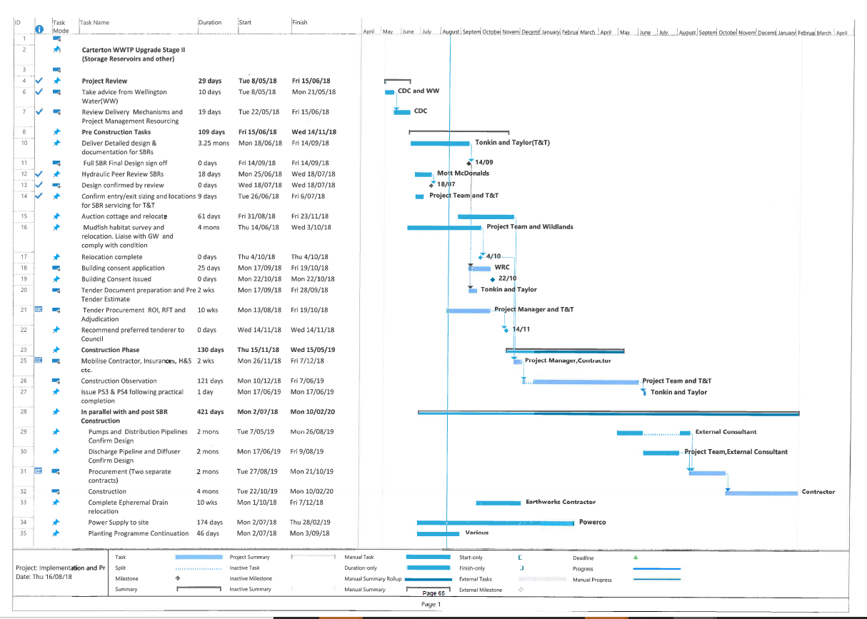

Attachment 2

Risk Identification and Raw risk score |  |  |  |  |  |  |  | Mitigated risk score
 | Item | Assessment  Likely, Moderate, Rare, Very rare, Unanticipated | Rating 1-5 | Description | Assessment  Minor, Moderate, Significant, High, Extreme | Rating 1-5 | Rating 1-25 | Actions | Residual  Risk 1-25
1 | AP Budget Overrun | likely | 5 | Overspend carried forward,negative impact on rates | moderate | 2 | 10 | Close expenditure management, share risk | 4
2 | Programme Time Overrun | likely | 5 | delay in tender processes , construction window lost 18/19 | significant | 3 | 15 | Provide tight control but adapt as necessary | 8
3 | Work Place Safety Incidents | rare | 3 | Council Legislative Liability | moderate | 2 | 6 | All protocols signed off evidential reporting from Contractor to Principal | 4
4 | Project Management Personnel Continuity | moderate | 4 | Slippage due to handover and time lost | moderate | 2 | 8 | Ensure project knowledge is shared throughout the delivery phase | 4
5 | Governance, lack of oversight, insufficient PM resources | Rare | 3 | Lack of project control and lost objectives | significant | 3 | 9 | Formation of and regular reporting to Governance committee and Infrastructure Services | 3
6 | Negative Reputation and public perception | moderate | 4 | Little understanding of Councils environmental objectives, no ratepayer buyin | moderate | 2 | 8 | Implement a Project Comms Plan | 4
7 | Legal and Non compliance with consents | Likely | 5 | Non compliance resulting court action against Council | significant | 3 | 15 | Tight project and construction controls | 3
8 | Environmental | rare | 3 | Poor Environmental Management Council/Contractor | moderate | 2 | 6 | Site education,compliance and reporting | 3
9 | Specification not met | likely | 5 | Poor quality not fit for purpose, reduced useful life | high | 4 | 20 | Robust QA Plan in place, PS4 sign off required | 9
10 | Project Scope Change | rare | 3 | Budget and design objectives threat, Dam permit requirements | high | 4 | 12 | Formal Contract in place | 4
11 | Natural Disaster Works Damage | moderate | 4 | Significant Damage to Works | extreme | 5 | 20 | Adequate Works Insurance Cover | 6
12 | Dam Consent Acquisition (WRC) delays | rare | 3 | Significant Delay in Contract Commencement | high | 4 | 12 | Robust Consent Application complying with NZSOLD Guidelines (2015) | 6
13 | Unidentified Risk | rare | 3 | Unanticipated internal and external intervention | Moderate | 2 | 6 | Continous evaluation of risk throughout the project | 6

Report from Ordinary Council Meeting 12 September 2018 Page 138
4.9 Wastewater
Registration of interest for Contractors to build the storage reservoirs is well advanced with 6 parties submitting registrations. Decisions on the chosen tenderers have been recommended to the Governance Group.
A good result in the auction for the cottage at the waste water treatment plant. The building would have had to be removed prior to reservoir construction and the final bid of $26,000 (less selling cost) is not only a financial positive but also represents a considerable saving for the Council not having to undertake the removal.
Mudfish habitat enhancement and monitoring continues with tree stumps been placed in the wetlands to provide shelter and shade. The burning off the shelter belt trimming has started on Daleton Farm in readiness for the building of the storage reservoirs.

26 September 2018

Infrastructure and Services Committee

Wastewater & Solid Waste Report

PURPOSE
The purpose of this report is to update and inform the Committee on operation for August - September 2018.

SIGNIFICANCE
The matters for decision in this report are not considered to be of significance under the Significance and Engagement Policy.

WASTEWATER – DALETON FARM
Officers have met with the current lessee of Daleton Farm to finalise the new lease agreement. Greg Boyle, former Waste Water Project Manager, assisted with drafting the new lease agreement for Pasture Feed Production, Harvest and Farm Management for a period 14 December 2018 to 14 December 2019.
The lease agreement provides a “cut and carry” pasture harvest. The cut and carry operation is a resource consent requirement to facilitate the removal of nutrient uptake accumulated in the pasture from the land irrigation activity. Bryce is pleased with the one year lease agreement and has a positive attitude towards Council Waste Water Operations on Daleton farm.
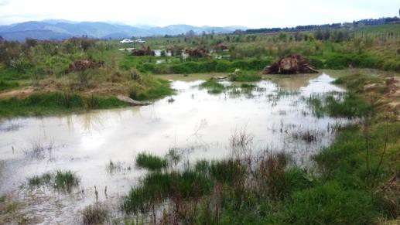
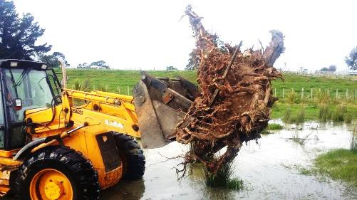
Tree Stumps have been placed into the amenity wetlands off Gallons Road. The purpose of the tree stumps is to create a habitat for the mud fish that are going to be relocated into the wetlands before construction of the new storage reservoirs. Once the weather settles, application of gypsum fertiliser to the irrigation zone will commence, as well as spraying dock weed, rolling and aerating the pivot area in readiness for the next irrigation season which is likely to start in December 2018.
Staff are working to remove the blue gum trees, from the boundary of the old farmhouse property on State Highway Two, in readiness for the construction of the new waste water storage reservoirs
The burning of shelter belt trimmings will continue when weather is suitable.
A new Contra sheer screen for removing solids from the inflow, to the Waste Water Treatment Plant, has been ordered and will be installed in January 2019.

SOLID WASTE
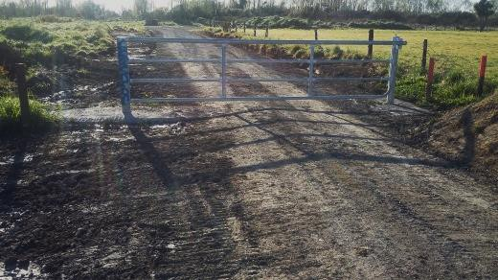
In conjunction with Greater Wellington Regional Council we installed a forestry type lockable gate at the entrance to the river bed at the end of Hughes Line.
The need for a gate to prevent vehicle access is due to an increasing amount of fly dumping of rubbish and green waste in this area. The river bed is still accessible by foot, for swimming and fishing.

RECOMMENDATIONS

That the Infrastructure and Services Committee:

  - Receives the report.

Garry Baker

Operations Manager

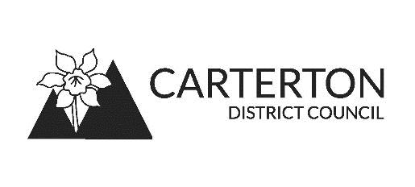

14 November 2018

Infrastructure and Services Committee

Carterton Wastewater Treatment Plant Upgrade Project

PURPOSE
The purpose of this report is to advise the committee of further progress with this project. The Project Governance group has met regularly since June of this year.

SIGNIFICANCE
The matters for decision in this report are not considered to be of significance under the Significance and Engagement Policy.

GENERAL
The projected and updated timelines associated with the project are indicated on the attached Gantt chart, Attachment 1.
To inform Councillors of other matters relevant to the project, the committee is advised:

Storage Reservoirs Design
The design and tender documents for the reservoirs were completed during the period. The building consent application was lodged on 27 September and is currently being processed by Waikato Regional Council.

Mud Fish Habitat and Rehoming

Planned relocation for mid- October to early November has been deferred. This is because water levels in the constructed amenity wetland have not been able to be maintained due to:
- Drier than desirable conditions in late September and October, and reduction of inflow into the wetlands. Supplementary water has been added using the solar powered pump and another portable pump over the period in an effort to retain the proposed habitat, but with little success as the wetland water levels remain low
- Enhancement work being undertaken in the habitat during August/September which may have inadvertently caused leakage in the wetland cell(s) floor

The consequence of all this is that rehoming of the mudfish, whose presence was identified within the construction footprint, may not be able to take place into the constructed wetland resulting in a delay with the next phase of work. The relevant consent conditions read:
Brown Mud Fish Survey
- The Consent Holder shall, prior to commencing the works authorised by this consent, submit to the Manager Environmental Regulation, Wellington Regional Council a methodology for surveying the ephemeral channel and any other drains/wet areas that are to be filled in as part of the earthworks for the site, for the presence of brown mudfish and for the transfer of any brown mudfish encountered prior to or during earthworks being undertaken. The Consent Holder shall not commence earthworks until the Manager Environmental Regulation, Wellington Regional Council has confirmed in writing that the methodology is approved. The Consent Holder shall implement the survey methodology and the fish transfer to the satisfaction of the Manager Environmental Regulation, Wellington Regional Council.
- Should any brown mudfish be identified within the survey undertaken under Condition 4 (Schedule E), like for like mudfish habitat shall be designed and constructed for any areas affected by earthworks/infrastructure. Habitat design and construction is to be undertaken by a suitably qualified ecologist and be to the satisfaction of the Manager Environmental Regulation, Wellington Regional Council.
Regional Council officers are working closely with Carterton District Council staff to achieve the compliance required with these particular conditions.
Other temporary re-homing location options are under active consideration and additional information will be available at the meeting.

Tender Procurement

Tenders for the storage reservoirs closed on 30 October. Three tenders were received and evaluation of these tenders is underway.
The pre-tender estimate for the project, inclusive of the completion of the ephemeral watercourse relocation work and inclusive of a 10% contingency allowance, is $4,326,500 GST excl. This is an increase of some $350,000 from the 2016 preliminary cost estimate.
Construction supervision costs are over and above and are estimated to cost $150,000 -
$200,000.
It is anticipated that that the preferred tender be taken to the Tenders Committee for consideration and adoption during the week beginning 12 November 2018. The aim remains subject to the resolution of outstanding matters to establish a contractor on site in early December although due to other factors there may be now some delay.

Cottage Removal from the Site and Site Access
The cottage was relocated in late October and other pre-clearing work is well advanced.
Discussion with NZTA has continued in relation to use of the existing vehicle access for construction and post construction purposes. NZTA have indicated their concerns on traffic safety grounds with heavy plant and any vehicle using this access and effectively asked that this

access point be abandoned, but have offered up a right hand turn bay solution into Gallons Road as an alternative.
Providing access to the site across the area occupied by Pivot # 1 is not deemed to be a satisfactory option.

Consent Management
Discussions continue with Iwi Representatives in regard of any likely changes that need to be made to the Tangata Whenua Value Monitoring Plan, which is three years old. Likely changes include linkage to the Proposed Natural Resources Plan and the recently adopted Ruamāhanga Whaitua Implementation Programme.
End of year reporting for the new consent was completed and lodged by due date.

4. RECOMMENDATIONS
That the Infrastructure and Services Committee:
1 Receives the report as tabled

Bill Sloan

PROJECT MANAGER

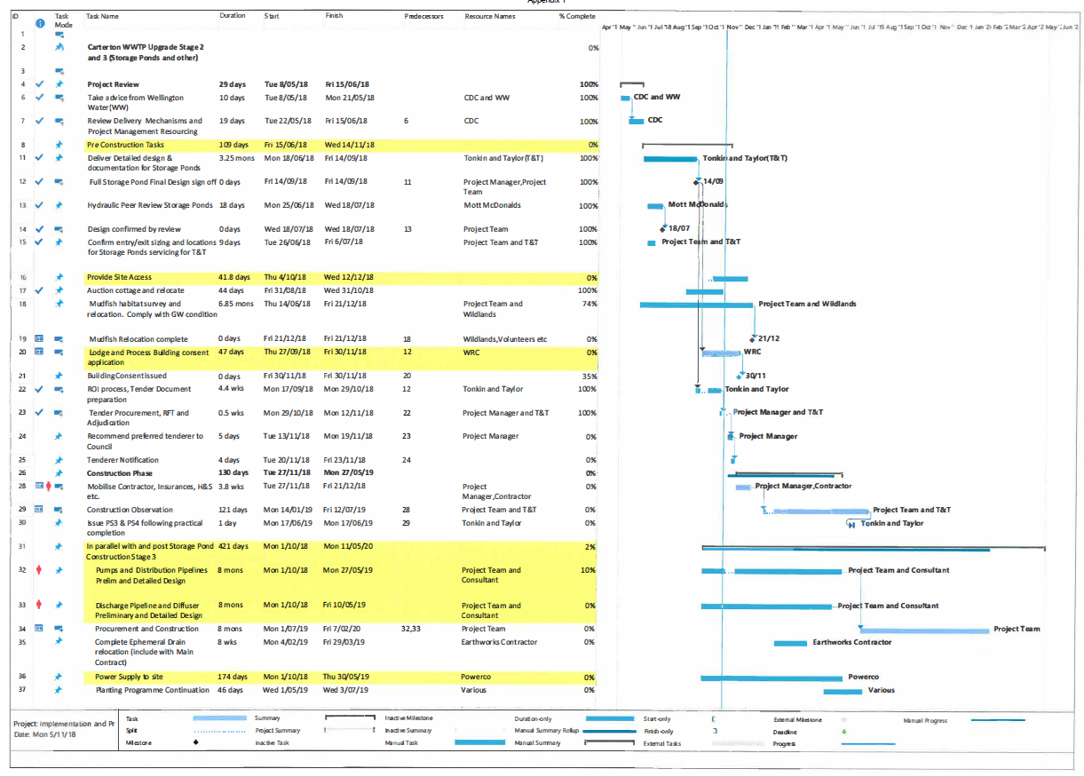

Report from Ordinary Council Meeting 5 December 2018

4.8. Wastewater

In early November high waste water pond levels and high ground water moisture levels meant we were unable to irrigate. Consequently Council required dispensation for an emergency release into the Mangatārere Stream, despite lower than desired stream flows. Under the Council’s consent, emergency discharges may be undertaken following notification to Greater Wellington Regional Council. This was completed successfully.

Following reduction of pond levels a noted oxygen level drop occurred in pond 1 (primary pond). Reduced oxygen levels mean production of high levels of odour and a number of residents notified Council of this. The large aerator was moved from pond 3 to pond 1 and run 24 hours a day to generate greater oxygen levels. The pond has since come back to normal operating levels and officers are reviewing the content of inflow into the pond to evaluate what may be done in the future to ensure, as much as possible, that oxygen levels in the pond remain high.

4.9. Wastewater Treatment Plant Upgrade

Four interested parties were invited to tender for the waste water treatment plant upgrade in September with tenders closing at the end of October. Three of the four companies submitted tenders. A rigorous two envelope process of tender evaluation was undertaken with external experts and Council officers on the evaluation panel. The winning tenderer is Central Hawkes Bay Earthmovers (CHB) Ltd. Central Hawkes Bay Earthmovers is planning to be on-site prior to Christmas 2018.

