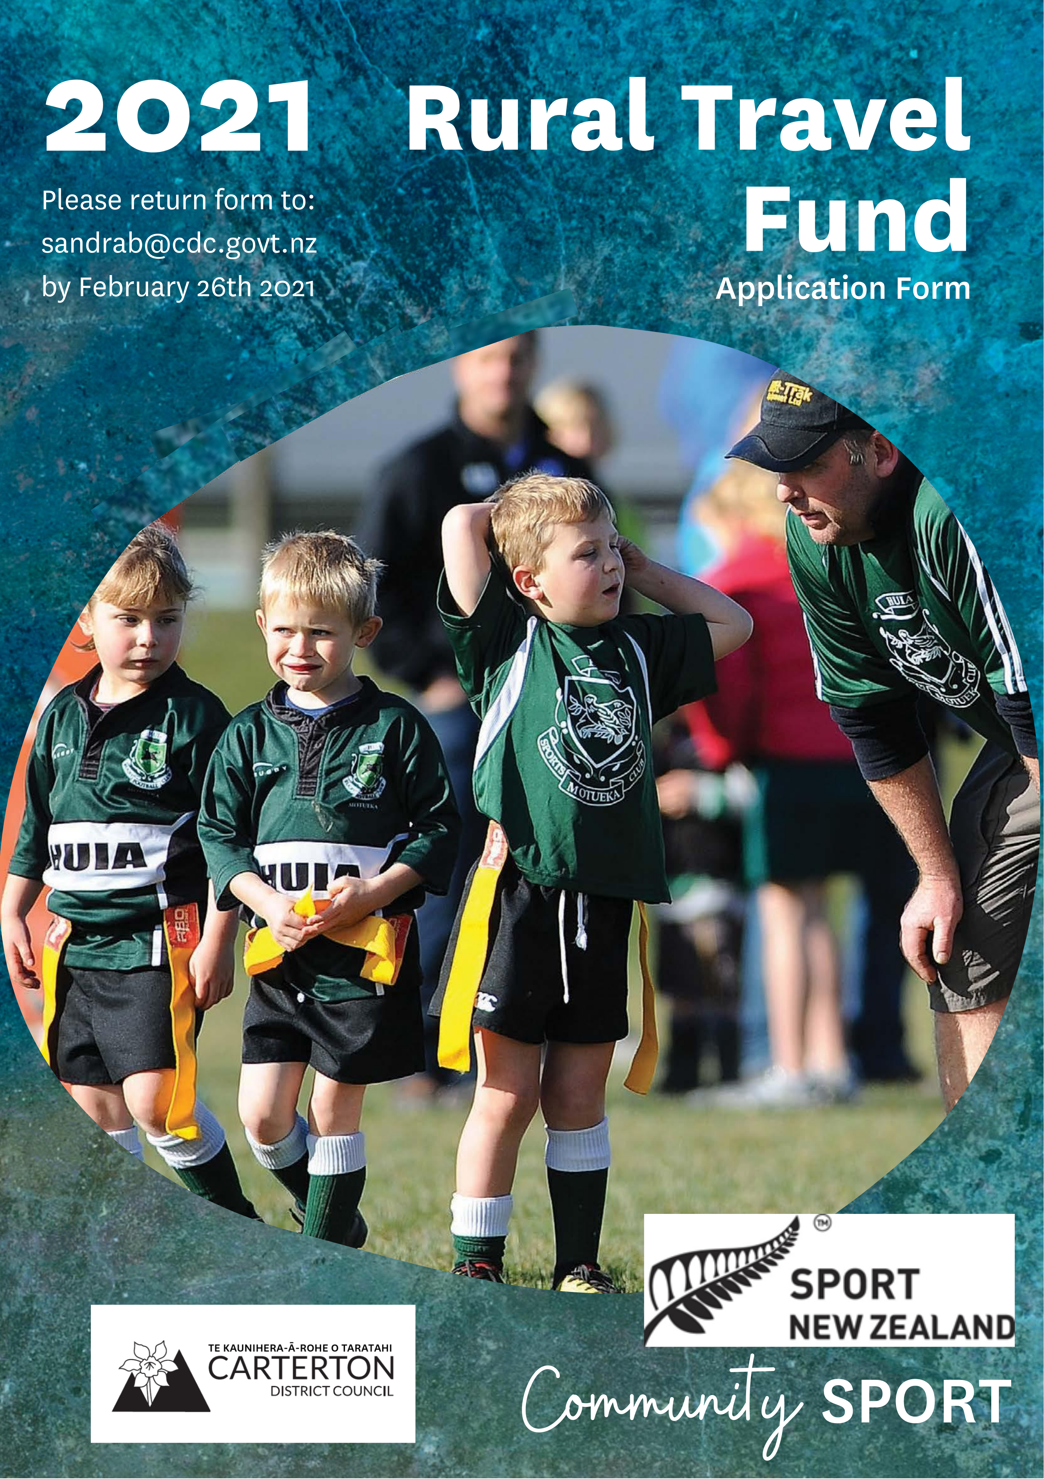
Application No. (office use only) APPENDIX 1

SPORT NZ RURAL TRAVEL FUND APPLICATION FORM 2020-2021

A. Details

Name of organisation: ________________________________________

Contact person: ________________________________________

Postal address: ________________________________________

PO Box address: ________________________________________

Telephone: __________________Email: _________________

B. Contact Names

Please provide

1. Name __________________________ Phone __________________

2. Name __________________________ Phone __________________

C. Organisation Details

Are you a club or a school?

- How many members belong to your club/school?

- How many participants aged between 5 & 18 will this travel subsidy benefit?

- How many participants are aged between 5-11 yrs

- How many participants are aged between 12-18 yrs

- Please detail how many applicants are female

- Please detail how many applicants are male

- Does your application involve a partnership with a local school / club YES/ NO

- What is this funding going to be used for? (Briefly explain)

______________________________________________________________

______________________________________________________________

______________________________________________________________

- Do you have any disabled individuals who are being supported by this fund?

  - If yes, how many will receive support from the RTF

- What percentage of your members live in the vicinity of the local authority you are applying to for the rural travel fund?
___________%

D. Financial Details

- Are you registered for GST? YES / NO

(If yes please write your GST Number in the space provided below)
GST NO.

- How much money are you $____________ Sport NZ funding
applying for?
$____________ other funders

$____________ your contribution

$____________ TOTAL

- If you have applied for funding from other organisations please supply details - refer to Table 1 below.

Table 1
Organisation - (including other councils) | Amount requested ($) | Results date (if known)

- Do you have endorsement from your local affiliated club/school for this application for funding? (this is only relevant if the group applying is the regional body).

YES/ NO (briefly explain and attach evidence of this)

_____________________________________________________________

_____________________________________________________________

E. Declaration

We hereby declare that the information supplied here on behalf of our
organisation is correct?

We consent to _________________________ authority collecting the
personal contact details and information provided in this application, retaining
and using these details and disclosing them to Sport NZ for the purpose of
review of the rural travel fund. This consent is given in accordance with the
Privacy Act 1993.

- Name:

Position in organisation / title:

Signature: Date:

- Name: ______________________________________________

Position in organisation / title:

Signature: Date:

Please attach:

- Latest financial statements from your organisation (i.e. P&L, financial statement)
- A deposit slip (in case your application is approved)
- Evidence of your endorsement from your local affiliated club/school (if required)

Checklist:

- Have you answered every question?
- Have you attached the relevant documents with your application?
- Send your application form with the relevant documents to your local authority by date ________________.

