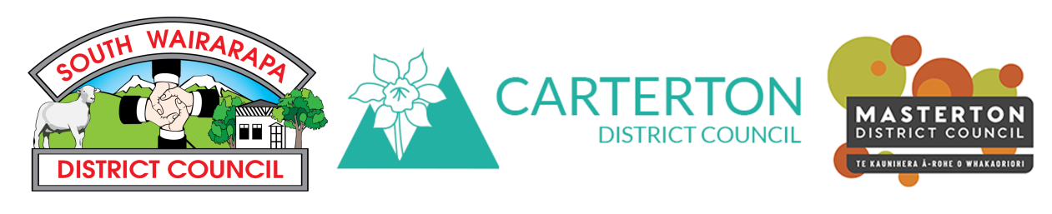Wairarapa Positive Ageing Strategy update #2

Date: October 2018
From: South Wairarapa Carterton District Council and Masterton District Councils
If you missed our Positive Ageing Strategy update #1, go to your local Council website and search Positive Ageing Strategy.

What we’ve been up to this month
We’ve had a busy month. We launched the Positive Ageing Strategy survey at the Age Concern Expo on 23rd September and haven’t looked back since with surveys, interviews, research and planning our community workshops.
Check out the survey at www.surveymonkey.com/r/PositiveAge and pass it on. For paper copies visit District Council libraries, information centres and offices. So far we have received over 200 responses from our surveys with lots of great information. Thanks to everyone who has contributed so far.

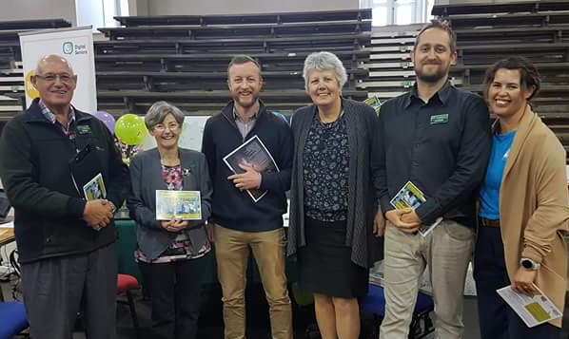
Age Concern Expo
At the very popular Age Concern Expo, we personally distributed 400 postcards to visitors and stall holders and conducted individual conversations with 150 expo visitors.

Community interviews
We have conducted interviews with over 40 leaders from over 30 community, health, housing, government and business sectors. They have shared their own plans, dreams and challenges with us. Many of the interviews are also older adults themselves and bring a dual perspective to the conversation.

What have we learnt so far?
A common theme is that residents love the lifestyle and friendliness of the Wairarapa.
Key issues for residents, business, government agencies and community organisations so far include:
- Transport
- Accessibility (footpaths, parking, building access etc)
- Accessible services
- Community connection
- Lack of cohesive planning for older adults

What’s next?
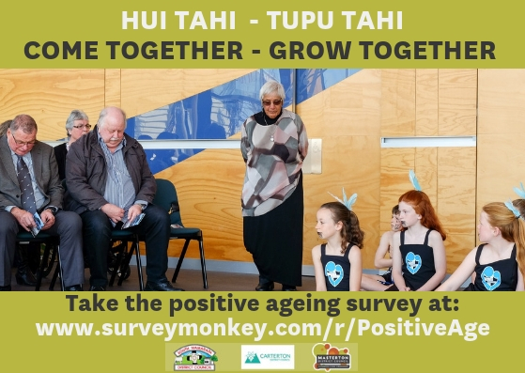
Our work in November will include:
- Focused consultation with Iwi and Māori
- Face-to-face and community conversations with groups of residents

- A community workshop to share findings and identify opportunities moving forward

Positive Ageing Community workshop
We are planning a community workshop to:
- Share the findings of our research and community consultation so far
- Workshop key themes
- Identify possible strategies and actions
- Next steps
When: 28th November, 9.30-12noon
Where: Carterton Events Centre, 50 Holloway Rd, Carterton
With whom: We will be inviting leaders from business, community and government to participate. If you have not yet received an invitation and would like to come, please get in touch with us (see contact details below).
Morning Tea provided

How can I support the Positive Ageing Strategy?
You can participate in a number of ways:
- Take the online survey at https://www.surveymonkey.com/r/PositiveAge
- Distribute the survey link to your family, members, clients, customers. This will also be available in paper copy from District Council websites, libraries, information centres.
- Display the Positive Ageing Strategy postcard and flyer
- Attend our resident and agency workshops – find out where they’re being held by contacting us at the details below

If you have any questions, or would like to be kept updated, please go to your local District Council website or contact:
- South Wairarapa District Council: enquiries@swdc.govt.nz
- Carterton District Council: gerry@cdc.govt.nz
- Masterton District Council: aaronb@mdc.govt.nz; hoanip@mdc.govt.nz
If you’d like to find out more about Positive Ageing Strategies in New Zealand and internationally, go to http://www.superseniors.msd.govt.nz/age-friendly-communities/index.html

All work on this project is:
- Aligned with Office for Seniors best practice
- Based on the World Health Organisation Age-Friendly cities guidelines
- Designed for cross-Council involvement and participation

