IN THE MATTER of the Sale and Supply of Alcohol Act 2012
AND

IN THE MATTER of an application by Bhune Trading Ltd for a Temporary Authority for an on-licence pursuant to s.99 and s136 of the Act in respect of premises situated at 2 Broadway, Carterton known as The Bottle ‘O’

BEFORE THE CARTERTON DISTRICT LICENSING COMMITTEE

Deputy Chairperson: Jill Greathead
Secretary: Colin Wright

DECISION

This is an application by Bhune Trading Ltd for a Temporary Authority for an off-licence in respect of premises situated at 2 Broadway Carterton , known as The Bottle ‘O”.
The application is in respect of premises in which the principal business is the manufacture and sale of alcohol.
We are satisfied as to the matters to which we must have regard as set out in s.105 of the Act and we grant the applicant a Temporary Authority for an OFF-Licence authorising the sale of liquor.
The applicant's attention is drawn to ss.55, 56, 57 and 214 (3) of the Act obliging the holder of an OFF-Licence to display:-
1. A sign attached to the exterior of the premises, so as to be readily read by persons outside each principal entrance, stating the ordinary hours of business during which the premises will be open for the sale of liquor; AND
2. A copy of the licence, and of the conditions of the licence, attached to the interior of the premises so as to be easily read by persons entering through each principal entrance; AND
3. A sign prominently displayed inside the premises, which identifies by name the manager for the time being on duty.

This Temporary Authority is for a period not exceeding three months

DATED at Carterton this 24th day of December 2014

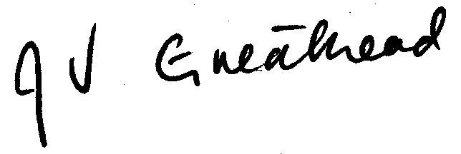
_____________________

Jill Greathead
Deputy Chairperson

Carterton District Licensing Committee

