IN THE MATTER of the Sale and Supply of Alcohol Act 2012

AND

IN THE MATTER of an application by Nation Events Limited for a Special Licence pursuant to s.22 of the Act in respect of premises situated at 141B Dakins Road and known as Borthwick Vineyard

BEFORE THE CARTERTON DISTRICT LICENSING COMMITTEE

Chairperson: Jill Greathead
Secretary: Jane Davis

DECISION

This is an application for a Special Licence under section 22 of the Sale and Supply of Alcohol Act 2012. The application is for a Mothers Day Lunch event to be held at 141B Dakins Road and known as Borthwick Vineyard, where alcohol will be consumed on the premises.

The application was sent to the Police, Inspector and Medical Officer of Health under s. 141 and no reports of opposition were received. The application was not required to be publically notified.

We are satisfied as to the matters to which we must have regard as set out in s.3, s.4 and s.142 of the Act. We grant the applicant a special licence in terms of s.22 subject to the restrictions imposed by s.147.

Accordingly, we set the following conditions under s147 on the licence:

- alcohol may be sold under the licence only on the following days and during the following hours: Sunday 8th May 2016 11.30 am to 6.30pm
- alcohol may be sold or supplied to the following types of people: event for members of the public
- the licensee must take the following steps to ensure that the provisions of this Act relating to the sale or supply of alcohol to prohibited persons are observed: display appropriate signs adjacent to every point of sale detailing the statutory restrictions on the supply of liquor to minors and the complete prohibition on sales to intoxicated persons
- the licensee must take the following steps to ensure that the provisions of this Act relating to the management of premises are observed: A certified manager will be on duty at all times
- drinking water must be freely available at the following places while the premises are open for business: The applicant has advised that water will be freely available to the patrons
- food must be available for consumption on the premises as follows: Food will be provided at the venue throughout the event by the SALT STREETFOOD FOOD TRUCK.
- non-alcohol beverages must be available for sale and supply on the premises as follows: Non-alcoholic beverages will be available at the venue throughout the event.
- the licensee must take the following steps to provide assistance with or information about alternative forms of transport from the premises: The applicant has indicated that the information on alternative forms of transport will be available.
- the licence is also subject to the following conditions, which in the committee's opinion are not inconsistent with the Act: a copy of this licence must be displayed at each point of sale so as to be easily read by persons present on the premises.

Dated at Carterton this 29th April 2016

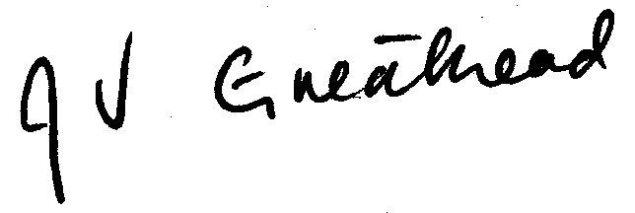

__________________
Jill Greathead
Deputy Chairperson
Carterton District Licensing Committee

