IN THE MATTER of the Sale and Supply of Alcohol Act 2012

AND

IN THE MATTER of an application by Elizabeth Ann Pollock for Wairarapa Wines Inc. for a Special Licence pursuant to s.22 of the Act in respect of premises situated at Dakins Road, Gladstone, Carterton and known as The Cliffs.

BEFORE THE CARTERTON DISTRICT LICENSING COMMITTEE

Chairperson: Elaine Brazendale
Secretary: Colin Wright

DECISION

This is an application for a Special Licence under section 22 of the Sale and Supply of Alcohol Act 2012. The application is for a Regional Wine Promotion at the Wairarapa Wines Harvest Festival event to be held at Dakins Road, Gladstone, Carterton and known as The Cliffs, where alcohol will be consumed on site.
The application was sent to the Police, Inspector and Medical Officer of Health under s. 141 and no reports of opposition were received. The application was not required to be publically notified.

We are satisfied as to the matters to which we must have regard as set out in s.3, s.4 and s.142 of the Act. We grant the applicant a special licence in terms of s.22 subject to the restrictions imposed by s.147.

Accordingly, we set the following conditions under s147 on the licence:

- alcohol may be sold under the licence only on the following days and during the following hours: Saturday March 7th, 2015 11am-5.30pm
- alcohol may be sold or supplied to the following types of people: ticket holders
- the licensee must take the following steps to ensure that the provisions of this Act relating to the sale or supply of alcohol to prohibited persons are observed: alcohol will not be sold to those under 18years of age or to intoxicated persons
- the licensee must take the following steps to ensure that the provisions of this Act relating to the management of premises are observed: a duty manager will supervise at all times
- drinking water must be freely available at the following places while the premises are open for business: as per application
- food must be available for consumption on the premises as follows: as per application
- non-alcohol beverages must be available for sale and supply on the premises as follows: as per application
- the licensee must take the following steps to provide assistance with or information about alternative forms of transport from the premises: access to mobile phones, taxi numbers and Regional Bus transfer available
- alcohol may be sold in the following types of container only: glass

Dated at Carterton this 2nd day of March, 2015

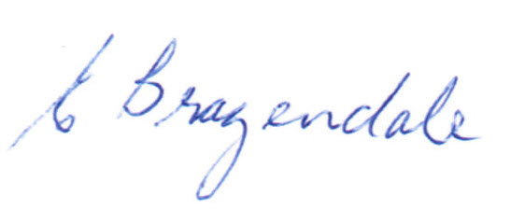

__________________
Elaine Brazendale
Chairperson
Carterton District Licensing Committee

