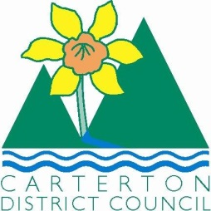

IN THE MATTER of the Sale and Supply of Alcohol Act 2012

AND

IN THE MATTER of an application by Vaughan Stewart Paul for a Special Licence pursuant to s.22 of the Act in respect of premises situated at the Showgrounds, Chester Road, Carterton and known as the Carterton A&P society.

BEFORE THE CARTERTON DISTRICT LICENSING COMMITTEE

Chairperson: Elaine Brazendale
Secretary: Colin Wright

DECISION

This is an application for a Special Licence under section 22 of the Sale and Supply of Alcohol Act 2012. The application is for a Wairarapa A&P Society “Made in Wairarapa Expo event to be held at the Showgrounds, Chester Road Carterton and known as the Wairarapa A&P Society pavilion where alcohol will be consumed on the premises.

The application was sent to the Police, Inspector and Medical Officer of Health under s. 141 and no reports of opposition were received. The application was not required to be publically notified.

We are satisfied as to the matters to which we must have regard as set out in s.3, s.4 and s.142 of the Act. We grant the applicant a special licence in terms of s.22 subject to the restrictions imposed by s.147.

Accordingly, we set the following conditions under s147 on the licence:

- alcohol may be sold under the licence only on the following days and during the following hours: August 30th and 31st, 2014 10am-4.30pm each day
- alcohol may be sold or supplied to the following types of people: attendees
- the licensee must take the following steps to ensure that the provisions of this Act relating to the sale or supply of alcohol to prohibited persons are observed Duty manager will be monitoring sales and alcohol will not be sold to those under 18years or intoxicated persons
- the licensee must take the following steps to ensure that the provisions of this Act relating to the management of premises are observed: the area of sales will be supervised
- drinking water must be freely available at the following places while the premises are open for business: available at the site
- wine samples will be available for consumption on the premises as follows: in 40ml quantities only
- non-alcohol beverages must be available for sale and supply on the premises as follows: NA
- the licensee must take the following steps to provide assistance with or information about alternative forms of transport from the premises: Taxi phones numbers and phone will be available
- alcohol may be sold in the following types of container only: bottles

Dated at Carterton this 14th day of August 2014

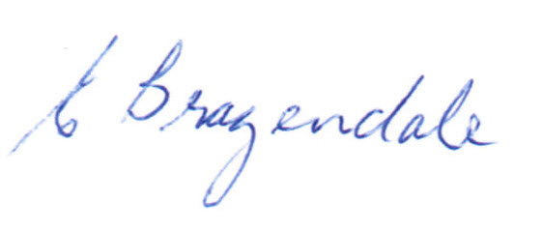

__________________
Elaine Brazendale
Chairperson
Carterton District Licensing Committee

