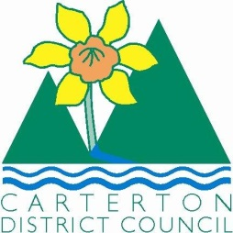

IN THE MATTER of the Sale and Supply of Alcohol Act 2012

AND

IN THE MATTER of an application by Robyn Campbell of The Oversew Fashion Award Ltd for a Special Licence pursuant to s.22 of the Act in respect of premises situated at Holloway Street, Carterton and known as the Events Centre

BEFORE THE CARTERTON DISTRICT LICENSING COMMITTEE

Chairperson: Elaine Brazendale
Secretary: Jane Davis

DECISION

This is an application for a Special Licence under section 22 of the Sale and Supply of Alcohol Act 2012. The application is for an Annual Oversew Fashion Awards function to be held at the Events Centre, Holloway Street, Carterton, where alcohol will be consumed on the premises.

The application was sent to the Police, Inspector and Medical Officer of Health under s. 141 and no reports of opposition were received. The application was not required to be publically notified.

We are satisfied as to the matters to which we must have regard as set out in s.3, s.4 and s.142 of the Act. We grant the applicant a special licence in terms of s.22 subject to the restrictions imposed by s.147.

Accordingly, we set the following conditions under s147 on the licence:

- alcohol may be sold under the licence only on the following days and during the following hours: Saturday 28th May 2016, 6.30pm-12.00 midnight
Sunday 29th May 2015, 12pm noon- 4.00pm
- alcohol may be sold or supplied to the following types of people: ticket holders
- the licensee must take the following steps to ensure that the provisions of this Act relating to the sale or supply of alcohol to prohibited persons are observed: alcohol will not be served to persons who are under 18 years of age or to those who are intoxicated
- the licensee must take the following steps to ensure that the provisions of this Act relating to the management of premises are observed: all areas supervised
- drinking water must be freely available at the following places while the premises are open for business: at the bar and on tables
- food must be available for consumption on the premises as follows: as per the application
- non-alcohol beverages must be available for sale and supply on the premises as follows: as per the application
- the licensee must take the following steps to provide assistance with or information about alternative forms of transport from the premises: taxi numbers and phone will be available
- alcohol may be sold in the following types of container only: as per the application

Dated at Carterton this 9th day of May 2016

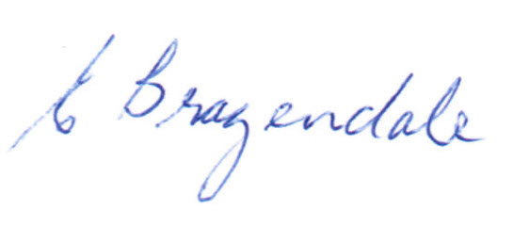

__________________
Elaine Brazendale
Chairperson
Carterton District Licensing Committee

