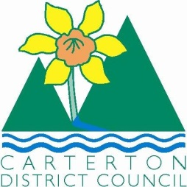

IN THE MATTER of the Sale and Supply of Alcohol Act 2012

AND

IN THE MATTER of an application by Vaughan Paul of Paulownia Estate for a Special Licence pursuant to s.22 of the Act in respect of premises situated at High Street North, Carterton and known as Memorial Square

BEFORE THE CARTERTON DISTRICT LICENSING COMMITTEE

Chairperson: Elaine Brazendale
Secretary: Colin Wright

DECISION

This is an application for a Special Licence under section 22 of the Sale and Supply of Alcohol Act 2012. The application is for the Carterton Farmers Market event to be held weekly at the Memorial Square, Carterton where alcohol will be consumed and sold on site.
The application was sent to the Police, Inspector and Medical Officer of Health under s. 141 and no reports of opposition were received. The application was not required to be publically notified.

We are satisfied as to the matters to which we must have regard as set out in s.3, s.4 and s.142 of the Act. We grant the applicant a special licence in terms of s.22 subject to the restrictions imposed by s.147.

Accordingly, we set the following conditions under s147 on the licence:

- alcohol may be sold under the licence only on the following days and during the following hours: weekly on Sundays, for 52 weeks, from February 22nd 2015, between the hours of 9am and 1pm
- alcohol may be sold or supplied to the following types of people: market attendees
- the licensee must take the following steps to ensure that the provisions of this Act relating to the sale or supply of alcohol to prohibited persons are observed: alcohol will not be sold to those under 18years of age or to intoxicated persons
- the licensee must take the following steps to ensure that the provisions of this Act relating to the management of premises are observed: a certified manager will be on site monitoring sales
- drinking water must be freely available at the following places while the premises are open for business: as per application, will be freely available for sale
- the licensee must take the following steps to provide assistance with or information about alternative forms of transport from the premises: Taxi details will be available
- alcohol may be sold in the following types of container only: glass/bottle purchases
- Sample provided will be 40ml or less.
- Taxi details will be available as needed
- Individual serves will be no more than four per person

Dated at Carterton this 2nd day of February 2015

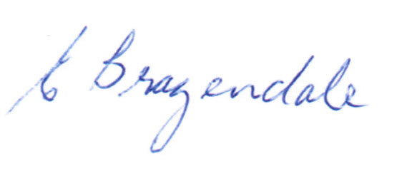

__________________
Elaine Brazendale
Chairperson
Carterton District Licensing Committee

