IN THE MATTER of the Sale and Supply of Alcohol Act 2012

AND

IN THE MATTER of an application by Donald Brent Goble for a Special Licence pursuant to s.22 of the Act in respect of premises situated at Carterton and known as Regent 58

BEFORE THE CARTERTON DISTRICT LICENSING COMMITTEE

Chairperson: Elaine Brazendale
Secretary: Colin Wright

DECISION

This is an application for a Special Licence under section 22 of the Sale and Supply of Alcohol Act 2012. The application is for a Christmas Party, Birthday Celebration and Summer Sunday Openings .to be held at Regent 58, Carterton, where alcohol will be consumed on site.
The application was sent to the Police, Inspector and Medical Officer of Health under
s. 141 and no reports of opposition were received. The application was not required to be publically notified.

We are satisfied as to the matters to which we must have regard as set out in s.3, s.4 and s.142 of the Act. We grant the applicant a special licence in terms of s.22 subject to the restrictions imposed by s.147.

Accordingly, we set the following conditions under s147 on the licence:

- alcohol may be sold under the licence only on the following days and during the following hours: Tuesday 23rd December 2014 between 2.00pm and 10.30pm
- Sunday 18th January 2015 between 11.00am and 12.00pm
- All other Sundays 25th January 2015 – 23rd March 2015 between 11am and 6pm
- Sunday 26th April between 11am and 9pm
- alcohol may be sold or supplied to the following types of people: attendees/patrons
- the licensee must take the following steps to ensure that the provisions of this Act relating to the sale or supply of alcohol to prohibited persons are observed the duty managers present will be monitoring sales, alcohol will not be sold to those under 18yrs of age or intoxicated persons
- the licensee must take the following steps to ensure that the provisions of this Act relating to the management of the site are observed: designated areas supervised
- drinking water must be freely available while the site is open for business: available at the bar and where food is provided
- food must be available for consumption on the site as follows: as per the application
- low and non-alcohol beverages must be available for sale and supply on site as follows: as per the application
- the licensee must take the following steps to provide assistance with or information about alternative forms of transport from the premises: taxi numbers and telephone available
- alcohol may be sold in the following types of container only: glass
- Any samples provided will not exceed: 40mls

Dated at Carterton this 8th day of December 2014

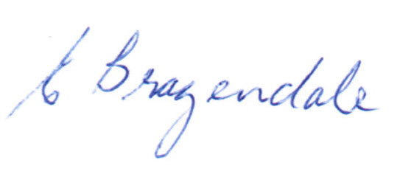
__________________
Elaine Brazendale
Chairperson
Carterton District Licensing Committee

