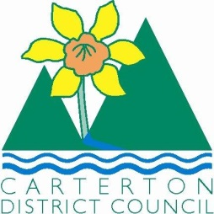

IN THE MATTER of the Sale and Supply of Alcohol Act 2012

AND

IN THE MATTER of an application by Rhys Morgan on behalf of the Wairarapa A & P Society for a Special Licence pursuant to s.22 of the Act in respect of premises situated at Chester Road, Carterton and known as The Clareville Show grounds

BEFORE THE CARTERTON DISTRICT LICENSING COMMITTEE

Chairperson: Elaine Brazendale
Secretary: Colin Wright

DECISION

This is an application for a Special Licence under section 22 of the Sale and Supply of Alcohol Act 2012. The application is for a Country and Western Music Festival event to be held at the Clareville show grounds, Chester Road, Carterton where alcohol will be consumed on the premises.

The application was sent to the Police, Inspector and Medical Officer of Health under s. 141 and no reports of opposition were received. The application was not required to be publically notified.

We are satisfied as to the matters to which we must have regard as set out in s.3, s.4 and s.142 of the Act. We grant the applicant a special licence in terms of s.22 subject to the restrictions imposed by s.147.

Accordingly, we set the following conditions under s147 on the licence:

- alcohol may be sold under the licence only on the following days and during the following hours:
- Friday 9th January, 2015 2pm-11pm,
- Saturday 10th January, 2015 10.00am-11pm
- Sunday 11th January, 2015 10.00am-6pm
- alcohol may be sold or supplied to the following types of people: ticket holders
- the licensee must take the following steps to ensure that the provisions of this Act relating to the sale or supply of alcohol to prohibited persons are observed: the duty manager will monitor sales and alcohol will not be sold to persons under the age of 18yrs or to those who are intoxicated
- the licensee must take the following steps to ensure that the provisions of this Act relating to the management of premises are observed: the bar and drinking area will be supervised

- drinking water must be freely available at the following places while the premises are open for business: at the bar
- food must be available for consumption on the premises as follows: as per the application
- non-alcohol beverages must be available for sale and supply on the premises as follows: as per the application
- the licensee must take the following steps to provide assistance with or information about alternative forms of transport from the premises: display signage providing taxi numbers, phone available and noting that the bus service stops at the show grounds
- alcohol may be sold in the following types of container only: glass & plastic
- the licence is also subject to the following conditions, which in the committee's opinion are not inconsistent with the Act: a maximum of four drinks per serve
Note: It is recommended that a debrief be held between agencies/organisers to work through what has worked well and what could be improved on at a future event in relation to the Alcohol management plan.

Dated at Carterton this 22nd day of December 2014
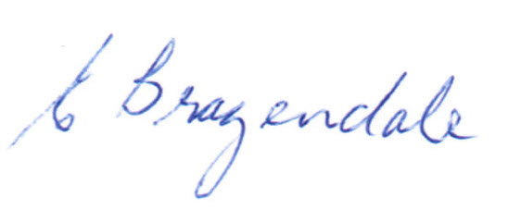

__________________
Elaine Brazendale
Chairperson
Carterton District Licensing Committee

