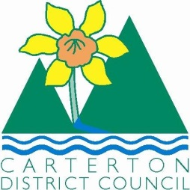

IN THE MATTER of the Sale and Supply of Alcohol Act 2012

AND

IN THE MATTER of an application by Vaughan Stewart Paul for a Special Licence pursuant to s.22 of the Act in respect of premises situated at Holloway Street and known as Carterton Events Centre.

BEFORE THE CARTERTON DISTRICT LICENSING COMMITTEE

Chairperson: Jill Greathead
Secretary: Colin Wright

DECISION

This is an application for a Special Licence under section 22 of the Sale and Supply of Alcohol Act 2012. The application is for a Rotary Dinner and the stage show Oaklahoma to be held at Holloway Street and known as Carterton Events Centre, where alcohol will be consumed on the premises.

The application was sent to the Police, Inspector and Medical Officer of Health under s. 141 and no reports of opposition were received. The application was not required to be publically notified.

We are satisfied as to the matters to which we must have regard as set out in s.3, s.4 and s.142 of the Act. We grant the applicant a special licence in terms of s.22 subject to the restrictions imposed by s.147.

Accordingly, we set the following conditions under s147 on the licence:

- alcohol may be sold under the licence only on the following days and during the following hours:
- Carterton Rotary Club Dinner on Monday the 30th June 2014 from 6.00pm till 10.30pm.
- Oklahoma Stage Show on Friday the 29th August 2014 from 7.00pm till 9.30pm.
- alcohol may be sold or supplied to the following types of people: Members for the Rotary Dinner and Ticket Holders for Oaklahoma over the age of 18.
- the licensee must take the following steps to ensure that the provisions of this Act relating to the sale or supply of alcohol to prohibited persons are observed: a certified manager will be on duty during the event.
- the licensee must take the following steps to ensure that the provisions of this Act relating to the management of premises are observed: a certified manager will be on duty during the event.
- drinking water must be freely available at the following places while the premises are open for business: Water provided at each table at the Rotary dinner and water at the bar at the Oaklahoma stage show.
- food must be available for consumption on the premises as follows: Dinner served at the Rotary dinner and sandwiches, savouries, muffins and slices served at the Oaklahoma stages how.
- non-alcohol beverages must be available for sale and supply on the premises as follows: Orange juice and soft drinks.
- the licensee must take the following steps to provide assistance with or information about alternative forms of transport from the premises: Taxi information and a free telephone is provided and signposted at the bar.
- alcohol may be sold in the following types of container only: Glass at the Rotary dinner and plastic at the Oaklahoma stage show.
- the licence is also subject to the following conditions, which in the committee's opinion are not inconsistent with the Act: a copy of this licence will be displayed so as to be easily read by people present.

Dated at Carterton this 16th day of June 2014

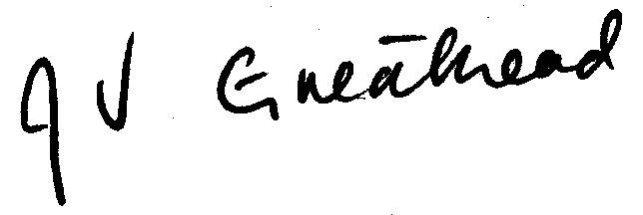

__________________
Jill Greathead
Deputy Chairperson
Carterton District Licensing Committee

