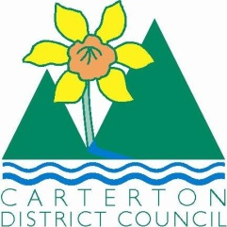

IN THE MATTER of the Sale and Supply of Alcohol Act 2012
AND

IN THE MATTER of an application by Ramesh Dayal for a renewal on-licence pursuant to s.127 of the Act in respect of premises situated at 63 High Street North, Carterton known as the Marquis of Normanby

BEFORE THE CARTERTON DISTRICT LICENSING COMMITTEE

Chairperson: Elaine Brazendale
Secretary: Colin Wright

DECISION

This is an application by Ramesh Dayal for a renewal on-licence in respect of premises situated at 63 High Street North, Carterton and, known as the Marquis of Normanby..

The application was duly advertised and no objection or notice of desire to be heard has been received. Accordingly we deal with the matter on the papers.

We are satisfied as to the matters to which we must have regard as set out in s.131 of the Act and we grant the applicant a renewal on-licence authorising the sale and supply of liquor for consumption on the premises, to any person who is present on the premises.
The licence is subject to the following conditions:
- No alcohol is to be sold on the premises on Good Friday, Easter Sunday, Christmas Day or before 1pm on Anzac day to any person who is not present on the premises to dine
- Alcohol may be sold only on the following days and during the following hours: Monday-Sunday- 8.00am-2am the following day
- The whole of the premises is a supervised area except the gaming area which is restricted
- Drinking water is to be freely available from the servicer counter to customers at all times when alcohol is available
- Food must be available for consumption on the premises at all times when the premises are authorised to be open for the sale of alcohol, a range of choices must be readily available. Meals must be served within a reasonable period of time from being ordered(20 minutes). Menus must be visible and food should be actively promoted.
- The following steps must be taken to promote the responsible consumption of alcohol: the licensee must have available for consumption on the premises, at all times when the premises are open for the sale of alcohol, a reasonable range of non-alcoholic refreshments and low alcohol beverages.
- The following steps must be taken to ensure that the provisions of the Act relating to the sale of alcohol to prohibited persons are observed: display appropriate signs adjacent to every point of sale detailing the statutory restrictions on the supply of alcohol to minors and the complete prohibition on sales to intoxicated persons.
- The following steps must be taken by the licensee to ensure the provisions of the Act relating to the management of the premises concerned are observed:
1/ the Host Responsibility Policy must be displayed in view of the public
2/ Signs must be prominently displayed detailing information regarding alternative forms of transport.

DATED at Carterton this 21st day of August, 2014

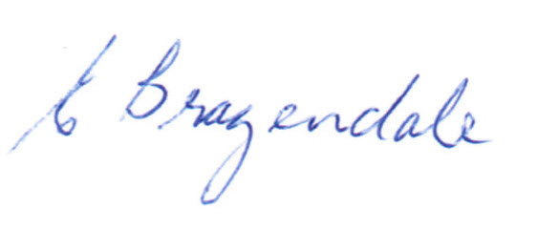
___________________
Elaine Brazendale
Chairperson
Carterton District Licensing Committee

