IN THE MATTER of the Sale and Supply of Alcohol Act 2012
AND

IN THE MATTER of an application by Richard Claude Skelley for a renewal on-licence pursuant to s.127 of the Act in respect of premises situated at 3258 SH2, Carterton and known as Taratahi Hotel

BEFORE THE CARTERTON DISTRICT LICENSING COMMITTEE

Chairperson: Elaine Brazendale
Secretary: Jane Davis

DECISION

This is an application by Richard Claude Skelley for a renewal on-licence in respect of premises situated at 3258 SH2, Carterton and known as Taratahi Hotel.
The application was duly advertised and no objection or notice of desire to be heard has been received. Accordingly we deal with the matter on the papers.

We are satisfied as to the matters to which we must have regard as set out in s.131 of the Act and we grant the applicant a renewal on-licence authorising the sale and supply of liquor for consumption on the premises, to any person who is present on the premises.

This licence is subject to the following conditions:

- No alcohol is to be sold on the premises on Good Friday, Easter Sunday, Christmas Day, or before 1 pm on Anzac Day to any person.
- 47 Sale and supply on Anzac Day morning, Good Friday, Easter Sunday, and Christmas Day restricted: on-licences
(1)The holder of an on-licence must ensure that no alcohol is sold or supplied on the premises on Good Friday, Easter Sunday, or Christmas Day, or before 1 pm on Anzac Day, unless—
  - (a)it is sold or supplied while the holder also holds a special licence for the premises; or
  - (b) The buyer is a person of a kind described in subsection (2).
(2)The kinds of person referred to in subsection (1) are—
  - (a)people residing or lodging on the premises:
  - (b) People who are present on the premises to dine.
(3)For the purposes of subsection (2),—
  - (a)a person resides or lodges on licensed premises if he or she resides or lodges in the building in which the premises are situated as the guest, lodger, tenant, or employee of the licensee:
  - (b)a person is not present on licensed premises to dine if he or she is there at a time—
    - (i) more than an hour before he or she starts (or is due to start) eating a meal; or
    - (ii) More than an hour after he or she finishes eating a meal.
(4)Subsection (1) is subject to section 173 of the Gambling Act 2003.

- alcohol may be sold only on the following days and during the following hours: Monday to Sunday - 10.00am to 1.00am
- The premise is designated as follows : Supervised
- Drinking water is to be freely available: from the service counter and water dispenser to customers at all times when alcohol is available.
- Food must be available (as outlined in the application) for consumption on the premises at all times when the premises are authorised to be open for the sale of alcohol, a range of choices must be readily available. Menus must be visible and food should be actively promoted.
- The following steps must be taken to promote the responsible consumption of alcohol: The licensee must have available for consumption on the premises, at all times when the premises are open for the sale of alcohol, a reasonable range of non-alcoholic refreshments and low-alcohol beverages
- The following steps must be taken to ensure that the provisions of the Act relating to the sale of alcohol to prohibited persons are observed: display appropriate signs adjacent to every point of sale detailing the statutory restrictions on the supply of alcohol to minors and the complete prohibition on sales to intoxicated persons
- Conditions prescribing steps to be taken by the licensee to ensure that the provisions of this Act relating to the management of the premises concerned are observed:
  - The Host Responsibility Policy must be displayed in view of the public.
  - Signs must be prominently displayed detailing information regarding alternative forms of transport.

DATED at Carterton this 8th day of March, 2016
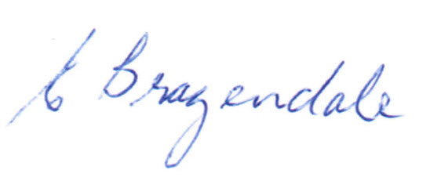
____________________
Elaine Brazendale
Chairperson
Carterton District Licensing Committee

