IN THE MATTER of the Sale and Supply of Alcohol Act 2012

AND

IN THE MATTER of an application by Dashmesh International (NZ) Ltd for a BYO ON-licence pursuant to s.99 and s.37 of the Act in respect of premises situated at 77 High Street North, Carterton known as Tandoori Dhaba.

BEFORE THE CARTERTON DISTRICT LICENSING COMMITTEE

- Chairperson: Elaine Brazendale
- Secretary: Colin Wright

DECISION

This is an application by Dashmesh International (NZ) Ltd for a BYO ON-licence in respect of premises situated at 77 High Street North, Carterton, known as Tandoori Dhaba
The general nature of the business to be undertaken is that of an Indian Restaurant.
The application was duly advertised and no objection or notice of desire to be heard has been received. Accordingly we deal with the matter on the papers.
We are satisfied as to the matters to which we must have regard as set out in s.105 of the Act and we grant the applicant an on-licence authorising the sale and supply of liquor for consumption on the premises, to any person who is present on the premises.
The applicant's attention is drawn to ss.56, 57 and 214 (3) of the Act obliging the holder of an on-licence to display:-
1. At each principal entrance to the premises a sign attached to the inside or outside of the premises, so as to be easily read by people immediately outside the entrance, stating the ordinary hours of business during which the premises will be open for the sale of alcohol; AND
- A copy of the licence, and of the conditions of the licence, attached to the interior of the premises so as to be easily read by persons entering through each principal entrance; AND
- A sign prominently displayed inside the premises, which identifies by name the manager for the time being on duty.
The following conditions will apply for an ON Licence BYO only:-
- Operating/opening hours on the following days and during the following hours: Monday to Sunday - 11.00am to 11.00pm
- the whole premise is designated as follows :
Undesignated
- Drinking water is to be freely available from the service counter to customers at all times when alcohol is being consumed.
- Food must be available for consumption on the premises at all times when the premises are authorised to be open, a range of choices must be readily available. Menus must be visible and food should be actively promoted.
- The licensee must have available for consumption on the premises, at all times when the premises are open, a reasonable range of non-alcoholic refreshments and beverages.
- conditions prescribing steps to be taken by the licensee to ensure that the provisions of this Act relating to the management of the premises concerned are observed:
  - The Host Responsibility Policy must be displayed in view of the public.
  - Signs must be prominently displayed detailing information regarding alternative forms of transport.

DATED at Carterton this 19th day of November 2015
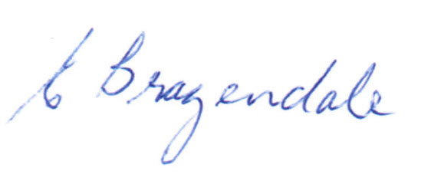
_____________________
Elaine Brazendale
Chairperson
Carterton District Licensing Committee

