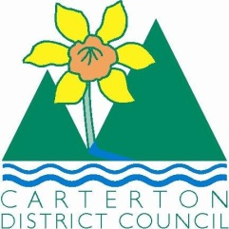

IN THE MATTER of the Sale and Supply of Alcohol Act 2012
AND

IN THE MATTER of an application by Shoaib & Anisha Investments Ltd for a renewal on-licence pursuant to s.127 of the Act in respect of premises situated at 109 High Street North, Carterton and known as Indian Taj Restaurant

BEFORE THE CARTERTON DISTRICT LICENSING COMMITTEE

Chairperson: Elaine Brazendale
Secretary: Milan Hautler

DECISION

This is an application by Shoaib & Anisha Investments Ltd for a renewal on-licence in respect of premises situated at 109 High Street North, Carterton and known as Indian Taj Restaurant.
The application was duly advertised and no objection or notice of desire to be heard has been received. Accordingly we deal with the matter on the papers.

We are satisfied as to the matters to which we must have regard as set out in s.131 of the Act and we grant the applicant a renewal on-licence authorising the sale and supply of liquor for consumption on the premises, to any person who is present on the premises.

This licence is for BYO only and subject to the following conditions:
a. Operating/opening hours will be on the following days and during the following hours
Monday - Sunday 11am-10pm

b. the whole premise is designated as follows:
undesignated

c. Drinking water is to be freely available to customers at all times when alcohol is being consumed

d. Food must be available for consumption on the premises at all times when the premises are authorised to be open, a range of choices must be readily available. Menus must be visible and food should be actively promoted.
e. The licensee must have available for consumption on the premises, at all times when the premises are open, a reasonable range of non-alcoholic refreshments and beverages.

f. The host responsibility Policy must be displayed in view of the Public.

g. Signs must be prominently displayed detailing information regarding alternative forms of transport

DATED at Carterton this 6th day of January 2016

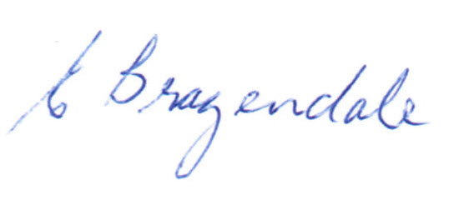

_____________________
Elaine Brazendale
Chairperson
Carterton District Licensing Committee

