IN THE MATTER of the Sale and Supply of Alcohol Act 2012
AND

IN THE MATTER of an application Mohammed Daud Khan for an on-licence pursuant to s.99 of the Act in respect of premises situated at 109 High Street North Carterton known as Indian Taj Restaurant

BEFORE THE CARTERTON DISTRICT LICENSING COMMITTEE
Deputy Chairperson: Jill Greathead
Secretary: Colin Wright
DECISION
This is an application by Mohammed Daud Khan for an on-licence in respect of premises situated at 109 High Street North Carterton, known as Indian Taj Restaurant.
The general nature of the business to be undertaken is that of a BYO Indian Restaurant.
The application was duly advertised and no objection or notice of desire to be heard has been received. Accordingly we deal with the matter on the papers.
We are satisfied as to the matters to which we must have regard as set out in s.105 of the Act and we grant the applicant an on-licence authorising the consumption on the premises, to any person who is present on the premises.
The applicant's attention is drawn to ss.56, 57 and 214 (3) of the Act obliging the holder of an on-licence to display:-
1. At each principal entrance to the premises a sign attached to the inside or outside of the premises, so as to be easily read by people immediately outside the entrance, stating the ordinary hours of business during which the premises will be open for the consumption of alcohol; AND
- A copy of the licence, and of the conditions of the licence, attached to the interior of the premises so as to be easily read by persons entering through each principal entrance; AND
- A sign prominently displayed inside the premises, which identifies by name the manager for the time being on duty.
THE LICENSED PREMISES
The premises, situated at 109 High Street North Carterton are more precisely identified in a plain date stamped as received by the Carterton District Licensing Committee.

DATED at Carterton this 5th day of December 2014
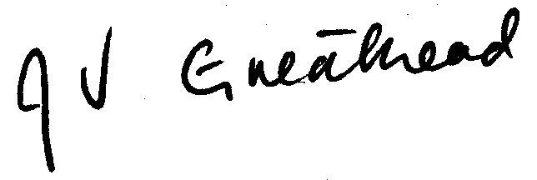

_____________________
Jill Greathead
Deputy Chairperson
Carterton District Licensing Committee

