IN THE MATTER of the Sale and Supply of Alcohol Act 2012
AND

IN THE MATTER of an application by Rhys Morgan for an off-licence pursuant to s.99 of the Act in respect of premises situated at 160 East Taratahi Road RD7, Masterton known as Peak Brewery Ltd.

BEFORE THE CARTERTON DISTRICT LICENSING COMMITTEE

Chairperson: Elaine Brazendale
Secretary: Jane Davis

DECISION

This is an application by Rhys Morgan for an off-licence in respect of premises situated at 160 East Taratahi Road RD7, Masterton, known as Peak Brewery Ltd.

The application is in respect of premises in which the principal business is the manufacture and sale of alcohol.

The application was duly advertised and no objection or notice of desire to be heard has been received. Accordingly, we deal with the matter on the papers.

We are satisfied as to the matters to which we must have regard as set out in s.105 of the Act and we grant the applicant an off-licence.

This licence is subject to the following conditions:
- no alcohol is to be sold or delivered on Good Friday, Easter Sunday, Christmas Day, or before 1 pm on Anzac Day
- alcohol may be sold only on the following days and during the following hours:
Mondays to Sundays 9.00am to 8.00pm.
- no alcohol may be sold other than—
Grape wine that complies with the appropriate New Zealand food standard for grape wine
The following steps must be taken to ensure that the provisions of the Act relating to the sale of alcohol to prohibited persons are observed: display appropriate signs adjacent to every point of sale detailing the statutory restrictions on the supply of alcohol to minors and the complete prohibition on sales to intoxicated persons
- conditions prescribing steps to be taken by the licensee to ensure that the provisions of this Act relating to the management of the premises concerned are observed: the Host Responsibility Policy must be displayed in view of the public
- Drinking water is to be freely available to customers, while alcohol is being supplied free as a sample.

The licence may issue immediately.

Dated at Carterton this 11th day of November 2016
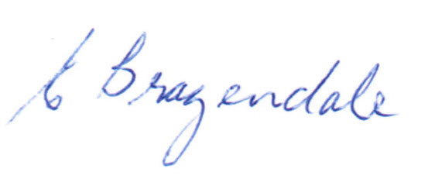
_____________________
Elaine Brazendale
Chairperson
Carterton District Licensing Committee

