IN THE MATTER of the Sale and Supply of Alcohol Act 2012
AND

IN THE MATTER of an application by Patrick A Borthwick for an off-licence pursuant to s.99 of the Act in respect of premises situated at 141 B Dakins Road, RD7, Masterton known as "Borthwick Vineyard"

BEFORE THE CARTERTON DISTRICT LICENSING COMMITTEE

Chairperson: Elaine Brazendale
Secretary: Jane Davis

DECISION

This is an application by Patrick A Borthwick for an off-licence in respect of premises situated at 141 B Dakins Road, RD7, Masterton, known as Borthwick Vineyard.

The application is in respect of premises in which the principal business is for the manufacture and sale of alcohol, Winery/ Cellar Door with On-Line/ Remote sales.

The application was duly advertised and no objection or notice of desire to be heard has been received. Accordingly, we deal with the matter on the papers.

We are satisfied as to the matters to which we must have regard as set out in s.105 of the Act and we grant the applicant an off-licence.

The licence may issue immediately.

This licence is subject to the following conditions:
- no alcohol is to be sold or delivered on Good Friday, Easter Sunday, Christmas Day, or before 1 pm on Anzac Day
- alcohol may be sold only on the following days and during the following hours:
Monday to Sunday 10.00am to 5.00pm
- no alcohol may be sold other than—
(iv) Grape wine that complies with the appropriate New Zealand food standard for grape wine;
The following steps must be taken to ensure that the provisions of the Act relating to the sale of alcohol to prohibited persons are observed: display appropriate signs adjacent to every point of sale detailing the statutory restrictions on the supply of alcohol to minors and the complete prohibition on sales to intoxicated persons
- conditions prescribing steps to be taken by the licensee to ensure that the provisions of this Act relating to the management of the premises concerned are observed: the Host Responsibility Policy must be displayed in view of the public
- Drinking water is to be freely available to customers, while alcohol is being supplied free as a sample.

The applicant's attention is drawn to ss.55, 56, 57 and 214 (3) of the Act obliging the holder of an off-licence to display:-

1. A sign attached to the exterior of the premises, so as to be readily read by persons outside each principal entrance, stating the ordinary hours of business during which the premises will be open for the sale of liquor; AND

2. A copy of the licence, and of the conditions of the licence, attached to the interior of the premises so as to be easily read by persons entering through each principal entrance; AND

3. A sign prominently displayed inside the premises, which identifies by name the manager for the time being on duty.

Dated at Carterton this 3rd day of February 2016
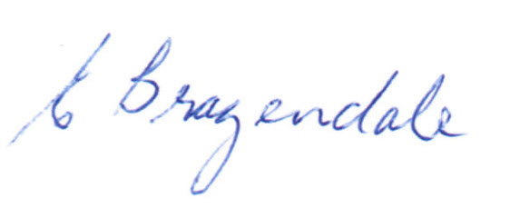
_____________________
Elaine Brazendale
Chairperson
Carterton District Licensing Committee

