IN THE MATTER of the Sale and Supply of
Alcohol Act 2012

AND

IN THE MATTER of an application by Jahlisa Eileen Namana for a Manager’s Certificate pursuant to s.217 of the Act.

BEFORE THE CARTERTON DISTRICT LICENSING COMMITTEE

DECISION

Reports from Police and an Inspector appointed under the Act do not oppose the issue of a certificate. Based on the information provided to us, and having regard to the matters set out in s.222 we grant the applicant a Manager’s Certificate.

A condition of this licence is that Jahlisa E Namana may only work under this licence at Wild Oats Bakery during the next twelve months.

A copy of the certificate is attached to this decision.

DATED at Carterton this 25th day of May 2016

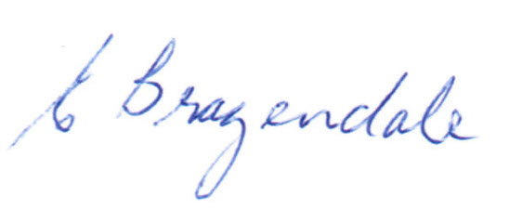

________________________________
Elaine Brazendale
Chairperson

Carterton District Licensing Committee

