IN THE MATTER of the Sale and Supply of
Alcohol Act 2012

AND

IN THE MATTER of an application by Matthew Bryan Kinder for a Manager’s Certificate pursuant to s.217 of the Act.

BEFORE THE CARTERTON DISTRICT LICENSING COMMITTEE

DECISION

Reports from Police and an Inspector appointed under the Act do not oppose the issue of a certificate. Based on the information provided to us, and having regard to the matters set out in s.222 we grant the applicant a Manager’s Certificate. A copy of the certificate is attached to this decision.

A condition of this licence is that Matthew Bryan Kinder may only work under this licence at Cafe Istanbul during the next twelve months

DATED at Carterton this 7th day of April 2016

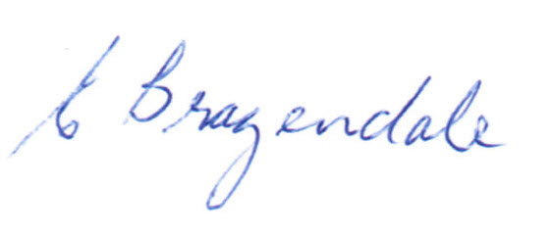

________________________________
Elaine Brazendale
Chairperson

Carterton District Licensing Committee

