IN THE MATTER of the Sale and Supply of
Alcohol Act 2012

AND

IN THE MATTER of an application by Barbara Marie Hill for a Manager’s Certificate renewal pursuant to s.217 of the Act.

BEFORE THE CARTERTON DISTRICT LICENSING COMMITTEE

DECISION

Reports from Police and an Inspector appointed under the Act do not oppose the renewal of the certificate. Based on the information provided, and having regard to the matters set out in s.227, the certificate is renewed. A copy of the certificate is attached to this decision.

DATED at Carterton this 25th day of May 2016

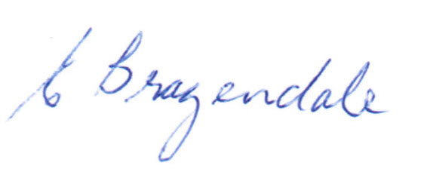

________________________________
Elaine Brazendale
Chairperson

Carterton District Licensing Committee

