IN THE MATTER of the Sale and Supply of Alcohol Act 2012

AND

IN THE MATTER of an application by Catherine Thompson for a renewal club licence pursuant to s.127 of the Act in respect of premises situated at Gladstone Road Carterton known as Gladstone Rugby Football Club Inc.

BEFORE THE CARTERTON DISTRICT LICENSING COMMITTEE

Deputy Chairperson: Jill Greathead
Secretary: Colin Wright

DECISION

This is an application by Catherine Thompson for a renewal club licence in respect of premises situated at Gladstone Road Carterton, known as Gladstone Rugby Football Club Inc.

The application was duly advertised and no objection or notice of desire to be heard has been received. Accordingly we deal with the matter on the papers.

We are satisfied as to the matters to which we must have regard as set out in s.131 of the Act and we grant the applicant a renewal club licence authorising the sale and supply of liquor for consumption on the premises, to any person who is present on the premises.

DATED at Carterton this 27th day of May 2014.

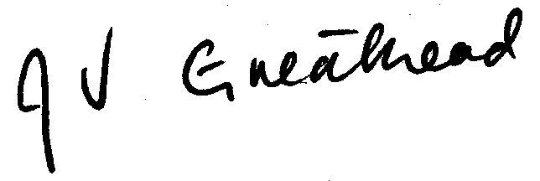

_____________________
Jill Greathead
Deputy Chairperson
Carterton District Licensing Committee

