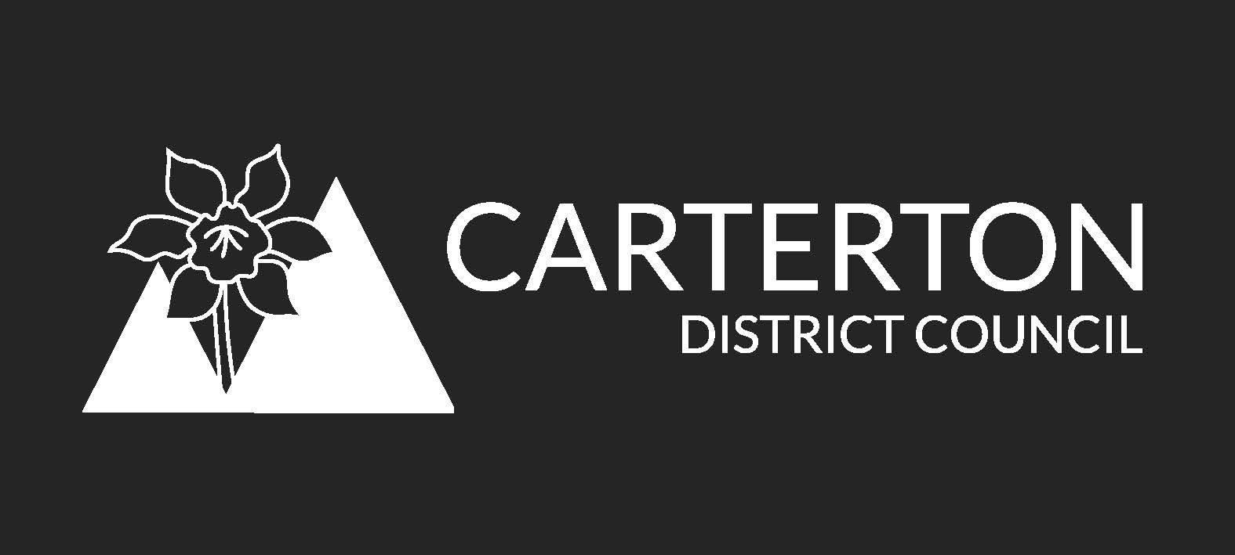
Carterton District Council Financial Grants Funds Policy
This policy provides the framework for allocating grants to groups and organisations that are delivering projects, activities and services that benefit the citizens of the Carterton District.
- The Grants Funds
  - The Grants Funds and their purpose
There are two categories of grants funds:
- Local Community Grants Fund
- Wairarapa Wide Regional Grants Fund.
In summary, the Local Community Grants Fund is to support local Carterton groups and organisations where their activities will benefit the Carterton community. The Wairarapa Wide Regional Grants Fund supports groups and organisations where their activities have wider benefits than just the Carterton community. When allocating this fund support will also be provided by at least one other Wairarapa Council.
There are a number of activities and projects carried out by organisations and agencies that Carterton District Council supports financially or in-kind that fall outside the grants funding process. These are essentially activities that assist the Council to meet its own obligations or implement a Council strategy or plan. They include, for example, Destination Wairarapa and Neighbourhood Support. Such organisations will not have access to the grants funds, and their relationships with the Council will be recorded in an MOU or contract.
  - Setting the value of the grants funds
The quantum of funding available through grants are set in the Long Term Plan and subsequently renewed at each Annual Plan. The value of these grants may vary according to Council’s priorities each year.
  - Allocation decisions to be made by the Grants Committee
Allocation decisions from the two grants funds will be made by a Grants Committee. The Council will set up a Grants Committee at the beginning of each Triennium, with Terms of Reference that will include the following:
- Delegations to meet to make a decision on the distribution of the Community Grants
- Elect a chairperson and a deputy chairperson
- Decisions by the committee to be made by consensus; a vote only being taken if required confirming the consensus view. If votes are tied the chairperson will have a casting vote
- A requirement that all conflicts of interest must be declared by elected members who cannot take any part in deliberations related to the conflict
The Committee will meet once a year to make allocation decisions, generally in August each year. It may meet more than once if funds are available and applications lodged seeking grants support.
- Local Community Grants Fund

  - The Local Community Grants Fund’s Purpose
The purpose of this fund is to support local community groups undertake charitable, cultural, philanthropic, recreational and other activities that are beneficial to the wider Carterton community.
These grants will be determined by the Grants Committee for distribution no later than 30 September of the year in question.
  - Eligibility of Applicants
Any community organisation or formally constituted group as described below is eligible to apply for a grant:
- An incorporated society with non-profit making objectives
- A charitable trust
- Other not for profit body that can demonstrate its legal status
- A club or other legally constituted body that can demonstrate a formal constitution or rules.
General funding requests from organisations such as service clubs or school fundraising associations do not usually qualify for grants, but these organisations can apply for grants for specific projects.
Groups or organisations seeking support to carry out projects or activities that are in effect an extension of the Council’s own business will not be funded through the Local Community Grants Fund. In these cases funding arrangements will be made through the Council’s operations budgets.
  - Eligibility of projects, activities and services
Grants may be made for projects, activities and services that contribute to the following outcomes:
    - Social
- Improve health, social and cultural outcomes for Carterton residents
- Promote communication and collaboration between agencies in the health and social services sector
- Effectively meet a demonstrated need in the health and social services sector
- Support and empower vulnerable people in our community
- Strengthen the ability of organisations to operate well in the health and social services sector
    - Environmental
- Protect, preserve, and restore Carterton’s environment
- Enable and encourage people to appreciate the environment
- Promote awareness of environmental issues and concepts of sustainability
    - Sport and recreation
- Encourage participation in sport and active recreation
- Encourage community engagement in sport and recreation
- Provide appropriate and sustainable facilities and infrastructure
- Support Carterton residents to achieve their sporting potential
- Reduce barriers to ensure reasonable access for all in the community
  - Grant Criteria
The following criteria will be used to guide decisions on the allocation of the Local Grants Fund.
    - The project is Carterton-based and primarily benefits the people of Carterton District.
    - There is evidence of (or, if a new group, systems for): the applicant’s sound financial management, good employment practice (where applicable), clear and detailed planning, clear performance measures, and demonstrated ability to report back on past funding as appropriate.
    - The project should be accessible to a range of people or to the intended users.
    - There is evidence of community support, collaboration, and building partnerships with other organisations (such as letters of support from other organisations/leaders).
    - The project or activity expands the capacity, range or level of similar types of services in the community and that it has involved users in identifying the need for the project.
    - The intent of the project or activity is not for private or commercial financial gain, though such gains may occur as a side effect of the project.
    - The applicant can demonstrate an awareness of the Treaty of Waitangi, if it involves mana whenua and taura here.
    - The applicant does not have excess reserve funds; unless the group can demonstrate that funds are being held for another specified project or purpose.
    - Priority or preference will be given to:
- projects completed within 12 months
- new or expanded activities.
- assisting the development of economically or socially disadvantaged groups
- supporting those projects that will give the greatest benefit to the people of Carterton
  - Applications that will not be funded are:
- Staff salaries including casual employees
- Retrospective requests to cover projects, events or programmes that have been completed
- The same projects, events or programmes will not be funded more than once in any financial year
- Rent and debt repayments are not covered, unless special circumstances can be demonstrated
- Commercial or profit making organisations
- Sponsorships or endowments
- Political organisations and lobby groups
- Individuals do not qualify for grants
- Overruns in projects, events or programmes costs
- Religious or faith based instruction, lobbying or education; church organisations may apply for grants towards the provision of non-sectarian social services
- Sports team accommodation, travel or uniforms
  - The Process
    - All completed grant applications will be submitted to the Council by a date set by the Council to enable allocation decisions to be made in August. Where the grants fund is not fully allocated in August, applications may be received through the financial year, until the funds are fully allocated.
    - A report will be provided to the Committee detailing:
- The total amount for allocation
- The organisations requesting a grant
- A brief analysis of the projects, events or programmes; including
  - How the application relates to the Council’s community outcomes
  - How the application relates to the criteria
  - The amount requested
  - Any conditions considered appropriate to place on the grant.
- The applications not meeting the policy, with the reasons why
- Any other information required that will assist the Grants Committee in their deliberation
    - The Committee will meet and consider applications. The meeting will be in public, unless there are reasons under the Local Government Official Information and Meetings Act that justify conducting the meeting with the exclusion of the public.
    - The Committee may invite applicants to speak to their application.
    - Where the Committee decides to make a grant it may include conditions. A standard condition should be included requiring reports back to the Council on the success, or otherwise, of the project or activity, as well as information on how the funds were spent.
    - Where the Committee decides to decline an application, or to grant less funding than applied, it will specify its reasons.
    - Decisions of the Committee will be reported to applicants as soon as possible following the Committee’s decisions.
    - No appeals on the decision of the Committee will be considered.
- Wairarapa Wide Regional Grants Fund

  - The Wairarapa Wide Regional Grants Fund’s Purpose
    - The purpose of this fund is to support organisations which may not be based in Carterton but undertake an activity or project that has regional benefits, including in the Carterton District.
    - Normally the activity or project offered by these organisations would not be available to the Wairarapa as a region without the Wairarapa Councils’ support.
    - These grants will be determined by the Grants Committee for distribution no later than 30 September of the year in question.
  - Eligibility
    - Any group, organisation or company may make application for a grant from this fund.
    - The application must be for an activity or project that supports, enhances or advances the Council’s community outcomes as defined in the Long Term Plan and Annual Plans, or in other ways benefits Carterton.
    - The organisation requesting the grant must have the support of South Wairarapa District Council or Masterton District Council, or provide evidence that it is seeking that support concurrently with the application to Carterton District Council.
  - Grant Criteria
The following criteria will be used to guide decisions on the allocation of the Wairarapa Wide Regional Grants Fund:
    - The project benefits the people of Carterton District either directly or indirectly, with sound evidence to demonstrate those benefits.
    - There is evidence of (or, if a new group, systems for): the applicant’s sound financial management, good employment practice (where applicable), clear and detailed planning, clear performance measures, and demonstrated ability to report back on past funding as appropriate.
    - There is evidence of community support, collaboration, and building partnerships with other organisations (such as letters of support from other organisations/leaders).
    - The project or activity expands the capacity, range or level of similar types of services in the community and that it has involved users in identifying the need for the project.
    - The intent of the project or activity is not for private or commercial financial gain, though such gains may occur as a side effect of the project.
    - The applicant can demonstrate an awareness of the Treaty of Waitangi, if it involves mana whenua and taura here.
    - The applicant does not have excess reserve funds; unless the group can demonstrate that funds are being held for another specified project or purpose.
  - Applications that will not be funded are:
- Staff salaries including casual employees
- Commercial profit making activities where the profit is not used to grow the activity or mitigate future operations
- Retrospective requests to cover projects, events or programmes that have been completed
- Rent and debt repayments
- Sponsorships or endowments
- Political organisations and lobby groups
- Overruns in projects, events or programmes costs
- Religious or faith based instruction, lobbying or education; church organisations may apply for grants towards the provision of non-sectarian social services
- Sports team accommodation, travel or uniforms
- The application is for an activity already provided by another organisation
An application not supported by at least one other Wairarapa Council. Support from the other Wairarapa Council(s) need not be financial, but could be the provision of infrastructure or in kind support; this must be quantified in the application.
  - The Process
    - All completed grant applications will be submitted to the Council by a date set by the Council to enable allocation decisions to be made in August by the Grants Committee. Where the grants fund is not fully allocated in July, applications may be received through the financial year, until the funds are fully allocated.
    - A report will be provided to the Grants Committee detailing:
- The total amount for allocation
- The organisations requesting a grant
- A brief analysis of the projects, events or programmes; including
  - How the application will benefit the Carterton community
  - How the application relates to the criteria, including the support from other Councils, or likelihood of support
  - The amount requested
  - Any conditions considered appropriate to place on the grant.
- The applications not meeting the policy, with the reasons why
- Any other information required that will assist the Grants Committee in their deliberation
    - The Committee may invite applicants to speak to their application.
    - Decisions of the Committee will be reported to applicants as soon as possible following the Committee’s decisions.
- Applicants’ Responsibilities
    - All applications are required to be completed in full and delivered to the Carterton District Council offices by the closing time on the closing day as advertised.
    - Where necessary supporting letters must be provided along with the completed application.
    - The financial page must be completed in full giving an indication of the real costs of each project (e.g. the cost of associated with volunteer time, or in-like contributions).
    - The last set of audited accounts available need to be attached to all applications.
    - A completed accountability form must be returned from Council within 12 months of the date of the grant being paid out, or prior to any future grant application being made for the following year.

Community Grant Application Form

Name of Organisation:
Postal Address:
Email Address:
Contact Person: Contact Ph No:
Is your organisation incorporated? Yes/No
Is your organisation GST registered? Yes/No
If yes, please provide your GST Number
Did you receive a grant last year? Yes/No
If yes, did you complete an Accountability Form? Yes/No
(to be eligible for future funding, an accountability form must have been completed and returned)
Please provide a detailed description of the project for which you require a grant
(Continue on a separate sheet and attach if needed)

How many people will benefit from the project?

Please provide a brief description of how the project will contribute to the Council’s community outcomes as specified in the Long Term Plan 2015-2025.
(Projects must demonstrate a contribution to one of the categories)

Which of the following Carterton Community Outcomes will your project contribute to?
(Tick appropriate community outcome/s which relate to your project.)
□ strong and positive leadership
□ a vibrant and prosperous economy
□ a safe district
□ a healthy district
□ a district that enjoys creativity and recreation
□ a district that encourages lifelong learning
□ a district that values and protects its natural environment
□ a district that promotes sustainable infrastructure and services

Total Cost of Project $

Funds Raised To-Date for This Project
Amount available from own funds $
Amounts raised from other sources (specify sources):
$
$
$
$

Total funds raised to date for this project $

Funds still to be raised for this project
By own organisation: $
Other sources:
$
$
$
$

Total still to be raised for this project $

Grant requested from the Community Grant Fund $

Declaration and Privacy Act Authorisation

This authorisation relates to information in this application that the Carterton District Council may hold about me/us now or in the future.
- I/we hereby declare that I am/we are authorised to submit this application and that any grant received will be used for the project for which it is approved
- I/we authorise the Carterton District Council to use this information for the purposes of administration of this application
- I/we authorise Carterton District Council to seek such information as may be required to complete consideration of this application
- I/we hereby declare that the information provided is correct
- I/we acknowledge that any decision made by the Carterton District Council is final and that no reasons for such decision will be given nor will any correspondence entered into
- I/we hereby declare that the enclosed annual accounts were presented at our most recent Annual General Meeting
- I/we hereby declare that we comply with any relevant obligations under the Vulnerable Childrens Act 2014

Full name of Chairperson

Signature

Full name of Secretary/Treasurer

Signature

Date

Check List
- All sections of the application form have been completed in full
- Applications which contain insufficient information to enable Council to assess eligibility for a grant will be declined

The following information is attached:
- A copy of your organisation’s most recent accounts
- A bank deposit slip

Applications should be forwarded to:

Gerry Brooking
Community Development Coordinator
Carterton District Council
P.O. Box 9
Carterton

Email: gerry@cdc.govt.nz

By 4.00pm Friday 27th July 2018

