IN THE MATTER of the Sale and Supply of Alcohol Act 2012
AND

IN THE MATTER of an application by Shoaib and Anisha Investments Ltd for a Temporary Authority for an on-licence pursuant to s.99 and s136 of the Act in respect of premises situated at 109 High Street North, Carterton known as “Indian Taj Restaurant”

BEFORE THE CARTERTON DISTRICT LICENSING COMMITTEE

Chairperson: Elaine Brazendale
Secretary: Colin Wright

DECISION

This is an application by Shoaib and Anisha Investments Ltd for a Temporary Authority for an on-licence in respect of premises situated at 109 High Street North, Carterton , known as Indian Taj Restaurant
The general nature of the business to be undertaken is that of a Restaurant
We are satisfied as to the matters to which we must have regard as set out in s.105 of the Act and we grant the applicant a Temporary Authority for an on-licence authorising the sale and supply of liquor for consumption on the premises, to any person who is present on the premises.
The applicant's attention is drawn to ss.56, 57 and 214 (3) of the Act obliging the holder of an on-licence to display:-
1. At each principal entrance to the premsies a sign attached to the inside or outside of the premises, so as to be easily read by people immediately outside the entrance, stating the ordinary hours of business during which the premises will be open for the sale of alcohol; AND
- A copy of the licence, and of the conditions of the licence, attached to the interior of the premises so as to be easily read by persons entering through each principal entrance; AND
- A sign prominently displayed inside the premises, which identifies by name the manager for the time being on duty.
This Temporary Authority is for a period not exceeding three months

DATED at Carterton this 28th day of July 2014
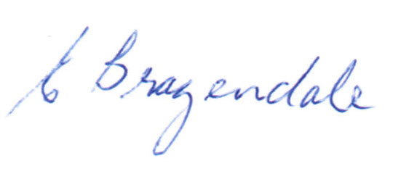
_____________________
Elaine Brazendale
Chairperson
Carterton District Licensing Committee

