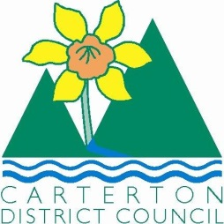

IN THE MATTER of the Sale and Supply of Alcohol Act 2012

AND

IN THE MATTER of an application by the Carterton Memorial Club for a Special Licence pursuant to s.22 of the Act in respect of premises situated at Broadway, Carterton and known as the Carterton Memorial Club

BEFORE THE CARTERTON DISTRICT LICENSING COMMITTEE

Chairperson: Elaine Brazendale
Secretary: Colin Wright

DECISION

This is an application for a Special Licence under section 22 of the Sale and Supply of Alcohol Act 2012. The application is for a Carterton Kindergarten Auction/ Fundraiser event to be held at the Carterton Memorial Club, Broadway Carterton where alcohol will be consumed on the premises.

The application was sent to the Police, Inspector and Medical Officer of Health under s. 141 and no reports of opposition were received. The application was not required to be publically notified.

We are satisfied as to the matters to which we must have regard as set out in s.3, s.4 and s.142 of the Act. We grant the applicant a special licence in terms of s.22 subject to the restrictions imposed by s.147.

Accordingly, we set the following conditions under s147 on the licence:

- alcohol may be sold under the licence only on the following day and during the following hours: Saturday August 30th, 2014 7pm-11.30pm
- alcohol may be sold or supplied to the following types of people: ticket holders over the age of 18
- the licensee must take the following steps to ensure that the provisions of this Act relating to the sale or supply of alcohol to prohibited persons are observed :the Duty manager will be monitoring sales and alcohol will not be sold to those under 18 or intoxicated, ID checks will be in place
- the licensee must take the following steps to ensure that the provisions of this Act relating to the management of premises are observed: Pokies/Gaming area will be restricted
- drinking water must be freely available at the following places while the premises are open for business: at the bar and on tables
- food must be available for consumption on the premises as follows: as per the application
- non-alcohol beverages must be available for sale and supply on the premises as follows: as per the application
- the licensee must take the following steps to provide assistance with or information about alternative forms of transport from the premises: shuttle/ courtesy bus and taxi numbers and telephone will be available
- alcohol may be sold in the following types of container only: glasses, jugs and bottles
- the licence is also subject to the following conditions, which in the committee's opinion are not inconsistent with the Act: a copy of this licence must be displayed at the point of sale so as to be easily read by persons present on the premises.

Dated at Carterton this 11th day of August 2014

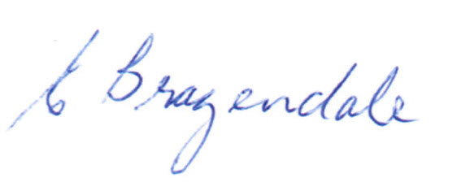

__________________
Elaine Brazendale
Chairperson
Carterton District Licensing Committee

