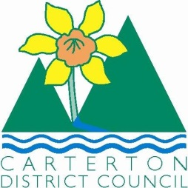

IN THE MATTER of the Sale and Supply of Alcohol Act 2012

AND

IN THE MATTER of an application by Graham Mark Aitken of Wildfern NZ Ltd for a Special Licence pursuant to s.22 of the Act in respect of premises situated at 50 Holloway Street, Carterton and known as Carterton Events Centre.

BEFORE THE CARTERTON DISTRICT LICENSING COMMITTEE

Chairperson: Elaine Brazendale
Secretary: Jane Davis

DECISION

This is an application for a Special Licence under section 22 of the Sale and Supply of Alcohol Act 2012. The application is for a Chocolate Food Expo (Carterton Chocolate Celebration) event to be held at the Carterton Events Centre 50 Holloway Street, Carterton where alcohol will be consumed on the premises.

The application was sent to the Police, Inspector and Medical Officer of Health under s. 141 and no reports of opposition were received. The application was not required to be publically notified.

We are satisfied as to the matters to which we must have regard as set out in s.3, s.4 and s.142 of the Act. We grant the applicant a special licence in terms of s.22 subject to the restrictions imposed by s.147.

Accordingly, we set the following conditions under s147 on the licence:

- alcohol may be sold under the licence only on the following days and during the following hours: Saturday October 29th, 2016 10am-5pm
- alcohol may be sold or supplied to the following types of people: tickets holders
- the licensee must take the following steps to ensure that the provisions of this Act relating to the sale or supply of alcohol to prohibited persons are observed: alcohol will not be sold to those persons under the age of 18 years or to those persons who are intoxicated, signs will be displayed during the event.
- the licensee must take the following steps to ensure that the provisions of this Act relating to the management of premises are observed: NA
- drinking water must be freely available at the following places while the premises are open for business: as per the application, from dispenser on a stand
- food must be available for consumption on the premises as follows: sale of products as per application
- non-alcohol and low alcohol beverages must be available for sale and supply on the premises as follows: coffee cart available throughout event as per application
- the licensee must take the following steps to provide assistance with or information about alternative forms of transport from the premises: taxi numbers and phone will be available
- alcohol may be sold in the following types of container only: offsite sales only, 180ml containers
- the licence is also subject to the following conditions, which in the committee's opinion are not inconsistent with the Act: tasting samples will be 40ml or less

Dated at Carterton this 14th day of October 2016

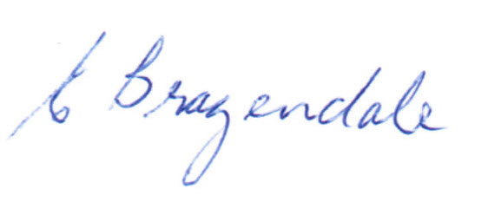

__________________
Elaine Brazendale
Chairperson
Carterton District Licensing Committee

