IN THE MATTER of the Sale and Supply of Alcohol Act 2012

AND

IN THE MATTER of an application by Lucia Zanmonti (Carterton Film Society Inc) for a Special Licence pursuant to s.22 of the Act in respect of premises situated at Holloway Street, Carterton and known as Carterton Events Centre.

BEFORE THE CARTERTON DISTRICT LICENSING COMMITTEE

Chairperson: Elaine Brazendale
Secretary: Jane Davis

DECISION

This is an application for a Special Licence under section 22 of the Sale and Supply of Alcohol Act 2012. The application is for Movie nights and Film Festival to be held at Carterton Events Centre, Holloway Street, Carterton, where alcohol will be consumed on the premises.

The application was sent to the Police, Inspector and Medical Officer of Health under s. 141 and no reports of opposition were received. The application was not required to be publically notified.

We are satisfied as to the matters to which we must have regard as set out in s.3, s.4 and s.142 of the Act. We grant the applicant a special licence in terms of s.22 subject to the restrictions imposed by s.147.

Accordingly, we set the following conditions under s147 on the licence:

- alcohol may be sold under the licence only on the following days and during the following hours: 7 February, 6 March, 3 April, 8 May, 12 June, 3 July, 7 August, 4 September, 2 October, 6 November, 4 December 2016, 7pm-8pm each evening
- alcohol may be sold or supplied to the following types of people: members/ticket holders
- the licensee must take the following steps to ensure that the provisions of this Act relating to the sale or supply of alcohol to prohibited persons are observed persons under the age of 18 years and those intoxicated persons will not be served
- the licensee must take the following steps to ensure that the provisions of this Act relating to the management of premises are observed: bar area will be supervised during sales
- drinking water must be freely available while the premises are open for business: for all ticket holders
- food must be available for consumption on the premises as follows: as per application
- non-alcohol and low alcohol beverages must be available for sale and supply on the premises as follows: as per application
- the licensee must take the following steps to provide assistance with or information about alternative forms of transport from the premises: taxi/shuttle numbers and phone will be available
- alcohol may be sold in the following types of container only: as per application

Dated at Carterton this 19th day of January 2016

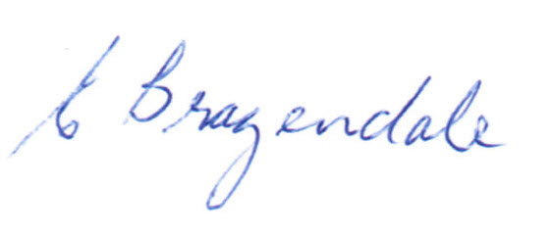

__________________
Elaine Brazendale
Chairperson
Carterton District Licensing Committee

