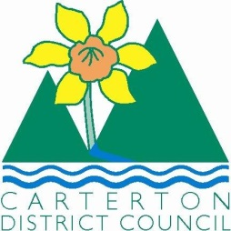

IN THE MATTER of the Sale and Supply of Alcohol Act 2012

AND

IN THE MATTER of an application by Vaughan Stewart Paul and Christine Gay Paul Partnership for a Special Licence pursuant to s.22 of the Act in respect of premises situated at Holloway Street, Carterton and known as Carterton Events Centre.

BEFORE THE CARTERTON DISTRICT LICENSING COMMITTEE

Chairperson: Jill Greathead
Secretary: Colin Wright

DECISION

This is an application for a Special Licence under section 22 of the Sale and Supply of Alcohol Act 2012. The application is for a Theatre Company Production event called “Par for the Course” to be held at Holloway Street and known as Carterton Events Centre, where alcohol will be consumed on the premises.

The application was sent to the Police, Inspector and Medical Officer of Health under s. 141 and no reports of opposition were received. The application was not required to be publically notified.

We are satisfied as to the matters to which we must have regard as set out in s.3, s.4 and s.142 of the Act. We grant the applicant a special licence in terms of s.22 subject to the restrictions imposed by s.147.

Accordingly, we set the following conditions under s147 on the licence:

- alcohol may be sold under the licence only on the following days and during the following hours:
- Wednesday 3rd to Saturday 6th December 2014 between 7.00pm & 8.00pm and 9.00pm & 9.30pm
- Wednesday 10th to Saturday 13th December 2014 between 7.00pm & 8.00pm and 9.00pm & 9.30pm
- alcohol may be sold or supplied to the following types of people: event for members of the general public
- the licensee must take the following steps to ensure that the provisions of this Act relating to the sale or supply of alcohol to prohibited persons are observed: display appropriate signs adjacent to every point of sale detailing the statutory restrictions on the supply of liquor to minors and the complete prohibition on sales to intoxicated persons
- the licensee must take the following steps to ensure that the provisions of this Act relating to the management of premises are observed: A certified manager will be on duty at all times
- drinking water must be freely available at the following places while the premises are open for business: carafes of water freely available to the public at the bar
- food must be available for consumption on the premises as follows: Nachos, cheese melts and mini pizzas to be available for consumption of the premises at all times alcohol is available.
- low-alcohol beverages must be available for sale and supply on the premises as follows: low alcohol beer available from the bar
- non-alcohol beverages must be available for sale and supply on the premises as follows: soft drinks available from the bar
- the licensee must take the following steps to provide assistance with or information about alternative forms of transport from the premises: the licensee must ensure that signs are prominently displayed within the licensed premises detailing information regarding alternative forms of transport from the premises
- alcohol may be sold in the following types of container only: Plastic
- the licence is also subject to the following conditions, which in the committee's opinion are not inconsistent with the Act: a copy of this licence must be displayed at each point of sale so as to be easily read by persons present on the premises.

Dated at Carterton this 17th day of November 2014.

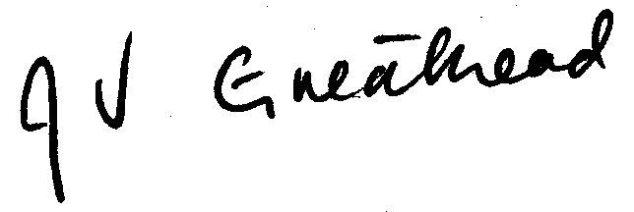

__________________
Jill Greathead
Deputy Chairperson
Carterton District Licensing Committee

