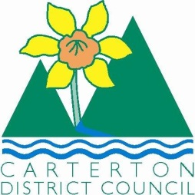

IN THE MATTER of the Sale and Supply of Alcohol Act 2012

AND

IN THE MATTER of an application by Elizabeth Pollock for Nation Events Ltd for a Special Licence pursuant to s.22 of the Act in respect of premises situated at 141B Dakins Road, Carterton and known as Nation Mobile Event Centre

BEFORE THE CARTERTON DISTRICT LICENSING COMMITTEE

Chairperson: Elaine Brazendale
Secretary: Colin Wright

DECISION

This is an application for a Special Licence under section 22 of the Sale and Supply of Alcohol Act 2012. The application is for a Conference Dinner and two Christmas Functions to be held at the Nation Mobile Event Centre, 141B Dakins Road, Carterton, where alcohol will be consumed on the premises.

The application was sent to the Police, Inspector and Medical Officer of Health under s. 141 and no reports of opposition were received. The application was not required to be publically notified.

We are satisfied as to the matters to which we must have regard as set out in s.3, s.4 and s.142 of the Act. We grant the applicant a special licence in terms of s.22 subject to the restrictions imposed by s.147.

Accordingly, we set the following conditions under s147 on the licence:

- alcohol may be sold under the licence only on the following days and during the following hours: Tuesday November 3rd 2015- 6.30pm-10pm
Thursday December 10th 2015- 5pm-8pm
Saturday December 12th 2015- 12noon-9pm
- alcohol may be sold or supplied to the following types of people: clients
- the licensee must take the following steps to ensure that the provisions of this Act relating to the sale or supply of alcohol to prohibited persons are observed: persons under the age of 18years and those intoxicated persons will not be served alcohol
- the licensee must take the following steps to ensure that the provisions of this Act relating to the management of premises are observed: designated areas will be supervised
- drinking water must be freely available at the following places while the premises are open for business: at the bar
- food must be available for consumption on the premises as follows: as per menus on application
- non-alcohol and low alcohol beverages must be available for sale and supply on the premises as follows: as per application
- the licensee must take the following steps to provide assistance with or information about alternative forms of transport from the premises: taxi numbers and phone will be available
- alcohol may be sold in the following types of container only: glasses

Dated at Carterton this 30th day of October 2015

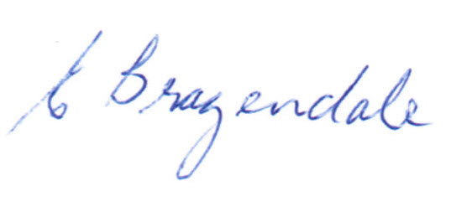

__________________
Elaine Brazendale
Chairperson
Carterton District Licensing Committee

