IN THE MATTER of the Sale and Supply of Alcohol Act 2012

AND

IN THE MATTER of an application by Gemma Ruby Keedwell for a Special Licence pursuant to s.22 of the Act in respect of premises situated at 35-77 Broadway, Carterton and known as Club Carterton .

BEFORE THE CARTERTON DISTRICT LICENSING COMMITTEE

Chairperson: Elaine Brazendale
Secretary: Colin Wright

DECISION

This is an application for a Special Licence under section 22 of the Sale and Supply of Alcohol Act 2012. The application is for a Disco Night event/Themed fundraiser to be held at Club Carterton, 35-77 Broadway, Carterton and known as Club Carterton Inc., where alcohol will be consumed on the premises.

The application was sent to the Police, Inspector and Medical Officer of Health under s. 141 and no reports of opposition were received. The application was not required to be publically notified.

We are satisfied as to the matters to which we must have regard as set out in s.3, s.4 and s.142 of the Act. We grant the applicant a special licence in terms of s.22 subject to the restrictions imposed by s.147.

Accordingly, we set the following conditions under s147 on the licence:

- alcohol may be sold under the licence only on the following day and during the following hours: Saturday 25th April, 2015 6pm- 1am Sunday 26th April.
- alcohol may be sold or supplied to the following types of people: members/ticket holders
- the licensee must take the following steps to ensure that the provisions of this Act relating to the sale or supply of alcohol to prohibited persons are observed Duty manager monitoring sales, not supplied to those under 18 or intoxicated persons
- the licensee must take the following steps to ensure that the provisions of this Act relating to the management of premises are observed: the Gaming area will be restricted and the Bar, function area and dining area will be supervised
- drinking water must be freely available at the following places while the premises are open for business: the Bar and on tables
- food must be available for consumption on the premises as follows: as per the application and officers report
- non-alcohol beverages must be available for sale and supply on the premises as follows: per the application
- the licensee must take the following steps to provide assistance with or information about alternative forms of transport from the premises: Taxi numbers and telephone will be available and also Shuttle/Courtesy vehicle
- alcohol may be sold in the following types of container only: glasses, plastic jugs and bottles

Dated at Carterton this 12th day of April, 2015

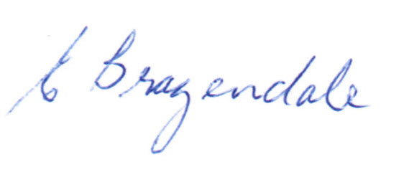
________________
Elaine Brazendale
Chairperson
Carterton District Licensing Committee

