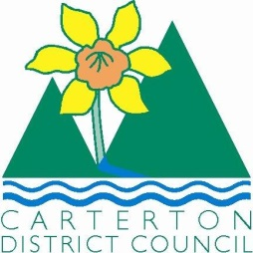

IN THE MATTER of the Sale and Supply of Alcohol Act 2012

AND

IN THE MATTER of an application by Nation Events for a Special Licence pursuant to s.22 of the Act in respect of premises situated at Dakins Road, Gladstone and known as Borthwick Estates

BEFORE THE CARTERTON DISTRICT LICENSING COMMITTEE

Deputy Chairperson: Jill Greathead
Secretary: Colin Wright

DECISION

This is an application for a Special Licence under section 22 of the Sale and Supply of Alcohol Act 2012. The application is for Pizza Night and Jazz Picnic events to be held at Dakins Road, Gladstone and known as Borthwick Estates, where alcohol will be consumed on the premises.

The application was sent to the Police, Inspector and Medical Officer of Health under s. 141 and no reports of opposition were received. The application was not required to be publically notified.

We are satisfied as to the matters to which we must have regard as set out in s.3, s.4 and s.142 of the Act. We grant the applicant a special licence in terms of s.22 subject to the restrictions imposed by s.147.

Accordingly, we set the following conditions under s147 on the licence:

- alcohol may be sold under the licence only on the following days and during the following hours:
  - Sunday 11th January 2015 between 5.00pm and 9.00pm
  - Sunday 1st February 2015 between 11.00am and 6.00pm
- alcohol may be sold or supplied to the following types of people: event for members of the general public with four drinks as the maximum serve
- the licensee must take the following steps to ensure that the provisions of this Act relating to the sale or supply of alcohol to prohibited persons are observed display appropriate signs adjacent to every point of sale detailing the statutory restrictions on the supply of liquor to minors and the complete prohibition to intoxicated persons
- the licensee must take the following steps to ensure that the provisions of this Act relating to the management of premises are observed: a certified manager will be on duty at all times
- The Duty Manager must not serve alcohol and must be monitoring sales and ensuring that alcohol will not be supplied to those under 18 or those who are intoxicated
- drinking water must be freely available at the following places while the premises are open for business
- food must be available for consumption on the premises as follows: As per applications and will be supplemented by antipasto platters, paninis and homemade pies
- non-alcohol beverages must be available for sale and supply on the premises as follows: as per the application
- The consumption of alcohol will be restricted to within the defined 20m x 28m licensed area
- Alcohol – both beer and wine will be sold and served by the glass
- the licensee must take the following steps to provide assistance with or information about alternative forms of transport from the premises: the licensee must ensure that signs are prominently displayed within the licensed premises detailing information regarding alternative forms of transport from the premises
- the licence is also subject to the following conditions, which in the committee's opinion are not inconsistent with the Act: a copy of this licence must be displayed at each point of sale so as to be easily read by persons present on the premises

Dated at Carterton this 24th December 2014

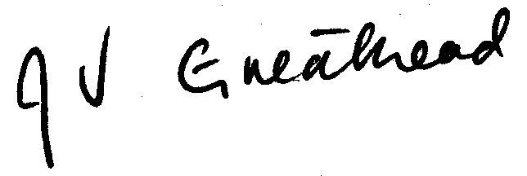

__________________
Jill Greathead
Deputy Chairperson
Carterton District Licensing Committee

