IN THE MATTER of the Sale and Supply of Alcohol Act 2012

AND

IN THE MATTER of an application by Raymond John Beale for a Special Licence pursuant to s.22 of the Act in respect of premises situated at 2-12 Chester Road, RD1 Carterton and known as The Wairarapa A&P Society Show grounds

BEFORE THE CARTERTON DISTRICT LICENSING COMMITTEE

Chairperson: Elaine Brazendale
Secretary: Colin Wright

DECISION

This is an application for a Special Licence under section 22 of the Sale and Supply of Alcohol Act 2012. The application is for the Annual A&P Show, trade exhibition and entertainment event to be held at 2-12 Chester Road, Carterton and known as the A & P Society show grounds, where alcohol will be consumed on the premises.

The application was sent to the Police, Inspector and Medical Officer of Health under s. 141 and no reports of opposition were received. The application was not required to be publically notified.

We are satisfied as to the matters to which we must have regard as set out in s.3, s.4 and s.142 of the Act. We grant the applicant a special licence in terms of s.22 subject to the restrictions imposed by s.147.

Accordingly, we set the following conditions under s147 on the licence:

- alcohol may be sold under the licence only on the following days and during the following hours:
Saturday November 1st 2014 from 11.00am until 4.00pm
Sunday November 2nd 2014 from 11.00am until 3.00pm
- alcohol may be sold or supplied to the following types of people: public, members and exhibitors
- the licensee must take the following steps to ensure that the provisions of this Act relating to the sale or supply of alcohol to prohibited persons are observed : alcohol will not be sold to intoxicated persons or those under 18 years of age
- the licensee must take the following steps to ensure that the provisions of this Act relating to the management of premises are observed: bar area will be restricted, food court area supervised and duty manager will be monitoring sales
- drinking water must be freely available at the following places while the premises are open for business: at the bar and as per application
- food must be available for consumption on the premises as follows: food court stalls as per application
- non-alcohol beverages must be available for sale and supply on the premises as follows: as per application
- the licensee must take the following steps to provide assistance with or information about alternative forms of transport from the premises: access to public bus service, taxi and shuttle phone numbers publicly available
- alcohol may be sold in the following types of container only: glass, plastic and cans
- the licence is also subject to the following condition, which in the committee's opinion is not inconsistent with the Act: a maximum of four beers served per person per serve

Dated at Carterton this 14th day of October 2014

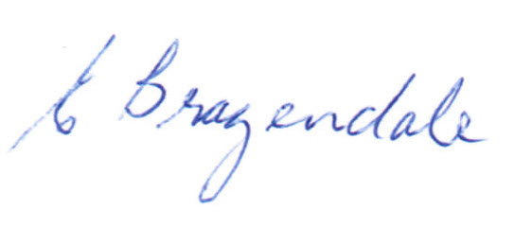

__________________
Elaine Brazendale
Chairperson
Carterton District Licensing Committee

