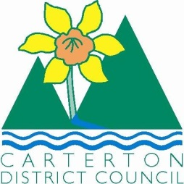

IN THE MATTER of the Sale and Supply of Alcohol Act 2012

AND

IN THE MATTER of an application by Carterton District Council for a Special Licence pursuant to s.22 of the Act in respect of premises situated at Holloway Street and known as Carterton Events Centre.

BEFORE THE CARTERTON DISTRICT LICENSING COMMITTEE

Chairperson: Jill Greathead
Secretary: Colin Wright

DECISION

This is an application for a Special Licence under section 22 of the Sale and Supply of Alcohol Act 2012. The application is for a Community Awards Dinner to be held at Holloway Street and known as Carterton Events Centre, where alcohol will be consumed on the premises.

The application was sent to the Police, Inspector and Medical Officer of Health under s. 141 and no reports of opposition were received. The application was not required to be publically notified.

We are satisfied as to the matters to which we must have regard as set out in s.3, s.4 and s.142 of the Act. We grant the applicant a special licence in terms of s.22 subject to the restrictions imposed by s.147.

Accordingly, we set the following conditions under s147 on the licence:

- alcohol may be sold under the licence only on the following days and during the following hours:
Saturday the 14th June 2014 between 6.00pm and 11.30pm
- alcohol may be sold or supplied to the following types of people: Tickets holders over 18 years old
- the licensee must take the following steps to ensure that the provisions of this Act relating to the sale or supply of alcohol to prohibited persons are observed A certified manager will be on duty at all times
- the licensee must take the following steps to ensure that the provisions of this Act relating to the management of premises are observed: The duty manager is to be monitoring sales and ensuring that alcohol will not be supplied to those under 18 or intoxicated
- Drinking water must be freely available at the following places while the premises are open for business: Water will be freely available on all tables and at all bars.
- Food must be available for consumption on the premises as follows: Two course meals will be provided to all attendants.
- non-alcohol beverages must be available for sale and supply on the premises as follows: Fruit punch and cold drinks will be available.
- the licensee must take the following steps to provide assistance with or information about alternative forms of transport from the premises: Taxis have been arranged for from 9.30pm until the end of the function – 12.00pm. A free Shuttle/courtesy bus will be made available for transportation of Carterton locals
- alcohol may be sold in the following types of container only: Glass – wine and beer glasses
- the licence is also subject to the following conditions, which in the committee's opinion are not inconsistent with the Act: A copy of this licence must be displayed at each point of sale so as to be easily read by persons present on the premises.

Dated at Carterton this 10th day of June 2014

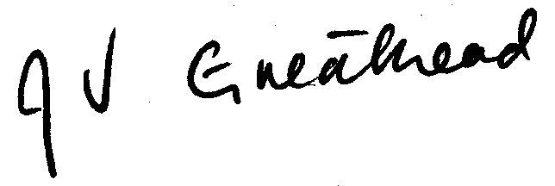

__________________
Jill Greathead
Deputy Chairperson
Carterton District Licensing Committee

