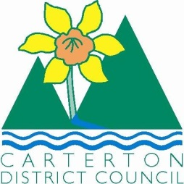

IN THE MATTER of the Sale and Supply of Alcohol Act 2012

AND

IN THE MATTER of an application by Masterton Petanque Club for a Special Licence pursuant to s.22 of the Act in respect of premises situated at Chester Road and known as the Cattle Pavilion at the Wairarapa A&P Show grounds.

BEFORE THE CARTERTON DISTRICT LICENSING COMMITTEE

Chairperson: Jill Greathead
Secretary: Colin Wright

DECISION

This is an application for a Special Licence under section 22 of the Sale and Supply of Alcohol Act 2012. The application is for Petanque Fun Sports Tournament to be held at Chester Road and known as the Cattle Pavilion at the Wairarapa A&P Show Grounds, where alcohol will be consumed on the premises.

The application was sent to the Police, Inspector and Medical Officer of Health under s. 141 and no reports of opposition were received. The application was not required to be publically notified.

We are satisfied as to the matters to which we must have regard as set out in s.3, s.4 and s.142 of the Act. We grant the applicant a special licence in terms of s.22 subject to the restrictions imposed by s.147.

Accordingly, we set the following conditions under s147 on the licence:

- alcohol may be sold under the licence only on the following days and during the following hours:
  - Saturday 31st of May 2014 between the hours of 9.00am and 8.00pm.
  - Sunday 1st of June 2014 between the hours of 9.00am and 8.00pm.
- alcohol may be sold or supplied to the following types of people: Players taking part in the tournament over 18 years old.
- the licensee must take the following steps to ensure that the provisions of this Act relating to the sale or supply of alcohol to prohibited persons are observed: a certified manager will be on duty during the event.
- the licensee must take the following steps to ensure that the provisions of this Act relating to the management of premises are observed: a certified manager will be on duty during the event.
- drinking water must be freely available at the following places while the premises are open for business: water and cordial is available free of charge throughout the tournament.
- food must be available for consumption on the premises as follows: toasted sandwiches, soup and BBQ food is on sale throughout the tournament.
- non-alcohol beverages must be available for sale and supply on the premises as follows: tea and coffee is supplied free and soft drinks are for sale.
- Low-alcohol beverages must be available for sales and supply on the premises as follows: Amstel light beer
- the licensee must take the following steps to provide assistance with or information about alternative forms of transport from the premises: Taxi numbers available, Club members available to transport. Morning briefing announcements and free phone available.
- alcohol may be sold in the following types of container only: glass and plastic cups
- the licence is also subject to the following conditions, which in the committee's opinion are not inconsistent with the Act: A copy of this licence must be displayed at each point of sale so as to be easily read by persons present.

Dated at Carterton this 22nd day in May 2014.

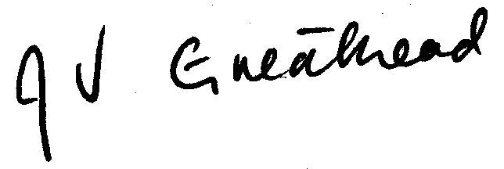

__________________
Jill Greathead
Deputy Chairperson
Carterton District Licensing Committee

