IN THE MATTER of the Sale and Supply of Alcohol Act 2012
AND

IN THE MATTER of an application by Donald Brent Goble for a renewal on-licence pursuant to s.127 of the Act in respect of premises situated at 1A Stubbs Lane, Carterton known as Regent 58 Brewery and Alehouse

BEFORE THE CARTERTON DISTRICT LICENSING COMMITTEE

Chairperson: Elaine Brazendale
Secretary: Colin Wright

DECISION

This is an application by Donald Brent Goble for a renewal on-licence in respect of premises situated at 1A Stubbs Lane, Carterton, known as Regent 58 Brewery and Alehouse.

The application was duly advertised and no objection or notice of desire to be heard has been received. Accordingly we deal with the matter on the papers.

We are satisfied as to the matters to which we must have regard as set out in s.131 of the Act and we grant the applicant a renewal on-licence authorising the sale and supply of liquor for consumption on the premises, to any person who is present on the premises.

This licence is subject to the following conditions:
- No alcohol is to be sold on the premises on Good Friday, Easter Sunday, Christmas day or before 1pm on Anzac Day to any person
- Alcohol may only be sold on: Thursdays 2pm-9pm, Fridays and Saturdays 2pm-10pm and Sundays 1pm-6pm
- The premise is designated as follows: Supervised
- Drinking Water is to be freely available from the service counter, to customers at all times when alcohol is available
- Food must be available at all times with a ranges of choices: menus must be visible and food actively promoted
- The following steps must be taken to promote the responsible consumption of alcohol: the licensee must have available at all times for consumption on the premises a reasonable range of non alcoholic and low alcohol beverages
- to ensure that the provisions of the Act relating to the sale of alcohol to prohibited persons are observed: signs must be displayed adjacent to every point of sale detailing the statutory restrictions on the supply of alcohol to minors and the complete prohibition on sales to intoxicated persons
- to ensure the provisions of the Act relating to the management of the premises are observed: 1. The Host Responsibility Policy must be displayed in view of the Public
2. Signs must be prominently displayed detailing information regarding alternative forms of transport, taxi phone numbers and freephone available.

DATED at Carterton this 2nd day of June 2015

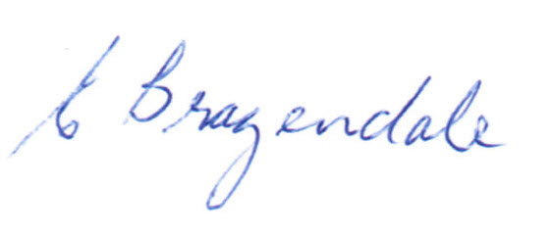

_____________________
Elaine Brazendale
Chairperson
Carterton District Licensing Committee

