IN THE MATTER of the Sale and Supply of Alcohol Act 2012
AND

IN THE MATTER of an application by Evan Raymond Futcher for a renewal on-licence pursuant to s.127 of the Act in respect of premises situated at 3 Belvedere Road known as “Ev’s Bar”

BEFORE THE CARTERTON DISTRICT LICENSING COMMITTEE

Deputy Chairperson: Jill Greathead
Secretary: Colin Wright

DECISION

This is an application by Evan Raymond Futcher for a renewal on-licence in respect of premises situated at 3 Belvedere Road known as “Ev’s Bar”.

The application was duly advertised and no objection or notice of desire to be heard has been received. Accordingly we deal with the matter on the papers.

We are satisfied as to the matters to which we must have regard as set out in s.131 of the Act and we grant the applicant a renewal on-licence authorising the sale and supply of liquor for consumption on the premises, to any person who is present on the premises.

DATED at Carterton this 23rd day of June 2014

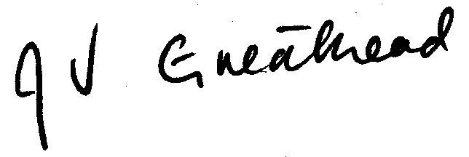

_____________________
Jill Greathead
Deputy Chairperson
Carterton District Licensing Committee

