IN THE MATTER of the Sale and Supply of Alcohol Act 2012
AND

IN THE MATTER of an application by Donald Brent Goble for an off-licence pursuant to s.99 of the Act in respect of premises situated at 1A Stubbs Lane, Carterton known as "Regent 58 Brewery"

BEFORE THE CARTERTON DISTRICT LICENSING COMMITTEE

Chairperson: Elaine Brazendale
Secretary: Colin Wright

DECISION

This is an application by Donald Brent Goble for an off-licence in respect of premises situated at 1A Stubbs lane, Carterton, known as Regent 58 Brewery.

The application is in respect of premises in which the principal business is the manufacture and sale of alcohol.
The application was duly advertised and no objection or notice of desire to be heard has been received. Accordingly, we deal with the matter on the papers.

We are satisfied as to the matters to which we must have regard as set out in s.105 of the Act and we grant the applicant an off-licence.

- Conditions that apply are that: Alcohol may be sold during the hours 7am-10pm Monday - Sunday
- The whole of the premises is to be designated as a supervised area

The licence may issue immediately.

The applicant's attention is drawn to ss.55, 56, 57 and 214 (3) of the Act obliging the holder of an off-licence to display:-

1. A sign attached to the exterior of the premises, so as to be readily read by persons outside each principal entrance, stating the ordinary hours of business during which the premises will be open for the sale of liquor; AND

2. A copy of the licence, and of the conditions of the licence, attached to the interior of the premises so as to be easily read by persons entering through each principal entrance; AND

3. A sign prominently displayed inside the premises, which identifies by name the manager for the time being on duty.

Dated at Carterton this 28th day of May 2015

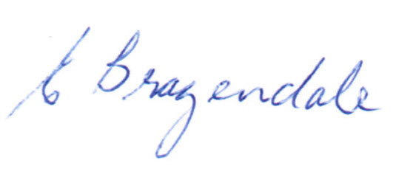
_____________________Elaine Brazendale
Chairperson
Carterton District Licensing Committee

