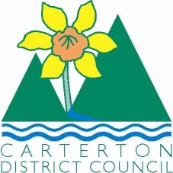

IN THE MATTER of the Sale and Supply of Alcohol Act 2012
AND

IN THE MATTER of an application by Jonathan Marcus McNab for an off-licence pursuant to s.99 of the Act in respect of premises situated at 364 Gladstone Road RD2 Carterton known as Fairmont Estate

BEFORE THE CARTERTON DISTRICT LICENSING COMMITTEE

Chairperson: Elaine Brazendale
Secretary: Jane Davis

DECISION

This is an application by Jonathan Marcus McNab for an off-licence with remote sales in respect of premises situated at 364 Gladstone Road RD2 Carterton known as Fairmont Estate.

The application is in respect of premises in which the principal business is the manufacture and sale of alcohol.

The application was duly advertised and no objection or notice of desire to be heard has been received. Accordingly, we deal with the matter on the papers.

We are satisfied as to the matters to which we must have regard as set out in s.105 and s.40 of the Act and we grant the applicant an off-licence with remote sales.

The licence may issue immediately.

The applicant's attention is drawn to ss. 40, 55, 56, 57 and 214 (3) of the Act

Conditions that will apply are:

- No alcohol is to be sold or delivered on Good Friday, Easter Sunday, Christmas Day, or before 1 pm on Anzac Day.
- Alcohol may be sold only on the following days and during the following hours:
Monday to Sunday 9:00am to 5:00pm
- Drinking water is to be freely available to customers while alcohol is being supplied free as a sample on the premises and signage directing people to drinking water must be prominently displayed on the premises at that time.
- The fees payable for the licensing of the premises concerned are the following risk rating: Low
- The following steps must be taken to ensure that the provisions of the Act relating to the sale of alcohol to prohibited persons are observed:
(i) Ensure that no intoxicated persons are allowed to enter or to remain on the premises.
(ii) Ensure that appropriate signs are prominently displayed detailing the statutory restrictions on the supply of liquor to minors and intoxicated persons, at each entry and adjacent to every point of sale.
- The whole of the premises is undesignated.
Conditions applying to all remote sales for the sale and supply of alcohol:
(a) The following information must be displayed on the internet site in a prominent place, in any catalogue used by the license holder and on every receipt issued for any alcohol sold via the internet site:
(b) The licence holders name, the licence number, and the date on which the licence expires.
(c) A copy of the licence or a clearly identified link to such an image must be displayed in a prominent place on the internet site.
(d) The following steps must be taken to verify that people are over the purchase age:
i) In the case of an order made using an internet site, telephone order, or physical order - the prospective buyer must declare that he or she is 18 years of age or over (and where the prospective receiver is involved that the prospective receiver is also 18 years of age or over) -
(i) Once, when the prospective buyer first commences the order process; and
(ii) again, immediately before the sale of alcohol is completed.

Dated at Carterton this 27th day of April 2016
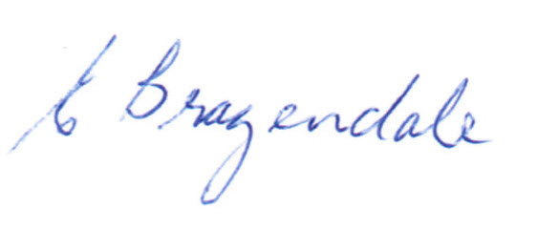
_____________________
Elaine Brazendale
Chairperson
Carterton District Licensing Committee

