IN THE MATTER of the Sale and Supply of Alcohol Act 2012
AND

IN THE MATTER of an application by Dipeshkumar Hasmukhbhai Patel, BHUNE Trading Ltd for an off-licence pursuant to s.99 of the Act in respect of premises situated at 2 Broadway Carterton and known as The Bottle 'O'

BEFORE THE CARTERTON DISTRICT LICENSING COMMITTEE

Chairperson: Elaine Brazendale
Secretary: Jane Davis

DECISION

This is an application by Dipeshkumar Hasmukhbhai Patel, BHUNE Trading Ltd for an off-licence in respect of premises situated at 2 Broadway Carterton, known as The Bottle 'O'.
The application is in respect of premises in which the principal business is sale and supply of alcohol.
The application was duly advertised and no objection or notice of desire to be heard has been received. Accordingly, we deal with the matter on the papers.

We are satisfied as to the matters to which we must have regard as set out in s.105 of the Act and we grant the applicant an off-licence.

The licence may issue immediately.

The applicant's attention is drawn to ss.55, 56, 57 and 214 (3) of the Act obliging the holder of an off-licence to display:-

1. A sign attached to the exterior of the premises, so as to be readily read by persons outside each principal entrance, stating the ordinary hours of business during which the premises will be open for the sale of liquor; namely 9am to 10pm daily Monday-Sunday AND

2. A copy of the licence, and of the conditions of the licence as per the Inspectors report, attached to the interior of the premises so as to be easily read by persons entering through each principal entrance; AND

3. A sign prominently displayed inside the premises, which identifies by name the manager for the time being on duty; AND
4. The whole of the premises will be supervised.

Dated at Carterton this 16th day of May 2016
E Brazendale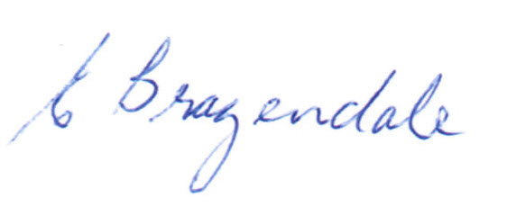
Chairperson
Carterton District Licensing Committee

