IN THE MATTER of the Sale and Supply of Alcohol Act 2012
AND

IN THE MATTER of an application by Nigel Raymond Knowles for an off-licence pursuant to s.99 of the Act in respect of premises situated at 160 East Taratahi Road RD7 Masterton known as 50 Knots Beverage Co. Ltd.

BEFORE THE CARTERTON DISTRICT LICENSING COMMITTEE

Chairperson: Elaine Brazendale
Secretary: Colin Wright

DECISION

This is an application by Nigel Raymond Knowles for an off-licence in respect of premises situated at 160 East Taratahi Road RD7 Masterton, known as 50 Knots Beverage Co. Ltd

The application is in respect of premises in which the principal business is the remote sale of alcohol online.

The application was duly advertised and no objection or notice of desire to be heard has been received. Accordingly, we deal with the matter on the papers.

We are satisfied as to the matters to which we must have regard as set out in s.105 of the Act and we grant the applicant an off-licence.

The licence may issue immediately.

The applicant's attention is drawn to ss.57,59 and 214 (3) of the Act obliging the holder of an off-licence to display:-

1. A copy of the licence, and of the conditions of the licence, attached to the interior of the premises and displayed on the website as required by the Act.

2. The duty manager will manage all sales and alcohol will not be delivered to any person under 18 years of age.

Dated at Carterton this 22nd Day of September 2015
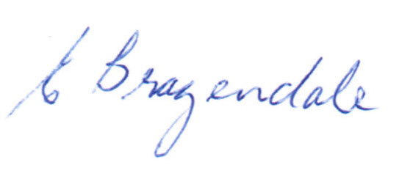
_____________________
Elaine Brazendale
Chairperson
Carterton District Licensing Committee

