IN THE MATTER of the Sale and Supply of
Alcohol Act 2012

AND

IN THE MATTER of an application by Kelly Malcolm for a Manager’s Certificate pursuant to s.217 of the Act.

BEFORE THE CARTERTON DISTRICT LICENSING COMMITTEE

DECISION

Reports from Police and an Inspector appointed under the Act do not oppose the issue of a certificate. Based on the information provided to us, and having regard to the matters set out in s.222 we grant the applicant a Manager’s Certificate.

A condition on the licence will be: Kelly Malcolm may only work at the Royal Oak Hotel for the next twelve months

A copy of the certificate is attached to this decision.

DATED at Carterton this 1st day of December 2015
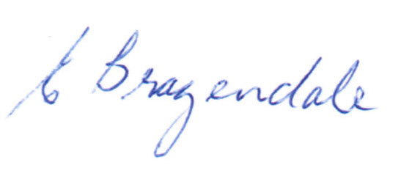

________________________________
Elaine Brazendale
Chairperson

Carterton District Licensing Committee

