IN THE MATTER of the Sale and Supply of
Alcohol Act 2012

AND

IN THE MATTER of an application by Simon Christopher Pittams for a Manager’s Certificate renewal pursuant to s.217 of the Act.

BEFORE THE CARTERTON DISTRICT LICENSING COMMITTEE

DECISION

We understand that Simon Pittams completed his 28 day suspension which the Police have consented to. Based on this information, and having regard to the matters set out in s.227, the certificate is renewed. A copy of the certificate is attached to this decision.

This certificate is valid for three years.

DATED at Carterton this 21st day of November 2014

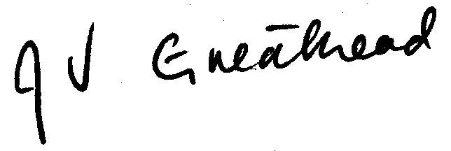

________________________________
Jill Greathead
Deputy Chairperson

Carterton District Licensing Committee

