CARTERTON DISTRICT COUNCIL
LIQUOR CONTROL BYLAW 2005

The bylaw was made on 20th July 2005 and has been subject to a review on 18th September 2007 and adopted on 26th September 2007.

The bylaw with amendments shall be operative from 10th October 2007

This Bylaw was further reviewed on 24th September 2014 and came into force on 3rd December 2014. Unless revoked or reviewed sooner, it shall be reviewed no later than 2nd December 2024. If not reviewed by 2nd December 2024, this bylaw terminates on 3rd December 2026.

……………………………………………………
Mayor

………………………………………………….
Chief Executive Officer

……………………………..
Date
Timetable under special consultative procedures

24th September 2014 Approved for Public Notification
1st October 2014 Public notice
3rd November 2014 Submissions close
26th November 2014 Hearing of submissions and adoption of Bylaw
3rd December 2014 Final Public Notification
5th January 2015 Bylaw takes effect

CARTERTON DISTRICT COUNCIL LIQUOR CONTROL BYLAW 2005

1. Introduction
Pursuant to Sections 83, 145, 147, and 169 Local Government Act 2002 the Carterton District Council makes this bylaw to The Control of Alcohol in Public Places and various private areas.

Amendment to this Bylaw has been made in compliance with sections 147 and 158 Local Government Act 2002

2. Title
The title of this bylaw is the Carterton District Council Liquor Control Bylaw 2005.

3. Date the liquor Control amendment takes effect
Liquor Control amendment described in the schedules comes into force on 3rd December 2014

4. Interpretation:
Carrington Park means that area as defined on the map contained within the First Schedule.

Central Business District CBD means that area as defined on the map contained within the Second Schedule

Liquor has the meaning given to it in the Sale and Supply of Alcohol Act 2012

Millennium Park means that area as defined on the map contained within the Third Schedule

Memorial Square means that area as defined on the map contained within the Fourth Schedule

Private Area
Means land in private ownership.

Public place
(a) Means a place—
(i) that is under the control of the territorial authority; and
(ii) that is open to, or being used by, the public, whether or not there is a charge for admission; and
(b) Includes—
(i) a road, whether or not the road is under the control of a territorial authority; and
(ii) Any part of a public place.

Town Clock Reserve and Access means that area as defined on the map contained within the Sixth Schedule.

5. Control of Alcohol in public places and other private areas.
That the Carterton District Council adopts an amendment to the Liquor Control Bylaw 2005 as follows:

The bylaw gives effect under the Local Government Act 2002 to the resolution adopted by the Council under the special consultative procedure.

This part of the bylaw controls the consumption and possession of liquor in public places and surrounding environs within the Carterton District Area. The bylaw includes a process to obtain prior Council written permission to authorise events that would otherwise breach the bylaw. The Council will erect signage to communicate the terms of the bylaw to the public.

The purpose of this bylaw is to address concerns relating to potential criminal offending and safety concerns that are linked to the possession or consumption of alcohol in public places and surrounding environs. It is a proactive restriction to limit alcohol in public and other areas to increase perceptions of safety and to reduce offending

The bylaw amendment is introduced pursuant to s147 and s158 of the Local Government Act 2002 - these sections should be read together with this part of the bylaw as they contain relevant definitions and the situations when this bylaw control will not apply (particularly relating to the transportation of unopened liquor). Pursuant to s169 and s170 of the Local Government Act 2002, the Police can enforce this part of the bylaw. Further details on the statutory provisions are provided as a note at the end of this part of the bylaw.

- Definitions
Carrington Park
Prohibited Area means the general area of Carrington Park, and defined as Lot 1 DP 59134 Pt Sections 4, 5, Pt Lot 2 DP 1024 Carterton Township. The area is depicted in the First Schedule, but excluding:
a) Any area that is subject to a road encroachment issued by the Council;
b) Any licensed premises that occupies a paved area on legal road or Council land where permission to occupy has been granted by the Council.

Central Business District (CBD)
Prohibited Area means the area defined in the Second Schedule, but excluding:
a) Any area that is subject to a road encroachment issued by the Council;
b) Any licensed premises that occupies a paved area on legal road or Council land where permission to occupy has been granted by the Council.

Millennium Park
Prohibited Area means the general area of Millennium Park, and defined as Part Section 206. The area is depicted in the Third Schedule, but excluding:
a) Any area that is subject to a road encroachment issued by the Council;
b) Any licensed premises that occupies a paved area on legal road or Council land where permission to occupy has been granted by the Council.

Memorial Square
Prohibited Area means the general area of Memorial Square, and defined as Lot 22 DP 414. The area is depicted in the Fourth Schedule, but excluding:
a) Any area that is subject to a road encroachment issued by the Council;
b) Any licensed premises that occupies a paved area on legal road or Council land where permission to occupy has been granted by the Council.

Private Areas
Prohibited Area means the general area of the private car park, and defined as Lot 1 DP 85196. The area is depicted in the Fifth Schedule, but excluding:
a) Any area that is subject to a road encroachment issued by the Council;
b) Any licensed premises that occupies a paved area on legal road or Council land where permission to occupy has been granted by the Council.

Town Clock Reserve
Prohibited Area means the general area of the Town Clock Reserve, and defined as Lot 1 DP 85196. The area is depicted in the Sixth Schedule, but excluding:
a) Any area that is subject to a road encroachment issued by the Council;
b) Any licensed premises that occupies a paved area on legal road or Council land where permission to occupy has been granted by the Council.

7 Liquor Prohibition
7.1 The consumption or possession of liquor in a public place (including while in a vehicle), is prohibited at all times in respect to the following areas:
- Carrington Park restricted area.
- Carterton Central Business District restricted area
- Millennium Park
- Memorial Square
- Private Areas as defined
- Town Clock Reserve

7.2 In addition to the prohibitions in Clause 7.1 above, the Council by resolution may order a prohibition of alcohol consumption or possession of liquor (including while in a vehicle) or prohibit vehicles in a public place within the Carterton District for certain specified times and/or within certain specified public places and areas within the Carterton District. The prohibition must be notified in the appropriate newspaper at least 14 days in advance of the special event. The Police powers of search under s170 (2) of the Local Government Act 2002 applies to these events

8 Council Permission
8.1 Any person may apply in writing to the Council for prior written permission for any activity that would be in breach of any prohibition under this part of the bylaw.

8.2 A special licence may be issued under the Sale and Supply of Alcohol Act 2012 in respect of any location or event, and subject to the terms of that special licence will include waivers and dispensation according to those terms.

9 Signage
9.1 The Council will erect signage within public places covered by this bylaw to provide information to the public on the terms of the bylaw. The size, location and terms of this signage shall be at Council's discretion. To avoid any doubt, the absence of signage in any public place does not authorise breach of this part of the bylaw.

10 Offences
10.1 Everyone commits an offence who:

a) Consumes or possesses any liquor in a public place in breach of a prohibition under this part of the bylaw; and
b) Breaches, or permits a breach of, the terms of any Council permission granted pursuant to clause 8.1 of this bylaw.

11. Powers to Amend by Resolution
11.1 The Council may from time to time by resolution publicly notified:

11.1.1 Amend or vary the hours or days when the consumption or possession of liquor is prohibited in a public place.

11.1.2 a) Add Schedules
b) Make additions or deletions from the schedules
c) Substitute new Schedules

Note: This bylaw is introduced pursuant to the specific empowering provisions of the Local Government Act 2002 that provide for bylaws for liquor control purposes. This bylaw does not repeat or paraphrase those statutory provisions, and accordingly those provisions should be read in conjunction with this bylaw. In particular, the following provisions are noted:

Section 147 empowers the Council to make this bylaw. It also defines 'liquor' and 'public place', In addition, s147(4) sets out a number of specific exemptions when the bylaw will not apply with respect to the transportation of unopened bottles or containers.

Section 158 empowers the Council to review this bylaw.

Section 169 provides the Police with powers of search and seizure, without warrant, to enforce the bylaw. The Police are responsible for enforcing the bylaw.

Section 170 sets out certain conditions imposed on the Police powers of search under s169.

This bylaw has no effect on any other Police powers of search, seizure and arrest or any other statutory offences.
First Schedule - Carrington Park - Prohibited Area

The area bounded by High Street South, being the west boundary, Carterton Fire Station, Carterton School, Carterton Bowling Club and Carterton Tennis Club on the north boundary and private properties on the east and south boundaries.
For the avoidance of doubt, this area includes the entire legal road reserve of the streets which form the boundary of the area specified above, up to the boundaries with adjoining properties and including the carriageway, berms and footpaths. Where the public place meets or is crossed by another road, the boundary of the public place shall be deemed to continue in an unbroken straight line across the other road.

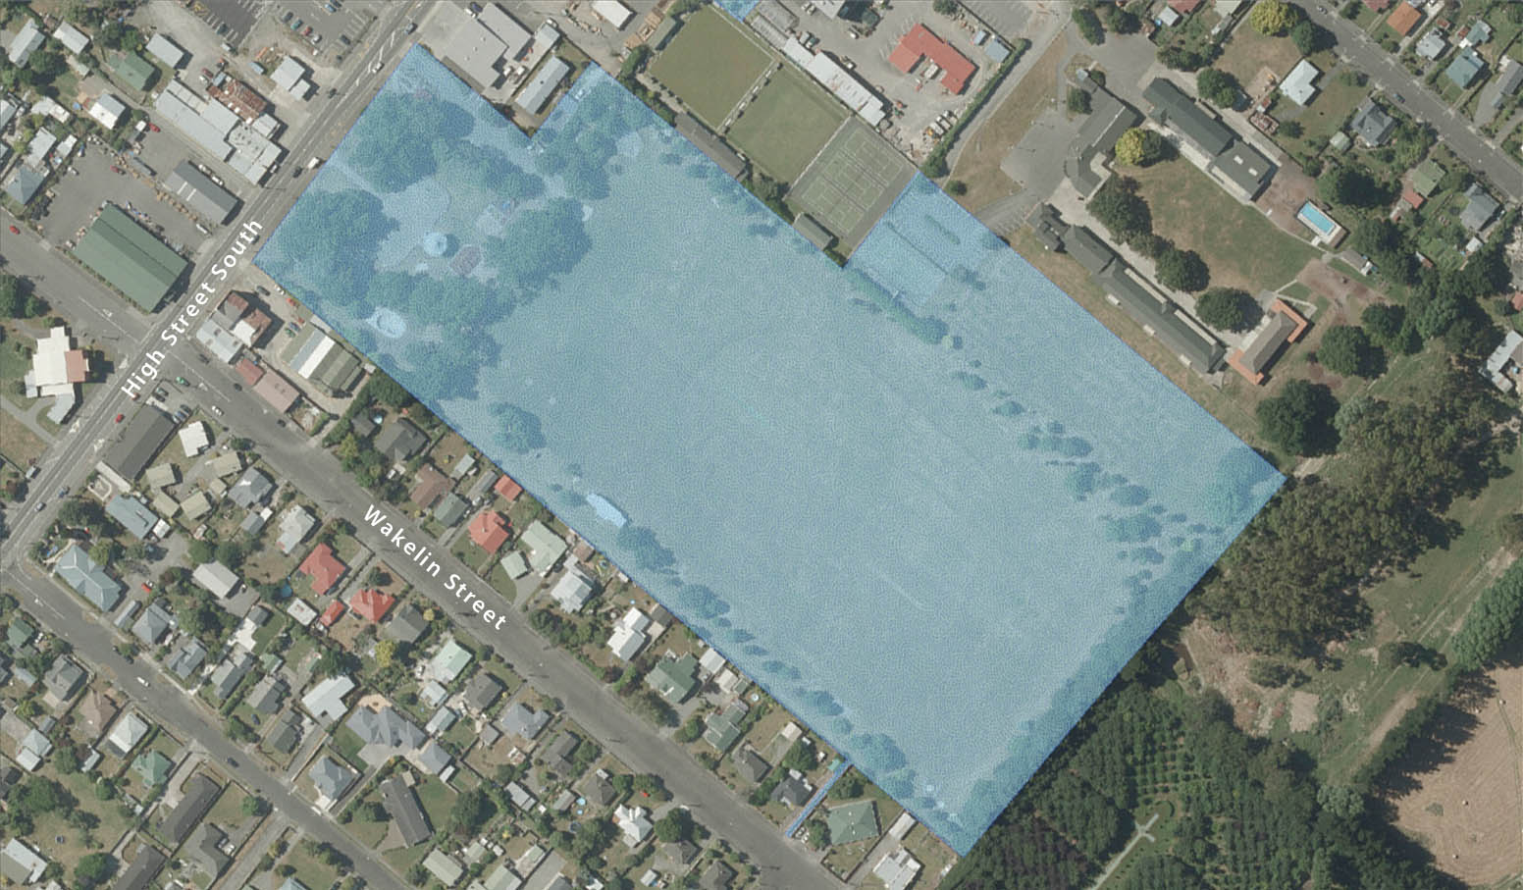

Second Schedule – Central Business District (CBD)
- From and including the northern roundabout at the intersections of High Street North/Belvedere Road/Park Road, including the entire length of High Street to its intersection with Wakelin Street/Victoria Street.
- Belvedere Road - between its intersections with High Street North and Masson Street
- Park Road – between its intersection with High Street North and The Square
- The Square – The entire road reserve surrounding Memorial Square.
- Broadway – between its intersection with High Street North and Masson Street
- Holloway Street – between its intersection with High Street North and Nelson Crescent.
- Access by Town Clock – between its intersection with High Street South and Carterton District Council Depot
- Pembroke Street – between its intersection with High Street South and Callister Lane.
- Victoria Street – between its intersection with High Street South and the western boundary of Victoria Street Kindergarten.
- Wakelin Street – between its intersection with High Street South and the eastern boundary of Holmes Construction Ltd

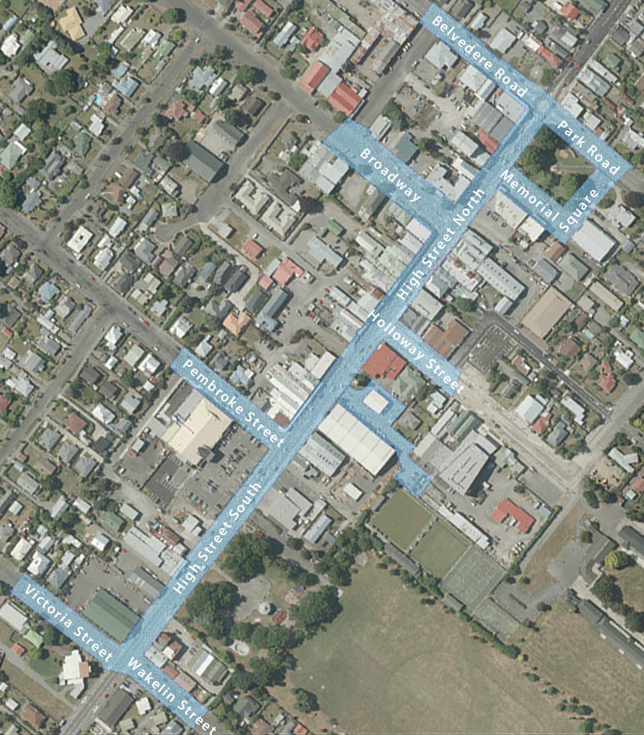

Third Schedule - Millennium Park

Prohibited Area means the general area of Millennium Park, and defined as Part Section 206

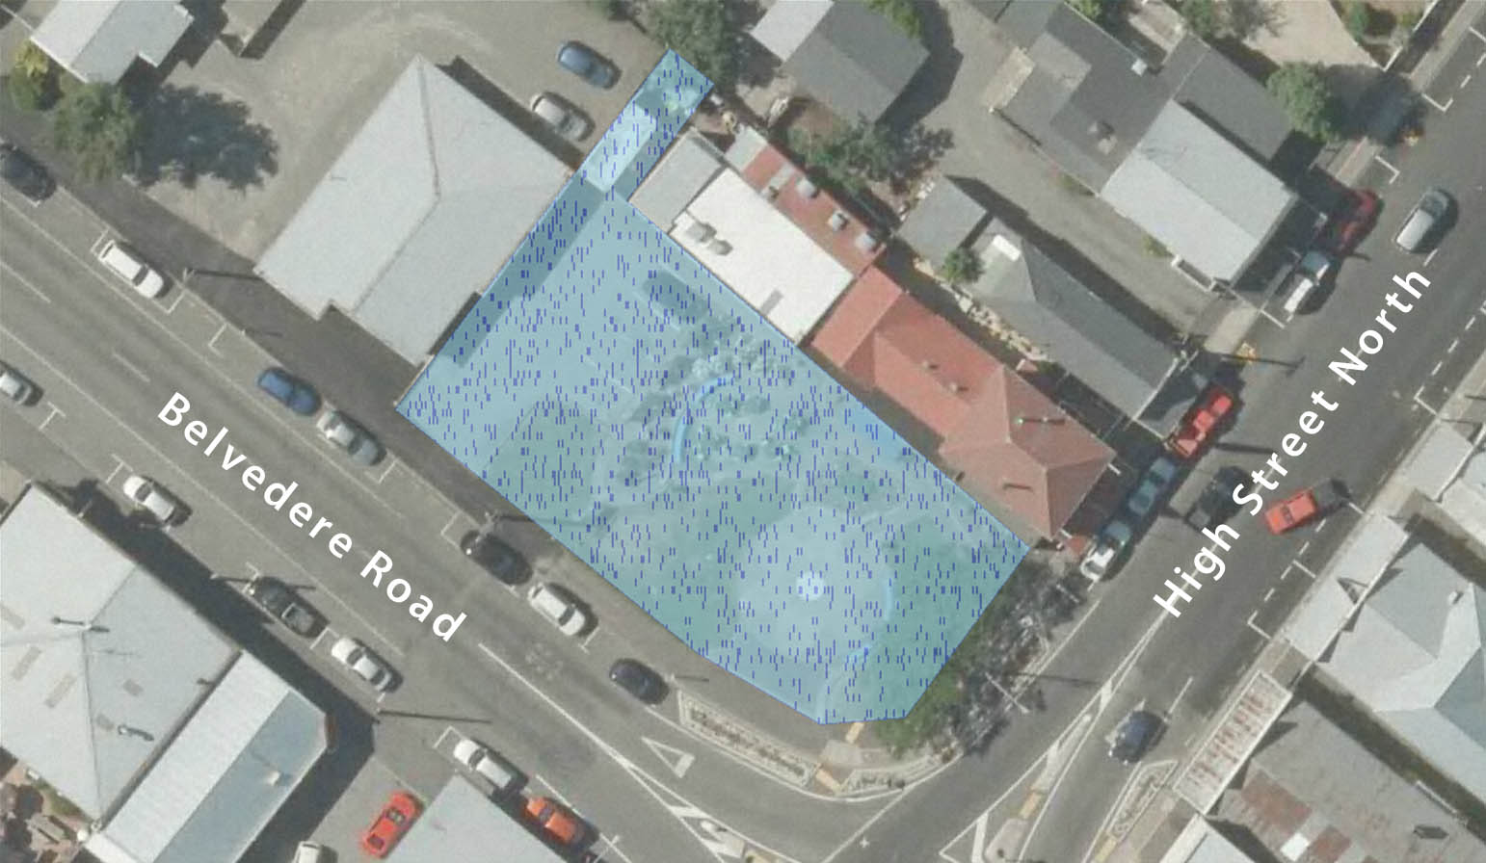

Fourth Schedule - Memorial Square
Prohibited Area means the general area of Memorial Square, and defined as Lot 22 DP 414.
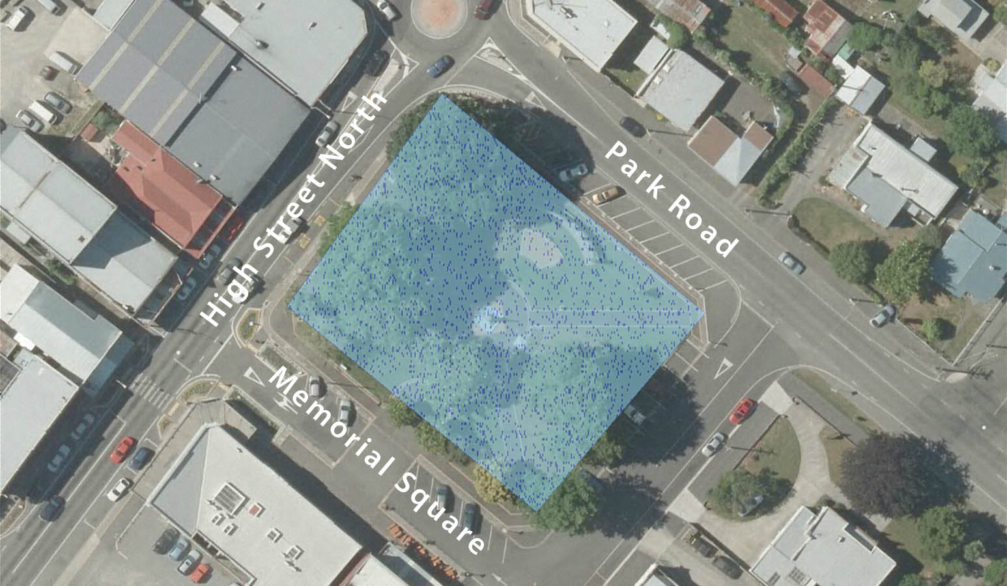

Fifth Schedule – Private Area
Prohibited Area means the general area of the private car park, and defined as Lot 1 DP 85196.

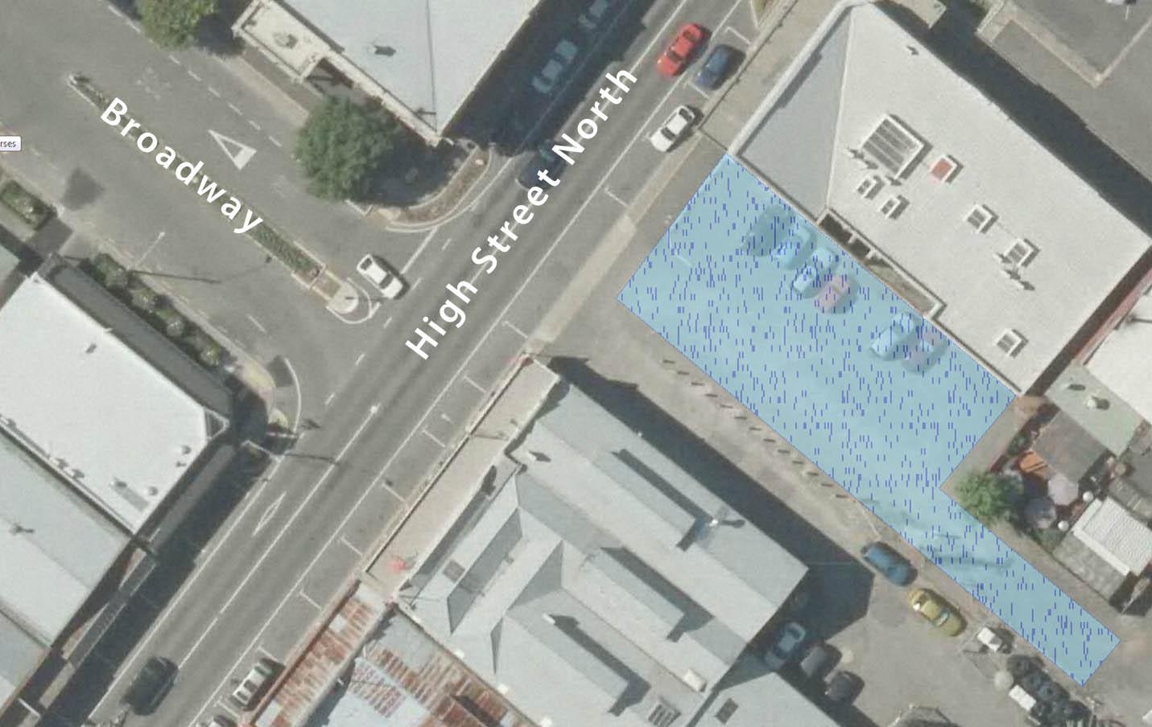

Sixth Schedule – Town Clock Reserve.

Prohibited Area means the general area of the Town Clock Reserve, and defined as Lot 1 DP 85196



