IN THE MATTER of the Sale and Supply of Alcohol Act 2012

AND

IN THE MATTER of an application by Carrington Bowling and Croquet Club (Inc) for a renewal club licence pursuant to s.127 of the Act in respect of premises situated at 57 High Street South, Carterton known as Carrington Bowling and Croquet Club”

BEFORE THE CARTERTON DISTRICT LICENSING COMMITTEE

Chairperson: Elaine Brazendale
Secretary: Colin Wright

DECISION

This is an application by Carrington and Bowling and Croquet Club (Inc) for a renewal club licence in respect of premises situated at 57 High Street South, Carterton known as Carrington and Bowling Club
The application was duly advertised and no objection or notice of desire to be heard has been received. Accordingly we deal with the matter on the papers.

We are satisfied as to the matters to which we must have regard as set out in s.131 of the Act and we grant the applicant a renewal club licence authorising the sale and supply of liquor for consumption on the premises, to any person who is present on the premises.

This licence is subject to the following conditions:

- alcohol must be sold only on the following days and during the following hours:
Mondays to Sundays - 9 am to 9 pm
- the following steps must be taken to promote the responsible consumption of alcohol:
- The licensee or manager must implement and maintain the procedures outlined in the alcohol management plan supplied with the licence application and the steps described in the application aimed at promoting the responsible consumption of alcohol.
- The licensee must have available for consumption on the premises, at all times when the premises are open for the sale of alcohol, a reasonable range of non-alcoholic refreshments and low-alcohol beverages.
- Food must be available for consumption on the premises at all times when the premises are open for the sale of alcohol in accordance with the menu submitted at the time of application for a licence, or variations of that menu of a similar range and standard. Patrons must be notified of the availability of food by appropriate notices throughout the premise
- Patrons must be notified of the availability of food by appropriate notices throughout the premises
- Drinking water is to be freely available to customers while the premises are open for business.
- the following steps must be taken to ensure that the provisions of the Act relating to the sale of alcohol to prohibited persons are observed: The Licensee or manager must ensure that:
- patrons do not become intoxicated and where intoxicated persons do present themselves, they are not served further alcohol
- Statutory restrictions on the supply of alcohol to minors are observed at all times and evidence of age documents is requested where necessary.
- Signs clearly stating the above requirements are placed at all points of sale.

DATED at Carterton this 17th day of July 2015

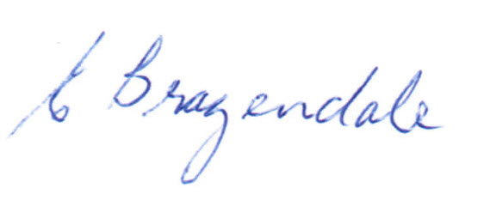

_____________________
Elaine Brazendale
Chairperson
Carterton District Licensing Committee

